**Charbonneau Activity Page**

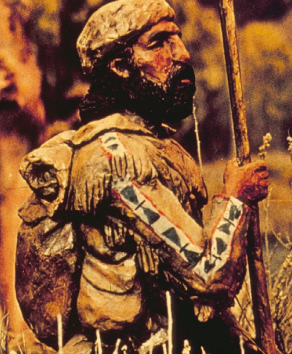

Point to Ponder

How are you and Charbonneau alike or different?

During the 1840’s, Jean Baptiste Charbonneau worked as a hunter for the Bent, St. Vrain, & Company. The items you see around the fort today would have been very familiar to Jean Baptiste.

**Charbonneau’s Tic-Tac-Toe**

All the facts below could be true for either you or Jean Baptiste Charbonneau or *both*. Draw an “X” over each fact that could describe your visit today. Draw an “O” over each fact that could describe Jean Baptiste Charbonneau when he worked at Bent’s Fort. Connect three in a row of either “X” or “O.”

Spoke French, German, Spanish, English, and several Native American languages

Spotted a live animal inside the plaza, corral, or fort grounds

Found a buffalo robe

Left Bent’s Fort to mine for gold with Jim Beckwourth

Worked as a guide, trapper, and military scout

Stepped on the original fort hearth stones in the kitchen

Remembered my mother who helped the Lewis and Clark expedition

Saw the red chiles hanging from the ceiling of a fort room

Stood at the counter inside the Trade Room