Cultural Contact

Draw a line to match the artifact with its name. Use the key below to write its trade origin in the blank.

England = E China = C Italy = I Mexico = M American Great Plans = A

Navajo blanket Trade beads Mexican reales Buffalo Robe Chocolate

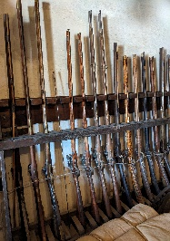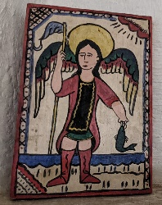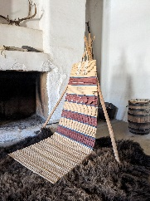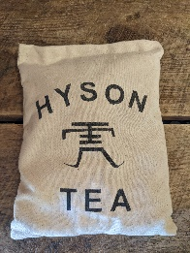

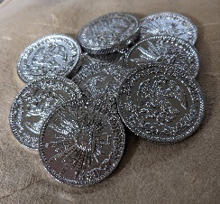 __________ __________ ____________ _________ __________

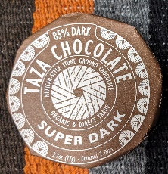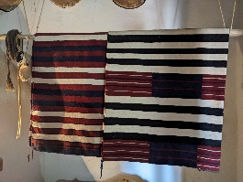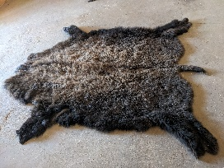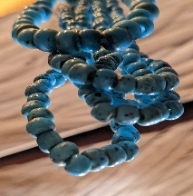

___________ __________ ____________ __________

Northwest trade gun Retablo Cheyenne backrest Tea

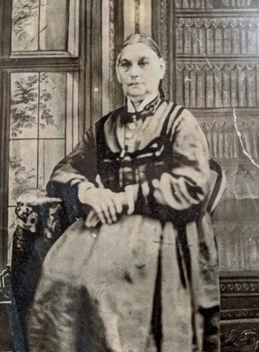

Point to Ponder

Why are some items only available from certain regions?

As the daughter of an influential Mexican merchant, Maria Ignacia would have helped her husband, Charles Bent, understand the language, habits, diet, and cultural objects of Mexico.