Distanced and Displaced Map Activity

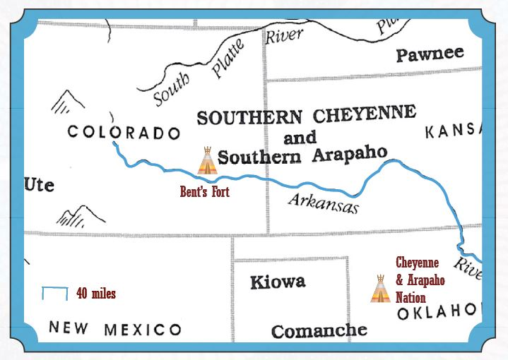

Use the mileage scale to estimate the distance between Bent’s Fort and where the Cheyenne and Arapaho Nations live today. Then, determine how long the journey would take if traveling an average of 12 miles per day.

_____________ miles ___________ days

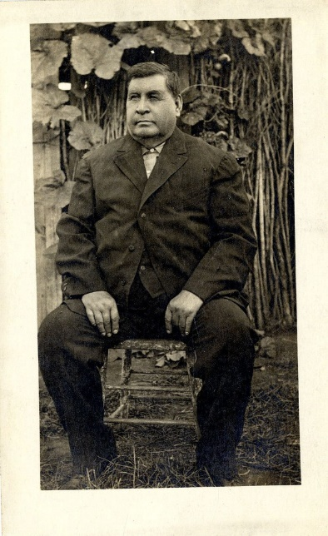

Ho-my-ike (George Bent), the son of William Bent and Mestaahéhe (Owl Woman) grew up in a culturally blended family. As a member of the Dog Soldier Society, Indian agent, and interpreter, George witnessed the reduction of tribal lands. Like many other Native American tribes, the Southern Cheyenne and Arapaho people were moved to reservations in Indian Territory (Oklahoma) in the 1800s by the government. At age 75, George died in Oklahoma among his Cheyenne family.

**Point to Ponder**

As years passed, Cheyenne and Arapaho nations overcame the hardships of relocation. Today, they thrive with a strong economy and culture. Imagine being a young Cheyenne or Arapaho child whose entire family and community was forced to leave their homeland. How would you feel?