Equal Exchange

Choose two goods from the top row to trade for two or more goods from the bottom row. Your total trade amount must be even. (See example.)

TRADE GOODS

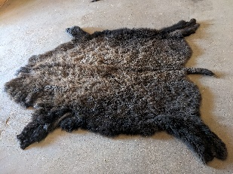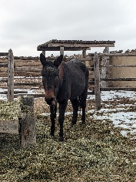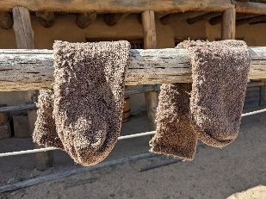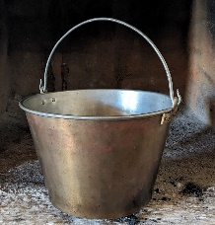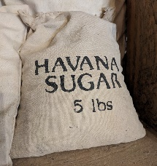

Sugar $1 Kettle $8 Wool socks $5 Mule $8 Buffalo robe $3

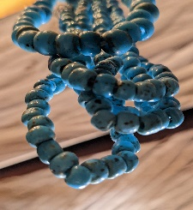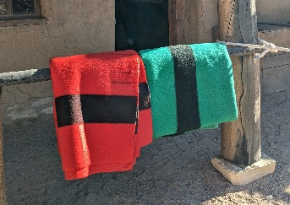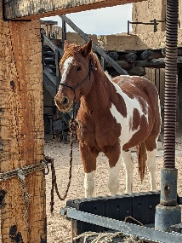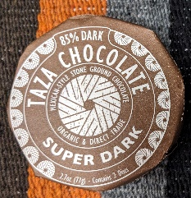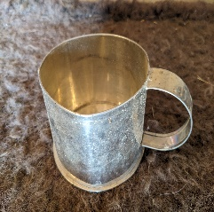

Tin cup $2 Chocolate $1.50 Wool blanket $9 Trade beads $2.50 Horse $20

EXAMPLE

|  |  |  |  |  |  |
| --- | --- | --- | --- | --- | --- |
| Item to trade | Quantity | Value | Traded for | Quantity | Value |
| kettle | 1 | $8.00 | blanket | 1 | $9.00 |
| bison robes | 2 | $6.00 | chocolate | 2 | $3.00 |
|  |  |  | tin cup | 1 | $2.00 |
|  |  | Total  $14.00 |  |  | Total  $14.00 |

YOUR TURN

|  |  |  |  |  |  |
| --- | --- | --- | --- | --- | --- |
| Item to trade | Quantity | Value | Traded for | Quantity | Value |
|  |  |  |  |  |  |
|  |  |  |  |  |  |
|  |  |  |  |  |  |
|  |  |  |  |  |  |
|  |  |  |  |  |  |
|  |  | Total  $ |  |  | Total  $ |

**Point to Ponder:** Would you rather trade items than buy them with cash, coin, credit card, or mobile payment? Why or why not?