William’s Wheel of Fortune

Decide if William’s choices created an overall positive or negative result. These are your opinions. Place a plus sign next to the positive results and a minus sign next to the negative ones.

* _______Profited from the hunting of buffalo
* _______Traded internationally with England, Italy, Mexico, China, etc.
* _______Provided goods which various Native American nations desired
* _______Traveled in trade caravans through Native American lands
* _______Served as Army scout for Kearney during the U.S./Mexican War
* _______Traded guns to Native American nations
* _______Learned to speak various languages
* _______Extracted a large amount of natural resources
* _______Built the first permanent trading post in Colorado territory
* _______Received buffalo robes from the Cheyenne and Arapaho for trade
* _______Enslaved Charlotte, Dick, and Andrew
* _______Worked toward creating peaceful relations with Native American tribes
* _______Served as government representative for the Treaty of 1865 which limited

Native American lands

* _______Gave Army of the West quarter and supplies as they prepared to invade

Mexico

* _______Warned Cheyenne/Arapaho encampment about smallpox outbreak
* _______Cautioned against revenge with those involved in Charles Bent’s

assassination

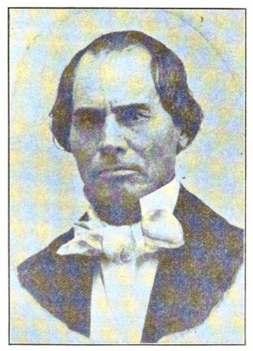

William Bent managed business at Bent’s Fort alongside Mestaahéhe (Owl Woman) during a difficult time in a remote location. He had to weigh his choices carefully.

Point to Ponder

How do you determine whether or not a past decision is a good one?