**PROGRAMMATIC OVERVIEW**

PLANT ADAPTATIONS

**ESSENTIAL QUESTION(S)**

How have native plants adapted to survive in our Mediterranean Climate?

**OBJECTIVES**

* Students will understand what adaptation means and the major abiotic and biotic drivers in an ecosystem that drive these adaptations
* Students will gain an in depth overview of what makes the Mediterranean Climate unique
* Students will understand the threats to Coastal Sage Scrub and Chaparral plant communities and how they can help preserve and protect them
* Students will make connections between how overcoming stress in nature can teach us valuable lessons on how to overcome stress in our lives

**LESSON GRADE LEVEL**

K- 12th Grade

**DESCRIPTION**

All living things on our planet have adapted to ensure their survival under a given set of conditions. In order to survive, an organism must gather enough food or energy for growth, protect itself from harm, and reproduce. To obtain or store enough water for growth, plants in climates such as ours have developed various adaptations. Some plants have long roots that can tap into the groundwater stored deep below. Others have shallow roots that spread out wide and allow the plant to absorb the water from short bursts of rainfall. Some plants have organs for water storage. These organs allow the plant to hold water to be used at a later time. Other plants have made various leaf adaptations. For example, having light-colored leaves help keep the plant cool or cupped-shaped leaves help reduce water loss during transpiration.

The native plant communities of the Coastal Sage Scrub and the Southern Maritime Chaparral have adapted to live in our Mediterranean Climate here in San Diego. For this activity, students will make observations about plant size, leaf size, color, scent, and feel of these plants. As these observations are occurring, questions are posed and pondered on why these adaptations have helped these plants to survive in these areas and how they play an important role in the ecosystems within the park.

**VOCABULARY**

* **Adaptations:** a change or the process of change by which an organism or species becomes better suited to its environment
* **Annual plant:** a plant that begins from a seed, and then grows, flowers, produces seed, and dies in less than a year
* **Climate:** The average weather of a given region taken over a significant period of time
* **Deciduous:** shedding or dropping leaves
* **Dormant:** not growing but resting or waiting for more suitable growing conditions
* **Evergreen:** having leaves all year round
* **Perennial plant:** a plant that lives for many years
* **Plant Communities:** a collection of plants with similar characteristics
* **Protection:** the act of preservation from harm
* **Urbanization:** the process by which rural areas transform into urban areas due to population influx
* **Weather:** the state of the atmosphere in regards to temperature, humidity, wind, cloudiness, etc., which can change day to day

**STANDARDS MET**

**K-5 PRIMARY:** K-LS1-1. K-ESS3-1. 1-LS1-1. 1-LS3-1. 2-LS2-1. 2-LS4-1. 3-LS3-1. 3-LS3-2. 3-LS4-2. 3-LS4-3. 4-LS1-1. 4-ESS2-1. 5-LS1-1. 5-LS2-1.

**MIDDLE SCHOOL:** MS-LS1-4. MS-LS1-5. MS-LS2-1. MS-LS2-2. MS-LS2-4. MS-LS4-4.

**HIGH SCHOOL:** HS-LS1-5. HS-LS2-1. HS-LS2-2. HS-LS2-6.

**VISIT PREPARATION**

**GUIDED QUESTIONS**

* What does it mean to adapt?
* What types of conditions in nature do plants and animals need to adapt to?
* Brainstorm different animal and plant adaptations and what they are for.

**ACTIVITY**

Have students draw or design an animal or plant to withstand a specific ecosystem and/or set of constraints. With their design have students write an explanation or present to the class their organism, what it’s adaptations are, and what environmental constraints it is overcoming. There are so many fun and effective ways to introduce your class to the concept of adaptations. Check out some of these and ‘adapt’ them for your classroom needs: <https://thesciencepenguin.com/2014/06/time-to-teach-animal-adaptations.html>

**VIDEOS AND ONLINE RESOURCES**

* Five Habitats of San Diego [Video]: <https://youtu.be/CLyXOFn7488>
* Coastal Sage Scrub [Video]: <https://youtu.be/BuxticCTj7k>
* Plant Adaptations: <http://studyjams.scholastic.com/studyjams/jams/science/plants/plant-adaptations.htm>
* Animal Adaptations [Video]: <https://www.youtube.com/watch?v=Dw7z8Fo5ijk>
* Example Species Guides: <https://www.nps.gov/cabr/learn/nature/field-guides.htm>
* Nature and Science: <https://www.nps.gov/cabr/learn/nature/index.htm>

**SAFETY AND GETTING TO CABRILLO**

Safety during your visit is our number one priority. Please review the ***Group Expectations*** and safety stipulations below. Prior to your visit, please thoroughly review our website for any questions you might have (FAQs – <https://www.nps.gov/cabr/learn/education/frequently-asked-questions.htm>) and further instructions on **Traveling To Cabrillo** and what to bring with you (<https://www.nps.gov/cabr/learn/education/traveling-to-cabrillo-national-monument.htm>).

**YOUR VISIT TO CABRILLO NATIONAL MONUMENT**

**ARRIVAL INSTRUCTIONS**

* Present your permit(s) to the Entrance Station and park in the designated bus parking spots.
* Check-in with a staff member at the Visitors Center upon your arrival.
* Arrive at least 15 minutes prior to the start of your program and allow plenty of time for your students to visit the restroom and have snack.
* Place your lunches in the designated receptacle.
* Meet staff for your program at the: Visitor Center Complex

**ESTIMATED TIME**

Our Ranger-led programs are one hour in duration and are offered twice daily at 10 a.m. and 11:15 a.m. (Offering for tidepool programs vary depending on the tide). Each hour long program can accommodate 35 students. If you have more than 35 students, you will need to reserve BOTH time slots for a day. If you have more than 70 students, you will need to request multiple days.

**MATERIALS**

*(provided by Cabrillo NM)*

* Plant Adaptations Data Sheet
* Field Guides (<https://www.nps.gov/cabr/learn/nature/field-guides.htm>)
* Clipboards
* Pencils

**INTRODUCTION** (*10-15 minutes – Cabrillo staff)*

* Welcome and Introduction to Cabrillo National Monument, the National Park Service, and Staff
* Topic Overview
  + Define the Mediterranean Climate and the characteristics that make it unique.
  + What are the specific needs of plants and animals that live in this climate?
  + How have these organisms adapted to withstand the pressures imposed by the Mediterranean Climate?
* Activity Review
  + Students will join Cabrillo scientists to observe and collect data on the different plants of the park and their specific adaptations.
  + What makes a good observation? Explain senses.
  + How do we collect data and why is it important?
* Safety Protocols
  + No running in the park
  + Please stay on designated paths and be aware of other visitors
  + All of the plants and animals at Cabrillo National Monument are protected
  + Please respect the tools we are using

**ACTIVITY** *(30-40 minutes – Cabrillo staff)*

* Pass out materials to students and review the data sheet and what students will be doing
* Guided exploration of select trail with students. Review 6-8 plants along the walk and then give students 10 minutes to collect data on one of the species reviewed. Give students 5 minutes at the end of activity to think-pair-share with a partner about what they found.

**CLOSING THOUGHTS** *(10 minutes – Cabrillo staff)*

* Reflective Questions (Think-Pair-Share)
  + What types of plants did students see?
  + What specific adaptations did students find interesting?
  + Did they find anything unique or surprising during their exploration?
  + How can students adapt to stressful situations in their own lives?
* Activity Review: Review methodology and inquire students on thoughts on the data collection process. What other tools could they use to collect data?
* Conservation Message: Review the mission of the National Park Service. How do we need to adapt to our changing world in order to protect and preserve these beautiful places?
* Conservation Commitment: What commitment will students make to help the Earth? How will they adapt to make a difference?
* Address Final Questions
* Encourage student gratitude to teachers and chaperones
* Provide next steps for group
  + Where to have lunch and leave no trace principles
  + Thank group for participation and visiting

**AFTER YOUR PROGRAM**

You are welcome to stay at the park until closing (5 p.m.) just remember that you are responsible for your group through this duration – See ***Group Expectations.***

Visit our website for additional educational materials to supplement your group’s learning (<https://www.nps.gov/cabr/learn/education/self-guided-field-trips.htm>).

**HANDOUTS**

See below

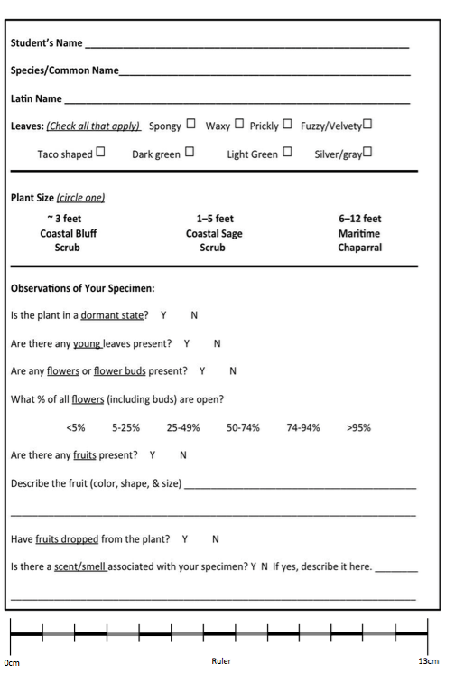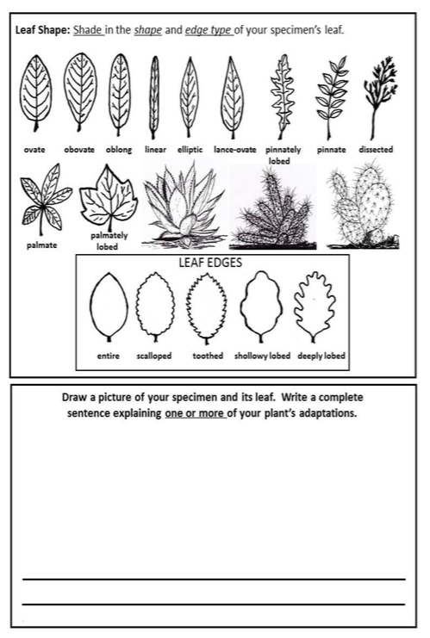

**AFTER YOUR VISIT**

**GUIDED REFLECTION**

* Looking at the data we collected, what are some conclusions we can make?
* Does this information spark more questions about adaptation?

**ACTIVITY**

There are many ways students can ‘adapt’ their lifestyle to promote sustainability and conservation – brainstorm these different ways and make a classroom commitment to help protect the earth and track it over a given time period. Encourage student creativity!

**VIDEOS AND ONLINE RESOURCES**

* See ***VISIT PREPARATION***

**ADDITONAL RESOURCES**

* Cabrillo Field Notes: <https://www.nps.gov/cabr/blogs/cabrillofieldnotes.htm>
* Cabrillo YouTube: <https://www.youtube.com/channel/UCFgWF77neF6I6bLt-Z7LL-w>
* San Diego Natural History Museum: <http://www.sdnhm.org>
* San Diego Zoo, Institute for Conservation Research: <http://institute.sandiegozoo.org>

**GROUP EXPECTATIONS**

*Please thoroughly review the following with your students and chaperones prior to your visit to Cabrillo National Monument. For the safety of the public and resources, we reserve the right to ask groups to leave the park if these expectations are not adhered to.*

**VEHICLE PASS**

Your vehicle pass will be attached to your confirmation email. Upon arriving at the park EACH VEHICLE in your group must present the vehicle pass that is attached to this email to the ranger at the entrance station. Please print and make copies of your vehicle pass ahead of time and distribute them before arriving at the park. Vehicles without a pass will be charged the entrance fee.

**WHERE TO MEET**

Unless otherwise stated, the teacher should check-in at the visitor center upon arrival. A ranger or volunteer will direct you where to go from there. If you are participating in a tidepool focused program, a ranger will meet you at the tidepool kiosk 15 minutes prior to the start of your program and you do not need to check in at the Visitors Center.

**LUNCH**

A lunch bin to store your lunches is located between the vending machines. If you are participating in a tidepool program, we recommend either bringing class lunches in tubs or student backpacks. Cabrillo is a trash-free park which requires that all trash that your group generates during your visit must be taken out of the park by your group. Please plan accordingly and bring a trash bag with you. Review our 'Zero-Waste' practices prior to your visit.

**PARKING**

For safety and convenience, buses should unload and pick up your group in the traffic circle near the flagpole. Bus parking is available in designated spaces in the middle bay of the main parking lot. Buses must turn off engines while unloading or loading passengers. For groups visiting the tidepools, please remember that access to the coastal area is only by vehicle via Cabrillo Road. Travel by any other means is dangerous and not permitted. There is no pedestrian access. Parking is limited, so we encourage carpools or bus transportation. Buses can drop off students at the tidepools and park up the hill in the main parking lot. However, buses must be promptly available to pick-up students from tidepools at culmination of program.

**MANNERS**

Please remember that many groups of people visit the park. Respect other visitors by keeping the noise level down, walking instead of running, and staying on the correct side of the path. Any collections of plants or animals is prohibited by Federal Law. Groups that disrespect the grounds of the National Park in any way will be asked to leave.

**SAFETY**

Groups should remain together and stay on designated walkways and trails. Cabrillo National Monument is a protected area. Please do not harass the wildlife or protected landscape in any way (subject to federal regulations). Stay away from cliff edges as they tend to be unstable. Students must not run in any area of the park and be spatially aware of other visitors to the park.

**CLOTHING**

Wear comfortable clothing and closed-toed shoes. Bring jackets and sweaters, as the waterfront tends to be cooler than the rest of San Diego. Sunscreen is recommended.

**CELL PHONES**

Due to our location, many cell phones do not work within the boundaries of the park. Alternatively, signals might re-direct into Mexican cell towers and can result in international charges. Please plan ahead should this be the case. Emergency phone calls may be made from the Visitors Center landline.

**TIDEPOOLS**

If your class is visiting the tidepools, there is an almost certain likelihood they will get wet. Additionally, there is only one restroom facility in the tidepool area. Please plan accordingly. Make sure that you have your tidepool permit on hand, you may be asked to show it. Please be aware that tidepool access requires walking down steep sandstone cliffs. Safety is our number one concern in the tidepools, please 1) remind students to wear closed-toed or water shoes (no flip flops), 2) walk slowly and with caution, 3) be mindful of large waves and loose cliffs, 4) do not pick up or throw rocks, and 5) be gentle with all of the critters that call Cabrillo home.

**CHAPERONES**

We kindly request that chaperones remain attentive and engaged throughout your stay at Cabrillo. Please help us with the safety and well-being of your students by adhering to the following guidelines:

* Assist in facilitating student learning and engagement by asking them questions about what they are observing or experiencing.
* Know who is in your group at all times and be responsible for your group’s whereabouts during their visit.
* Know your group’s plan for the day: how long will they be in certain locations, what time will they eat lunch, what time will you be leaving and where will you meet, etc.
* Stay with your group at all times and make sure that they adhere to the park rules and are respectful of other visitors.
* Consider establishing a meeting place just in case anyone gets separated from the group. We suggest the Visitors Center.

**Thank-you for your participation in our program. Hope to see you back soon!**

**Connect with us on social media @CabrilloNPS**