

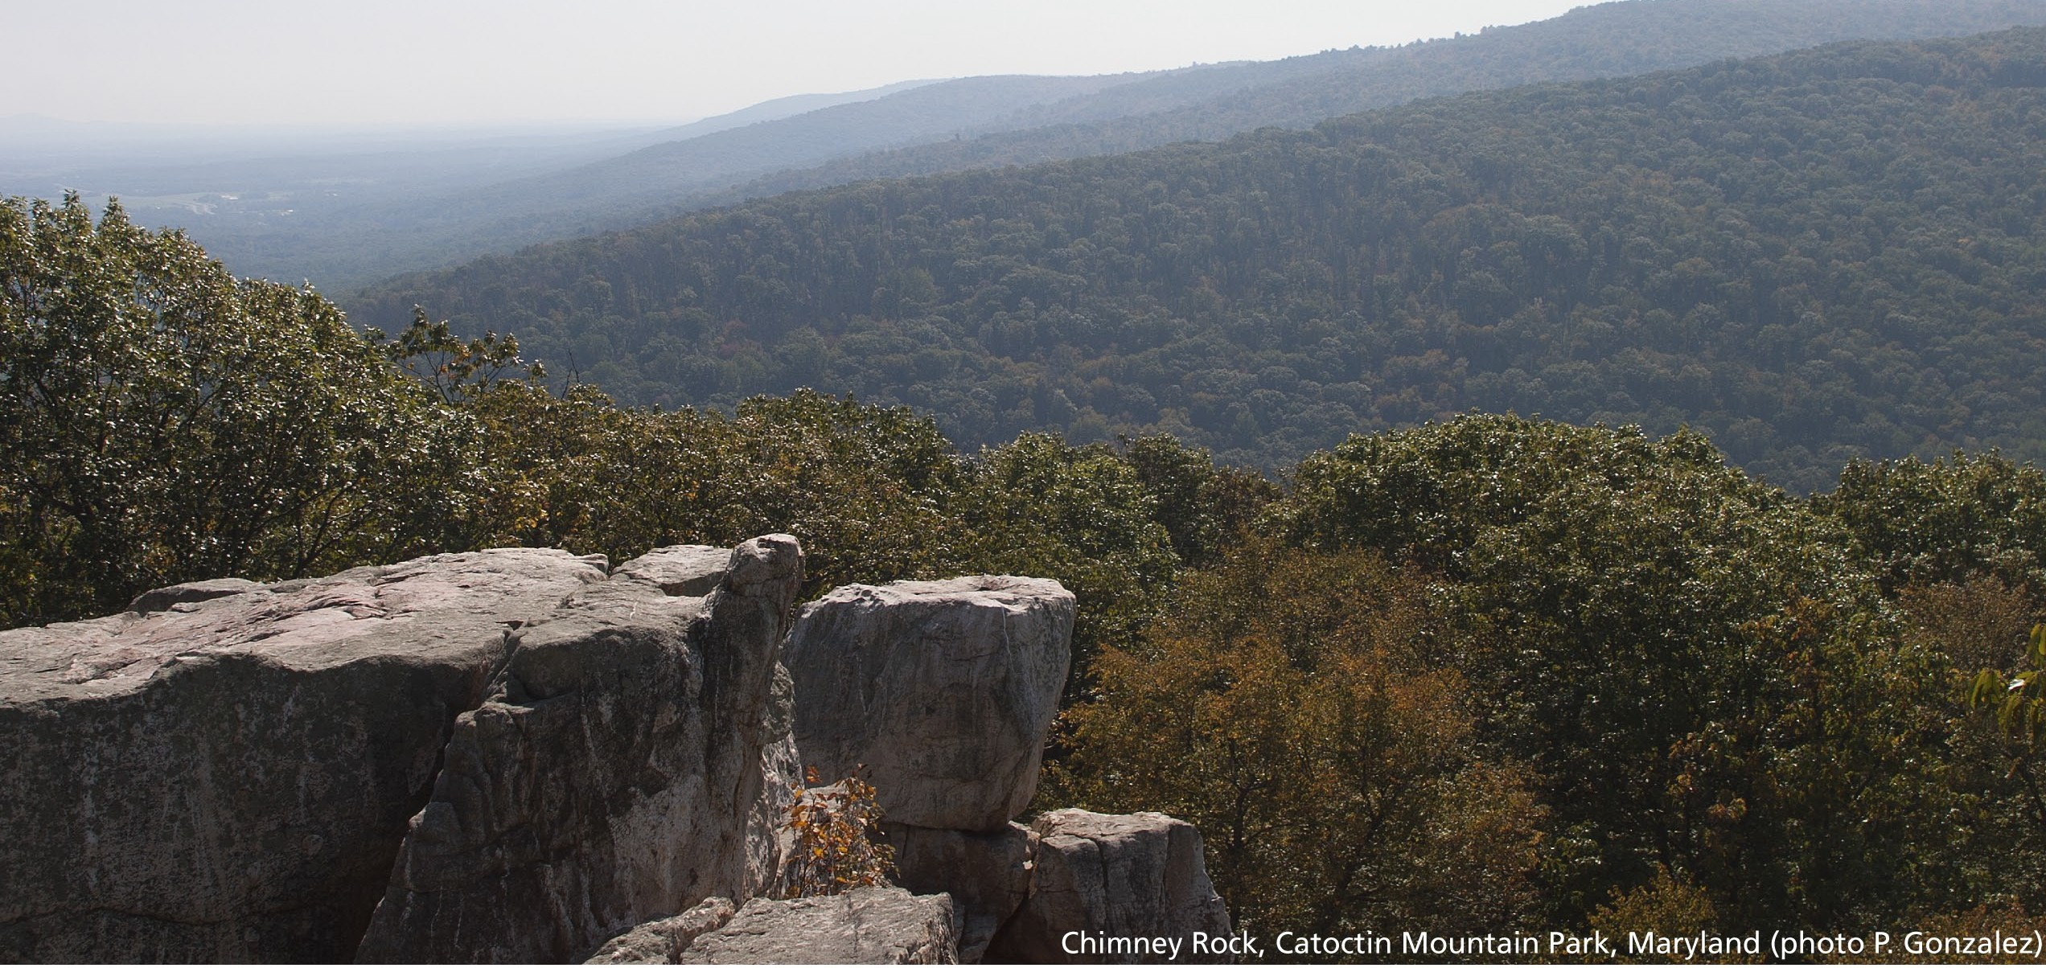

Climate Change Trends for Resource Planning at Catoctin Mountain Park, Maryland

Patrick Gonzalez, Ph.D.

Climate Change Response Program Natural Resource Stewardship and Science National Park Service
1201 I Street NW
Washington, DC 20005-5905 USA June 25, 2012

Historical Trends
From 1901 to 2002, temperature increased across the U.S. mid-Atlantic region (Figure 1; Gonzalez et al. 2010) and showed a statistically significant increase in the 50 km x 50 km area that includes Catoctin Mountain Park (MP) (Figure 2, Table 1; Gonzalez et al. 2010). From 1957 to 2011, temperature at the Emmitsburg, Maryland weather station also shows a statistically significant increase (Figure 2; data from National Oceanic and Atmospheric Administration).
Analyses of causal factors attribute 20th century temperature and precipitation changes to
greenhouse gas emissions from vehicles, power plants, deforestation, and other human activities (Intergovernmental Panel on Climate Change (IPCC) 2007, Bonfils et al. 2008).

From 1901 to 2002, precipitation increased across the U.S. mid-Atlantic region (Figure 3), in the 50 km x 50 km area that includes Catoctin MP (Figure 4, Table 1; Gonzalez et al. 2010), and at the Emmitsburg weather station (Figure 4; data from National Oceanic and Atmospheric Administration). The precipitation trends, however, are not statistically significant (Figure 4).

Mean annual snowfall in the Catoctin MP area has decreased approximately 2% per decade from 1937 to 2007 (Kunkel et al. 2009b). Historical station records from 1900 to 2006 for northeast U.S. weather stations shows a slight decrease (-2%) in extreme high snowfall seasons (10% extreme or 1-in-10 year winters) and an increase (+12%) in extreme low snowfall seasons (10% extreme or 1-in-10 year winters), but neither trend is statistically significant (Kunkel et al.
2009a).

Since 1950, the frequency of extreme hot temperatures, indicated by the number of four-day periods of one-in-five year hot temperatures (or 80% extreme), has not shown a statistically significant change (Kunkel et al. in review). The length of the growing season has been increasing since approximately 1970 (Kunkel et al. in review). In the northeastern U.S., extreme precipitation events have increased, with a statistically significant increase of 6% per decade of one-day periods of one-in-five year precipitation (or 80% extreme) (Kunkel et al. in review).

North Atlantic hurricanes can bring extreme rainfall and wind in the late summer and autumn. Analyses of 1970-2004 hurricane records and potential causal factors indicate that human- caused climate change has increased the proportion of hurricanes in the most severe categories (Hoyos et al. 2006, Webster et al. 2006), although the absolute number of hurricanes and

hurricane landfalls have shown no statistically significant trend (Wang and Lee 2008).

Future Climate Projections
The Intergovernmental Panel on Climate Change (IPCC) has coordinated research groups to project possible future climates under defined greenhouse gas emissions scenarios (IPCC 2007). The three main IPCC greenhouse gas emissions scenarios are B1 (lower emissions), A1B (medium emissions), and A2 (higher emissions). Actual global emissions are on a path above IPCC emissions scenario A2 (Friedlingstein et al. 2010). IPCC has also developed methods to characterize uncertainty in climate projections, establishing a standard set of colloquial terms that correspond to quantified confidence levels (Table 2).

For the three main IPCC emissions scenarios, temperature could increase four to seven times the warming already observed in the 50 km x 50 km area that includes Catoctin MP (Table 1; Gonzalez et al. 2010). Precipitation could increase in all three emissions scenarios in the 50 km x 50 km area that includes the park (Table 1; Gonzalez et al. 2010).

Spatial analyses of the area within Catoctin MP, using climate projections for IPCC emissions scenario A2 downscaled to 4 km x 4 km, show the spatial variation and the uncertainty of temperature and precipitation projections (data from Conservation International
<http://futureclimates.conservation.org> using method of Tabor and Williams (2010)). Projected temperature changes increase with distance from the ocean (Figure 5). The temperature projections of the 18 general circulation models (GCMs) are generally in close agreement, with a coefficient of variation (the standard deviation as a fraction of the mean) of 0.21, indicating that the temperature uncertainty is approximately one-fifth of the mean (Figure 6).

Under emissions scenario A2, total annual precipitation could increase 6-7% (Figure 7). The GCMs show an agreement of approximately 88% (Figure 8), with 16 of 18 GCMs projecting precipitation increases (Figure 9). The coefficient of variation of the precipitation projections is 1.4, indicating that the precipitation uncertainty is approximately one and a half times the mean. Taken together, the temperature and precipitation projections from the 18 GCMs form a cloud of potential future climates (Figure 9).

Projections indicate potential increases in the frequency of extreme temperature and

precipitation events (Table 3, IPCC 2012). Across eastern North America, one-in-twenty year hot temperatures (or 95% extreme) may increase in frequency to once every year or once in three years (IPCC 2012). At the Emmitsburg weather station, the one-in-twenty year average annual maximum temperature for the period 1981-2000 was 19.4ºC. One-in-twenty year storms may increase in frequency to one in 8 to 10 years (IPCC 2012).

In the area around Catoctin MP, modeling under emissions scenario A2 projects 15-18 more days per year with maximum temperatures > 35ºC (95º F.), up to two more days per year with rainfall > 25 mm in a day, and 1-2 more consecutive days per year with rainfall < 3 mm per day, compared to the 1980-2000 average of 27-30 (Kunkel et al. in review).

Over the tropical Atlantic Ocean, 18 GCMs under emissions scenario A1B project a 33% decrease in the total number of hurricanes, but a 75% increase in the number of intense hurricanes (Categories 4 and 5) (no range given, Bender et al. 2010).

In the area of Catoctin MP area, one projection of snowfall under emissions scenario A2 projects a decrease of 10-50% (Brown and Mote 2009). For the northeastern U.S., frost projections under emissions scenario A2 project an increase in the growing season of 27-29 days (Kunkel et al. in review)

Summary Table and Least Change Estimate for Scenario Planning
Table 3 summarizes published scientific information on historical and projected climate change in and around Catoctin MP. To develop management options under scenario planning, NPS staff will start with a scenario that considers the least amount of future climate change. From Table 3, this least change scenario estimate for the year 2100 includes:
- temperature increase of ~2.6ºC
- precipitation change of ~6%
- ~15 more days per year with temperatures > 35ºC
- one-in-twenty year hot temperatures (annual average maximum > 19.4ºC (67ºF.) occurring every three years
- one-in-twenty-year rain storms occurring every 10 years
- snow decrease of 10%
- growing season increase ~27 more days per year

References
Bender, M.A., T.R. Knutson, R.E. Tuleya, J.J. Sirutis, G.A. Vecchi, S.T. Garner, and I.M. Held.
2010. Modeled impact of anthropogenic warming on the frequency of intense Atlantic hurricanes. Science 327: 454-458.
Bonfils, C., B.D. Santer, D.W. Pierce, H.G. Hidalgo, G. Bala, T. Das, T.P. Barnett, D.R. Cayan,
C. Doutriaux, A.W. Wood, A. Mirin, and T. Nozawa. 2008. Detection and attribution of temperature changes in the mountainous western United States. Journal of Climate 21: 6404-6424.
Brown, R.D. and P.W. Mote. 2009. The response of northern hemisphere snow cover to a changing climate. Journal of Climate 22: 2124-2145.
Friedlingstein, P., R.A. Houghton, G. Marland, J. Hackler, T.A. Boden, T.J. Conway, J.G. Canadell, M.R. Raupach, P. Ciais, and C. Le Quéré. 201. Update on CO2 emissions. Nature Geoscience 3: 811-812.
Gonzalez, P., R.P. Neilson, J.M. Lenihan, and R.J. Drapek. 2010. Global patterns in the vulnerability of ecosystems to vegetation shifts due to climate change. Global Ecology and Biogeography 19: 755-768.
Hoyos, C.D., P.A. Agudelo, P.J. Webster, and J.A. Curry. 2006. Deconvolution of the factors contributing to the increase in global hurricane intensity. Science 312: 94-97.
Intergovernmental Panel on Climate Change (IPCC). 2007. Climate Change 2007: The Physical Science Basis. Cambridge University Press, Cambridge, UK.
Intergovernmental Panel on Climate Change (IPCC). 2012. IPCC, 2012: Managing the Risks of Extreme Events and Disasters to Advance Climate Change Adaptation. Cambridge University Press, Cambridge, UK.
Kunkel, K.E., M.A. Palecki, L. Ensor, D. Easterling, K.G. Hubbard, D. Robinson, and K. Redmond. 2009a. Trends in twentieth-century U.S. extreme snowfall seasons. Journal of Climate 22: 6204-6216.
Kunkel, K.E., M. Palecki, L. Ensor, K.G. Hubbard, D. Robinson, K. Redmond, D. Easterling.
2009b. Trends in twentieth-century U.S. snowfall using a quality-controlled dataset. Journal of Atmospheric and Oceanic Technology 26: 33-44.
Kunkel, K.E., L.E. Stevens, S.E. Stevens, E. Janssen, J. Rennells, and A. DeGaetano. in review.
Climate of the Northeast U.S. National Climate Assessment. U.S. Global Change Research Program, Washington, DC.
Mitchell, T.D. and P.D. Jones. 2005. An improved method of constructing a database of monthly

climate observations and associated high-resolution grids. International Journal of Climatology 25: 693-712.
Tabor, K. and J.W. Williams. 2010. Globally downscaled climate projections for assessing the conservation impacts of climate change. Ecological Applications 20: 554-565.
Wang, C. and S.K. Lee. 2008. Global warming and United States landfalling hurricanes.
Geophysical Research Letters 35: L02708, doi:10.1029/2007GL032396.
Webster, P.J., G.J. Holland, J.A. Curry, H.R. Chang. 2006. Changes in tropical cyclone number, duration, and intensity in a warming environment. Science 309: 1844-1846.

Table 1. Historical and projected climate (mean ± standard deviation (SD)) trends for the 50 km x 50 km square area that includes Catoctin MP (Mitchell and Jones 2005, IPCC 2007, Gonzalez et al. 2010). Historical trends also given for the weather station at the park. The climate projection under IPCC emissions scenario A2 for the 50 km x 50 km square area matches the
climate projection downscaled to 4 km x 4 km for the area within the park (data from Conservation International using method of Tabor and Williams (2010)). Note “century-1” is the fractional change per century, so that 0.30 century-1 is an increase of 30% in a century.
 | mean | SD | units
Historical
temperature 1901-2002 annual average | 13.1 | 0.7 | ºC
temperature 1901-2002 linear trend | 0.6 | 2.0 | ºC century-1
temperature 1957-2011 annual average (station) | 5.3 | 0.9 | ºC
temperature 1957-2011 linear trend (station) | 3.2 | 4.6 | ºC century-1
precipitation 1901-2002 annual average | 1030 | 130 | mm y-1
precipitation 1901-2002 linear trend | 0.01 | 0.42 | century-1
precipitation 1958-2011 annual average (station) | 1100 | 240 | mm y-1
precipitation 1958-2011 linear trend (station) | 0.30 | 1.45 | century-1
Projected
IPCC B1 scenario (lower emissions)  temperature 1990-2100 annual average | 2.6 | 0.9 | ºC century-1
precipitation 1990-2100 annual average | 0.06 | 0.10 | century-1
IPCC A1B scenario (medium emissions) temperature 1990-2100 annual average | 3.6 | 0.9 | ºC century-1
precipitation 1990-2100 annual average | 0.07 | 0.10 | century-1
IPCC A2 scenario (higher emissions) temperature 1990-2100 annual average | 4.4 | 0.9 | ºC century-1
precipitation 1990-2100 annual average | 0.07 | 0.10 | century-1

Table 2. Intergovernmental Panel on Climate Change (IPCC 2007) treatment of uncertainty. Confidence Degree of confidence in being correct
Very high At least 9 out of 10 chance
High About 8 out of 10 chance
Medium About 5 out of 10 chance
Low About 2 out of 10 chance
Very low Less than 1 out of 10 chance

Variable Trend Historical 20th Century
Projected 21st Century Change
Confidence in Scientific








Temperature

Precipitation

Extreme temperature events
Change

50 km x 50 km area: +0.6
± 2ºC (+1.1 ± 3.6º F.)
(Gonzalez et al. 2010)

50 km x 50 km area: +1%
± 42% (Gonzalez et al. 2010)

Northeastern U.S.: No statistically significant trend in heat waves (four- day periods of one-in-five year hot temperatures or 80% extreme) (Kunkel et al. in review)
Lower Emissions
Scenario (IPCC B1)

50 km x 50 km area:
+2.6 ± 0.9ºC (+4.7 ± 1.6º F.) (3 GCMs,
Gonzalez et al. 2010)

50 km x 50 km area:
+6% ± 10% (3 GCMs,
Gonzalez et al. 2010)

Eastern North America: one-in- twenty year hot temperatures (annual average maximum
>19.4 ºC (67ºF.), 95%
extreme) might occur every three years (12 GCMs, IPCC 2012)
Central Emissions
Scenario (IPCC A1B)

50 km x 50 km area:
+3.6 ± 0.9ºC (+6.5 ± 1.6º F.) (3 GCMs,
Gonzalez et al. 2010)

50 km x 50 km area:
+7% ± 10% (3 GCMs,
Gonzalez et al. 2010)

Eastern North America: one-in- twenty year hot temperatures (annual average maximum
>19.4 ºC (67ºF.), 95%
extreme) might occur every one and a half years (12 GCMs,
IPCC 2012)
Higher Emissions Scenario
(IPCC A2)
Catoctin MP: +4.4 ± 0.9ºC (+7.9 ± 1.6º F.) (18 GCMs,
data Conservation International
<http://futureclimates.conserv ation.org>, method of Tabor and Williams (2010))
Catoctin MP: +7% ± 10% (18 GCMs, data Cons. Int.
<http://futureclimates.conserv ation.org>, method of Tabor and Williams (2010))

Eastern North America: one-in- twenty year hot temperatures (annual average maximum
>19.4 ºC (67ºF.), 95%
extreme) might occur every year (12 GCMs, IPCC 2012);
Catoctin MP area: 15-18 more days per year of days > 35ºC (95ºF.) (4 GCMs, Kunkel et al. in review)
Understanding (IPCC Terms)

Very High (IPCC 2007)

High (IPCC 2007)

Medium to High

Variable Trend Historical 20th Century
Projected 21st Century Change
Confidence in Scientific

Change

Northeastern U.S.: Statistically significant increase of 6% per decade of one-day periods of one-in-five
Lower Emissions
Scenario (IPCC B1)

Eastern North America: one-in-
Central Emissions
Scenario (IPCC A1B)

Eastern North America: one-in- twenty year storms may increase in frequency to one in
Higher Emissions Scenario
(IPCC A2)

Eastern North America: one-in- twenty year storms may increase in frequency to one in eight years (14 GCMs, IPCC 2012); Catoctin MP area: 0-2
Understanding (IPCC Terms)

Extreme
year precipitation or 80%
twenty year storms
eight years (14 GCMs, more days per year with

precipitation
extreme) (Kunkel et al. in
may increase in
IPCC 2012); Tropical
precipitation > 25 mm per day,
Medium to High

events
review); Eastern U.S.: No
frequency to one in 10 Atlantic: total
1-2 more consecutive days

statistically significant trend in hurricane
years (14 GCMs,
IPCC 2012)
hurricanes -33%,
intense hurricanes
per year with rainfall < 3 mm per day over 1980-2000

landfalls (Wang and Lee
(Categories 4 and 5) + average of 27-30 (4 GCMs,

2008)
75% (18 GCMs,
Bender et al. 2010)
Kunkel et al. in review)







Snow

Growing season length
Catoctin MP area: Decrease of mean annual snowfall 2% per decade 1937-2007 (Kunkel et al. 2009b); Northeast U.S.: 1900 to 2006 extreme high snowfall seasons (10% extreme or 1-in-10 year winters) -2%, extreme low snowfall seasons +12%, neither trend statistically significant (Kunkel et al. 2009a)

Northeastern U.S.: Increasing since 1970 (Kunkel et al. in review)

Catoctin MP area: Decrease of 10-50% (1 GCM, Brown
and Mote 2009)

Northeastern U.S.: Increase of 27-29 days (4 GCMs, Kunkel et al. in review)

High

High

Figure 1.
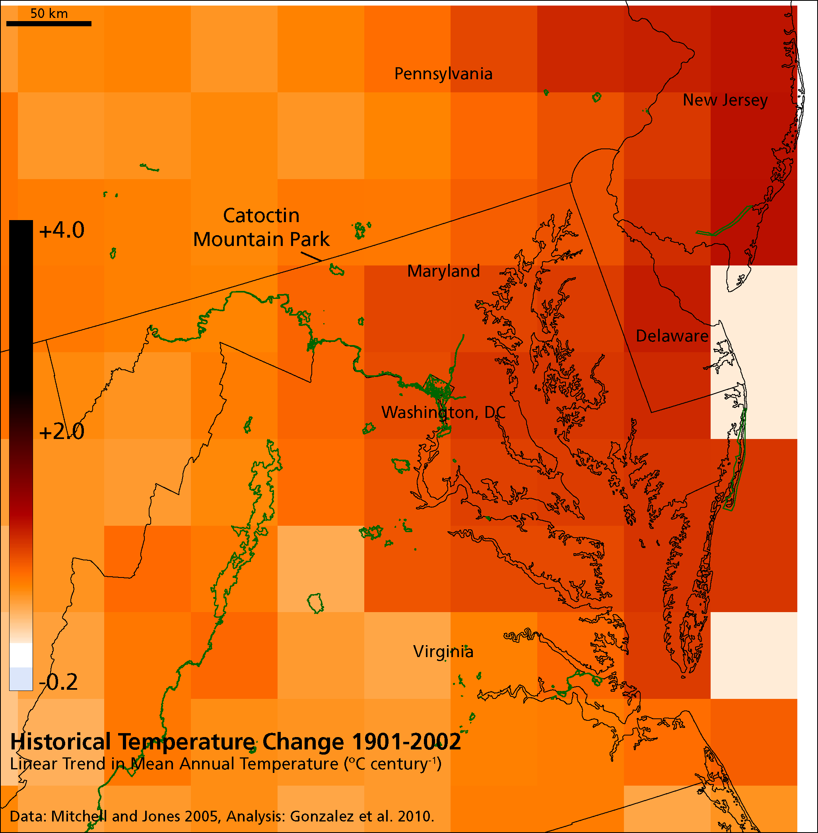

Figure 2.
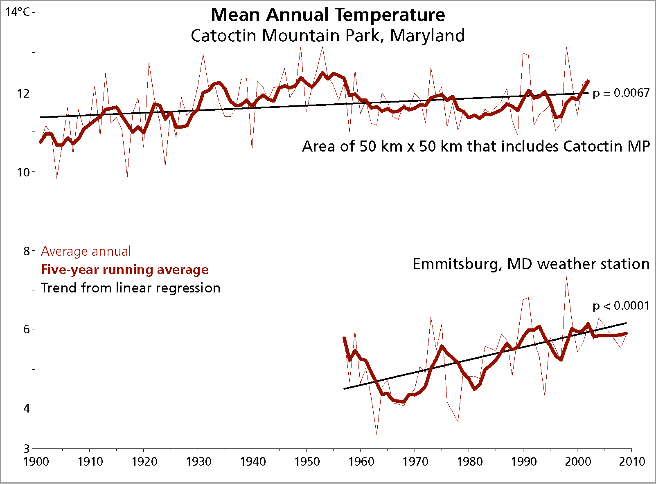

Figure 3.
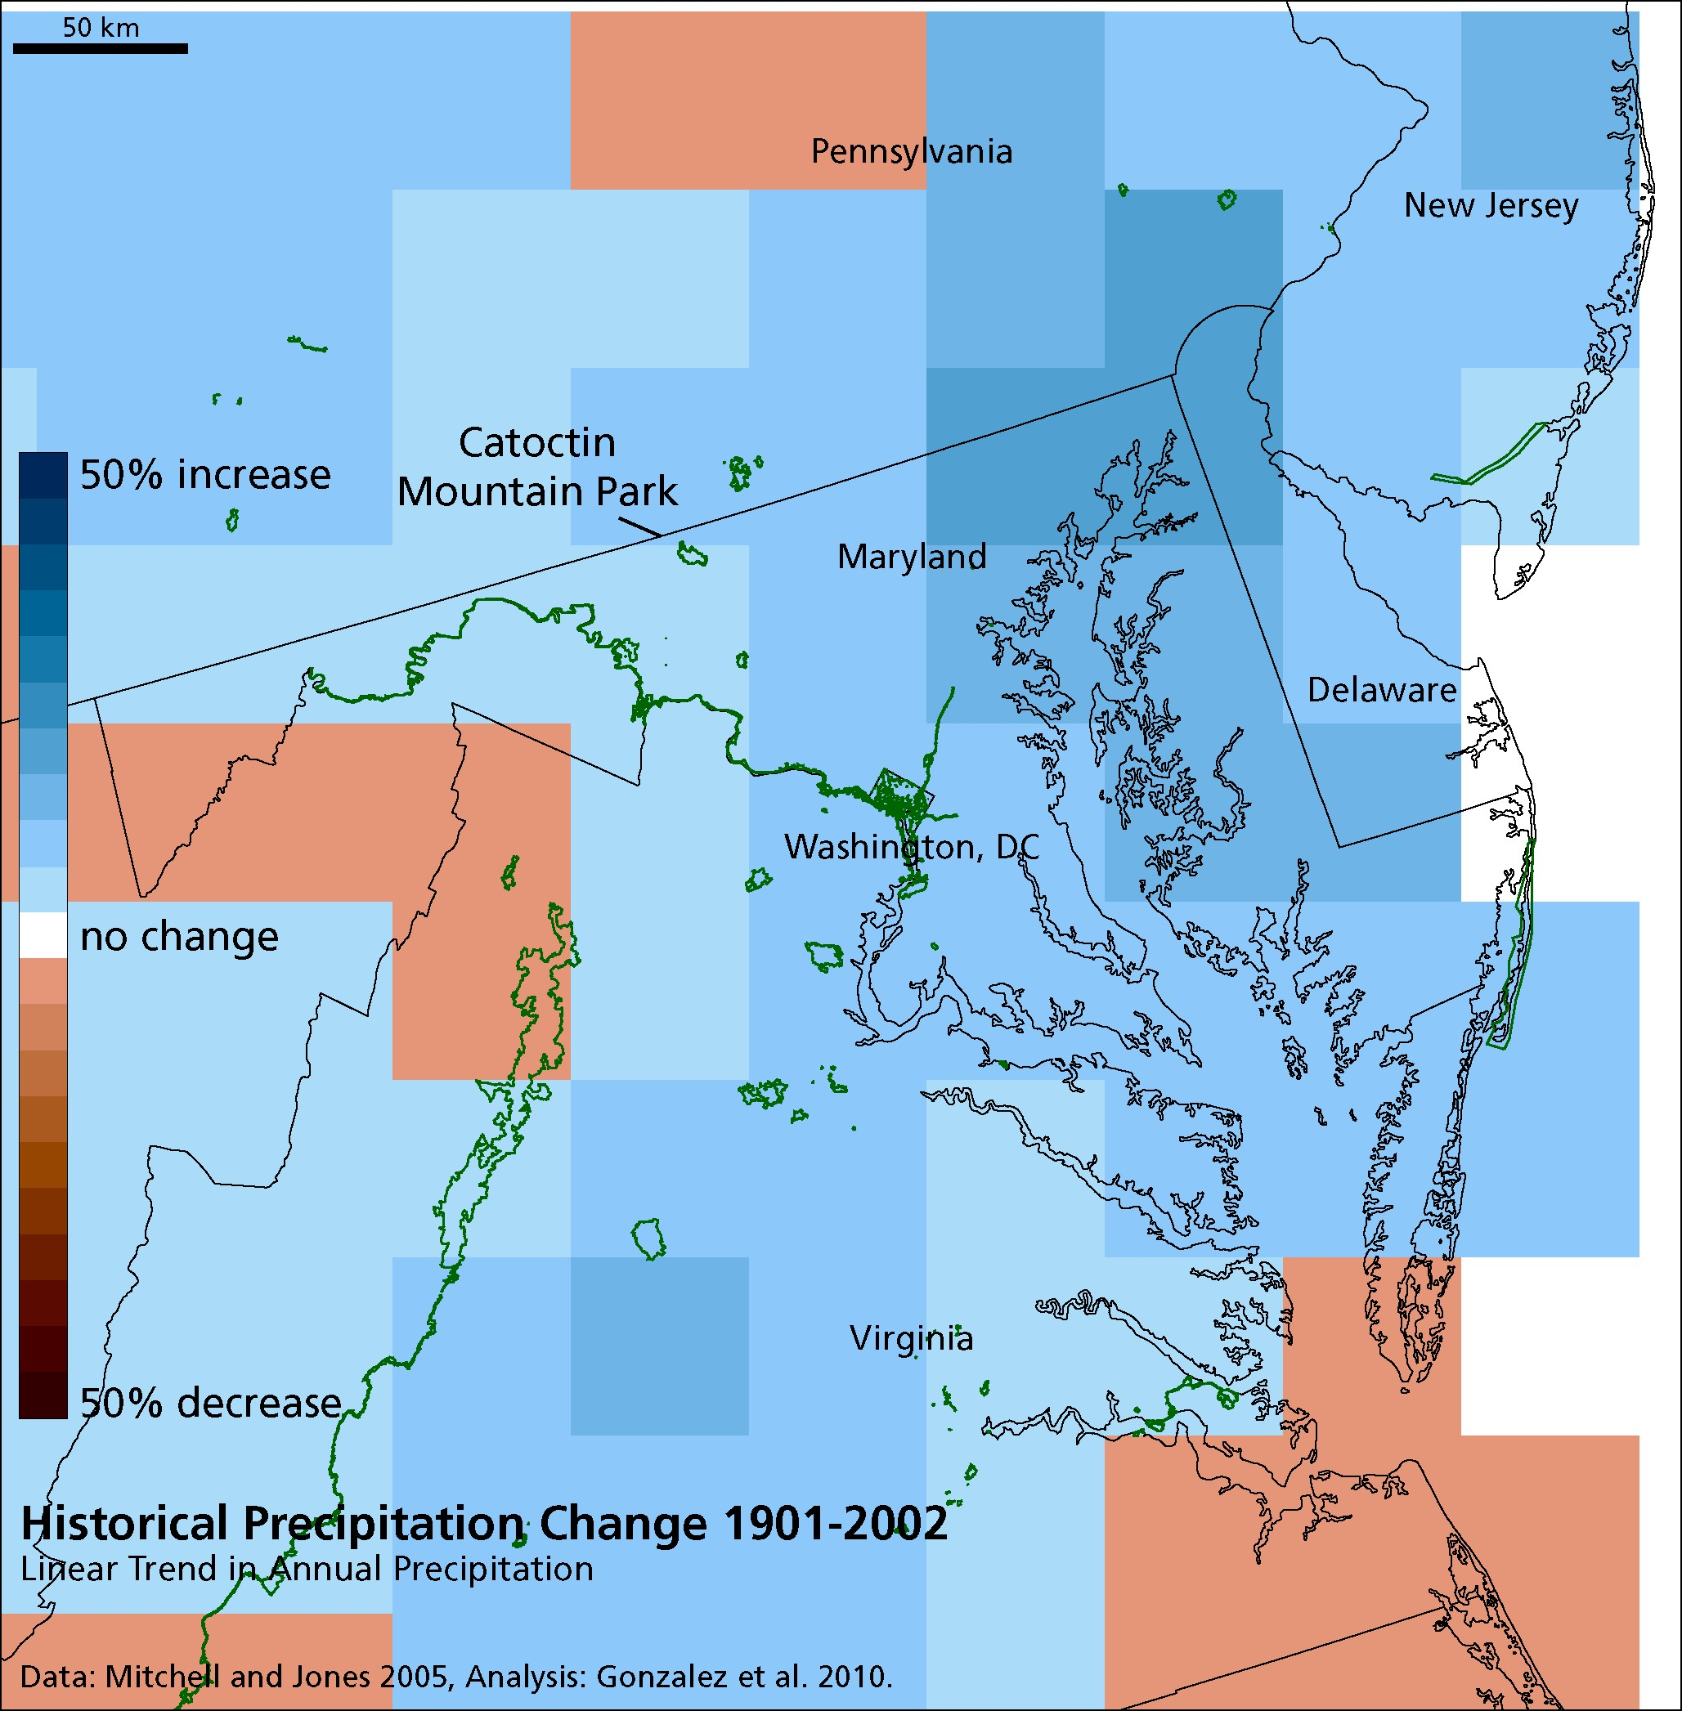

Figure 4.
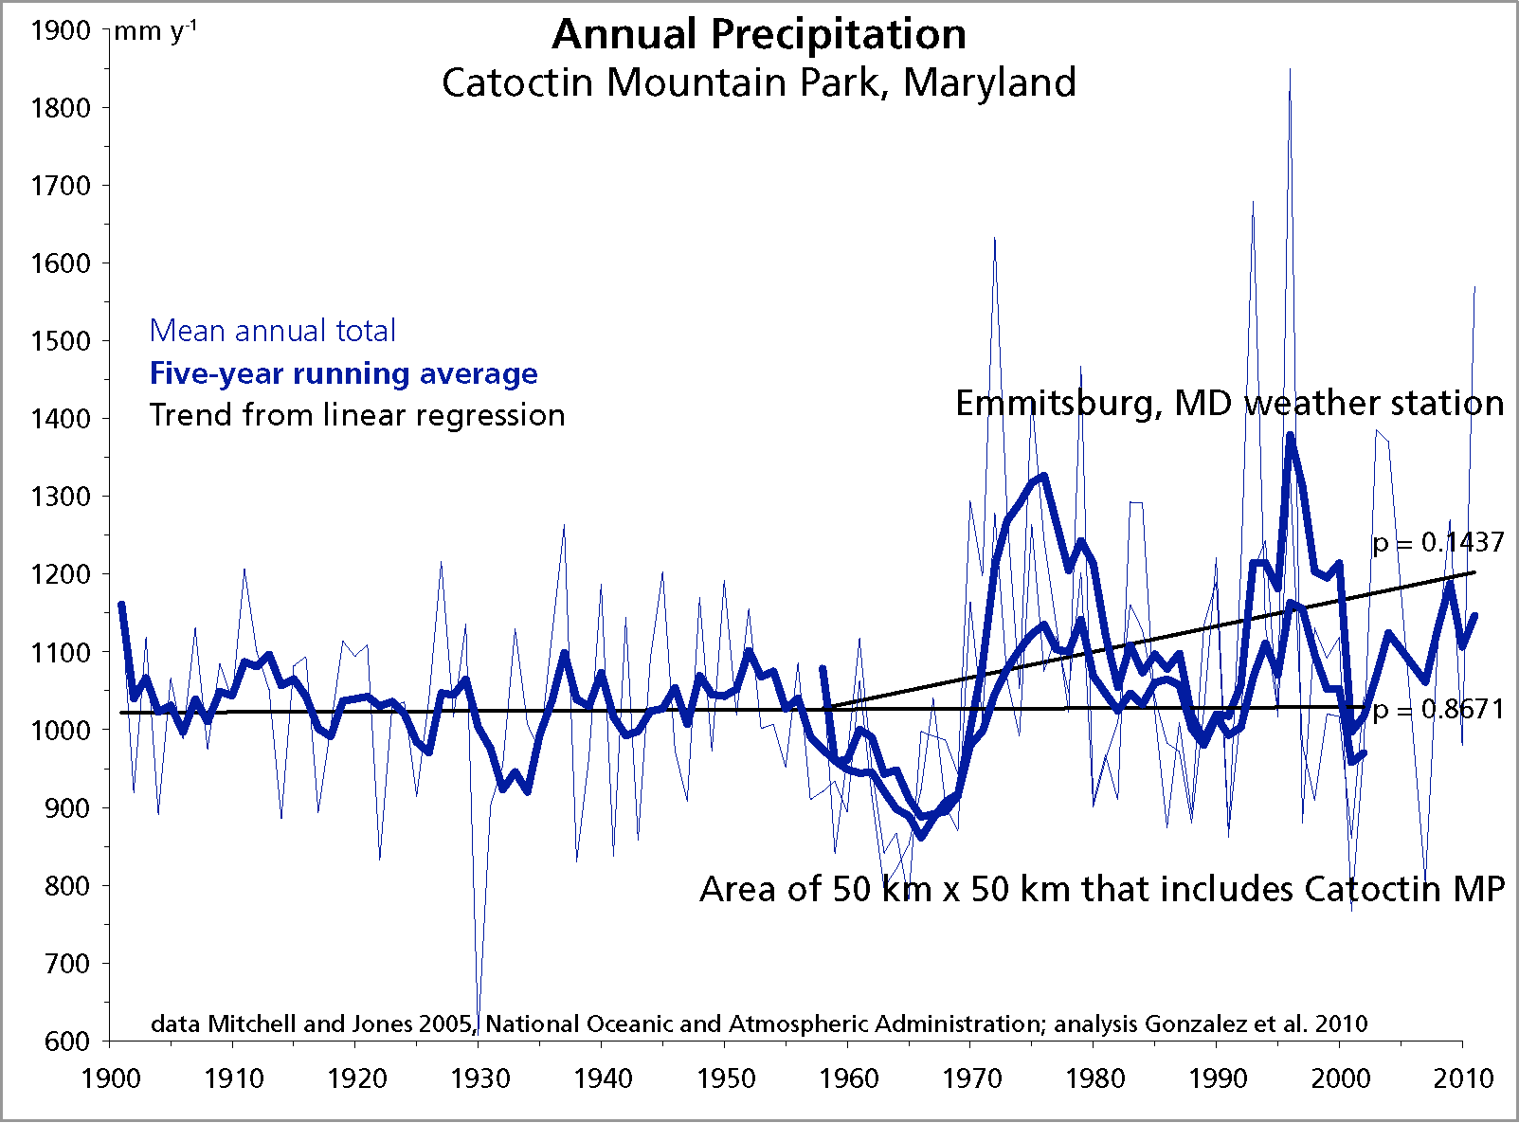

Figure 5.
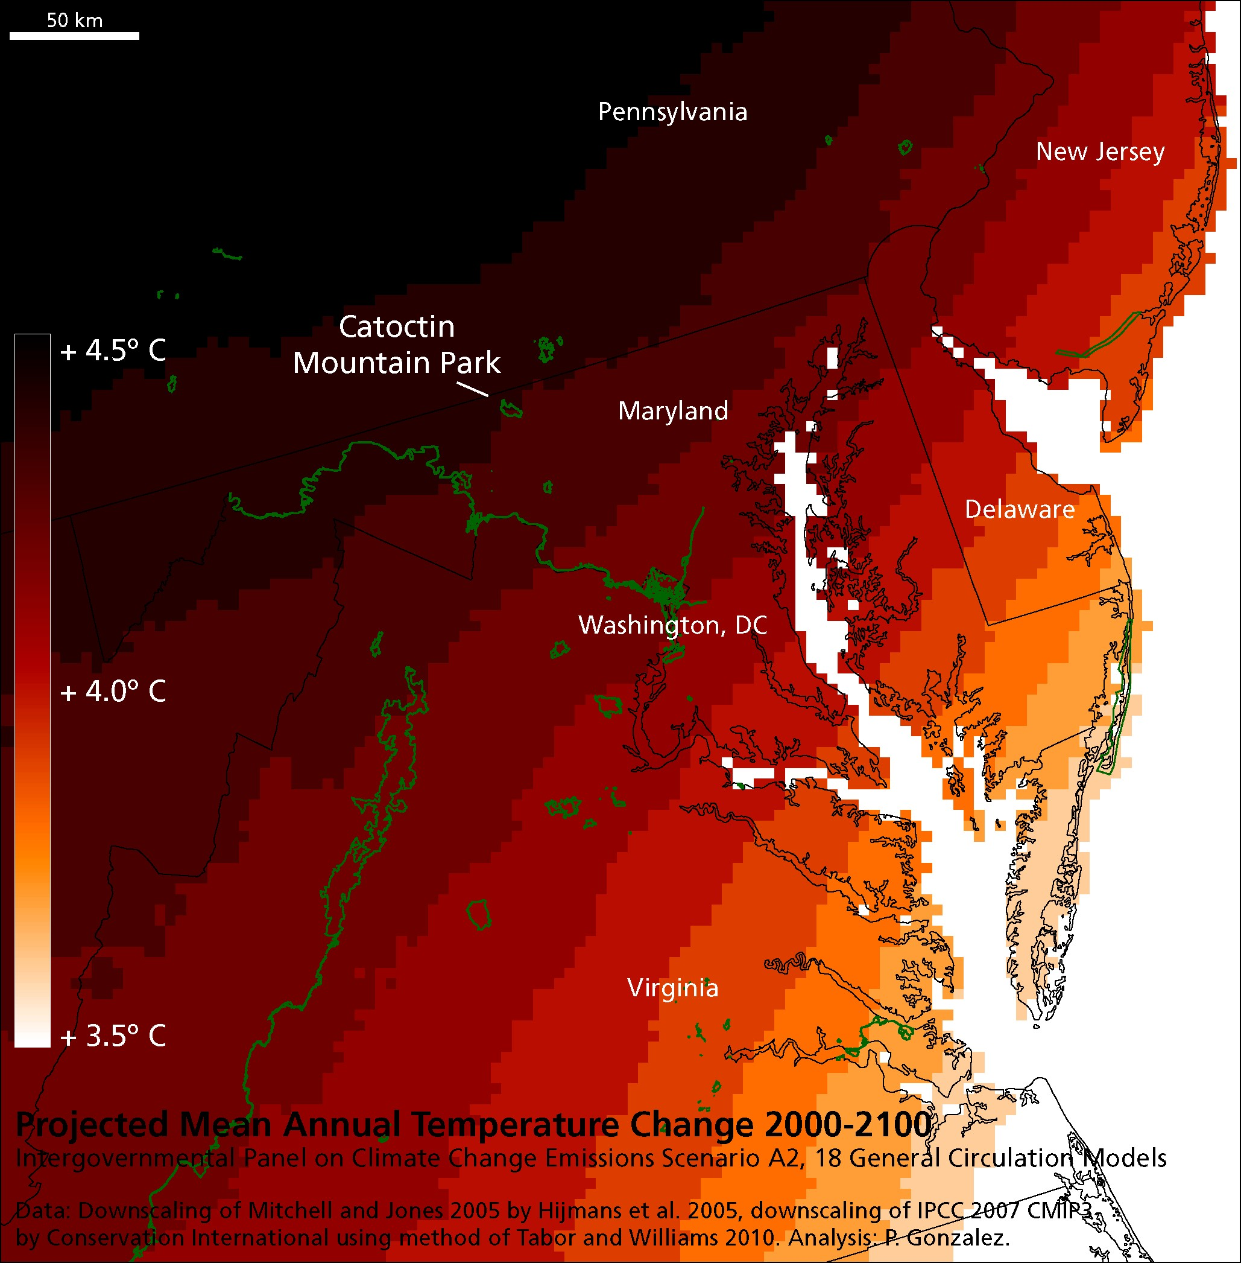

Figure 6.
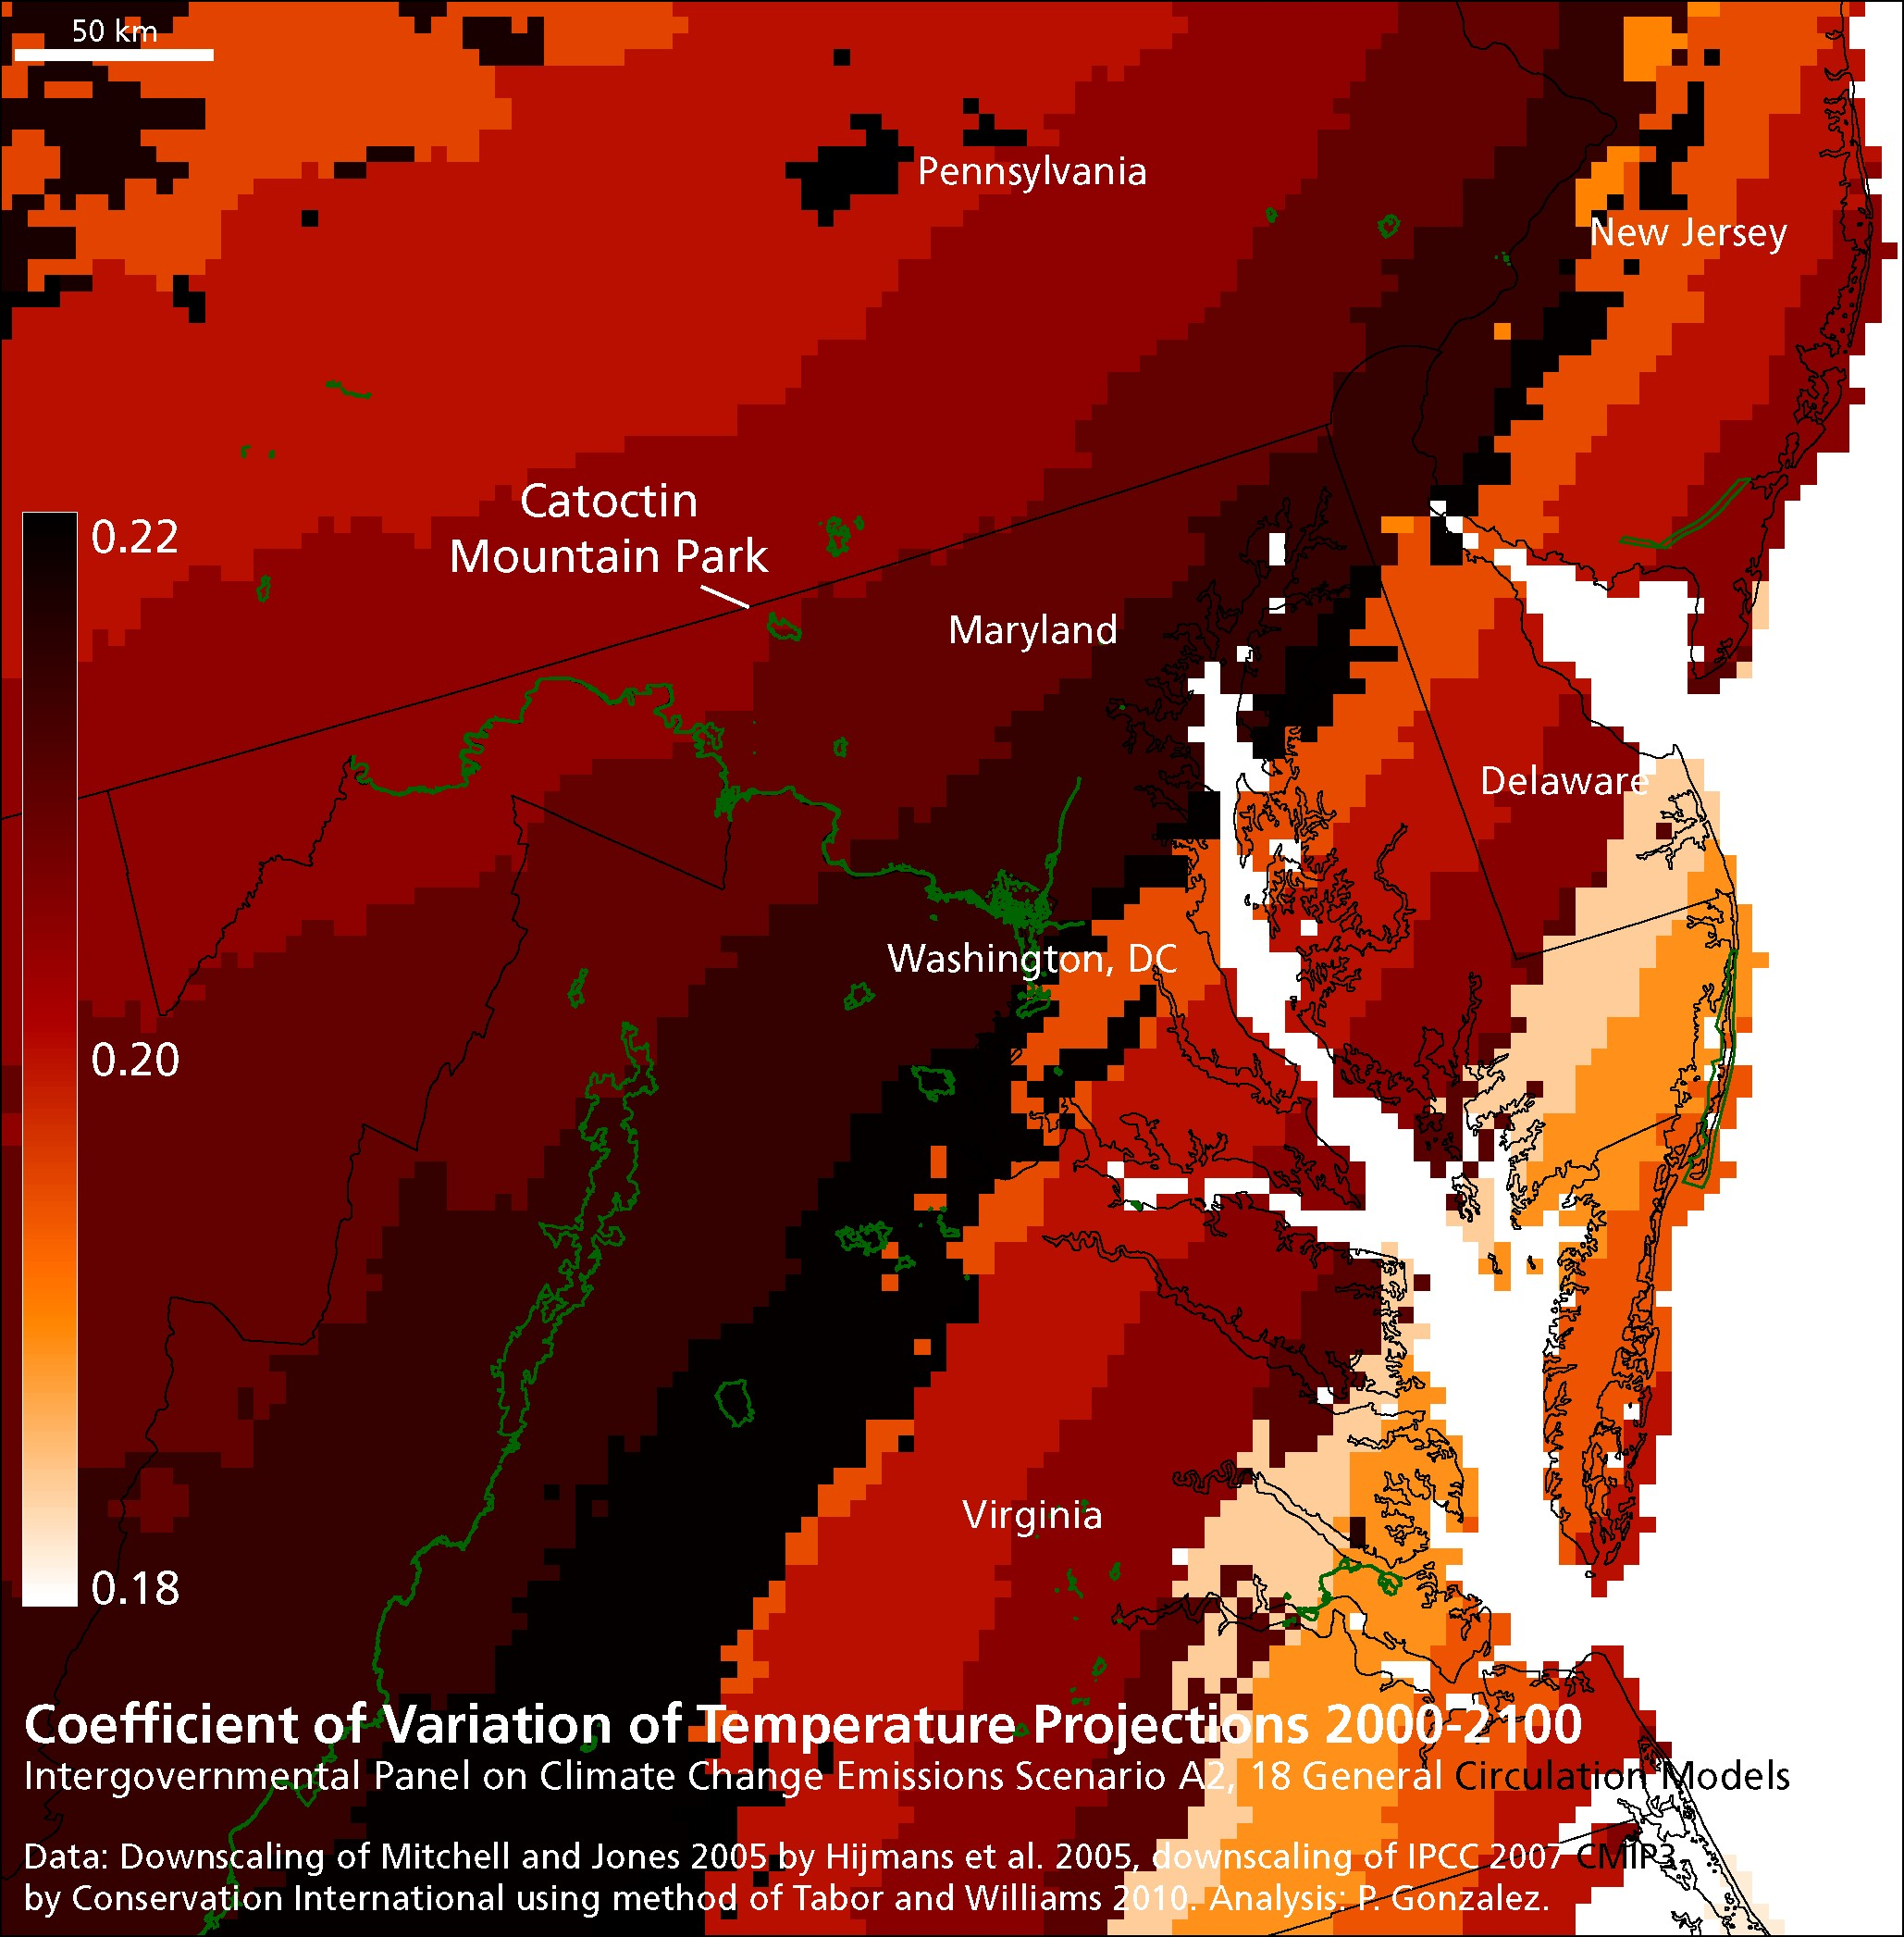

Figure 7.
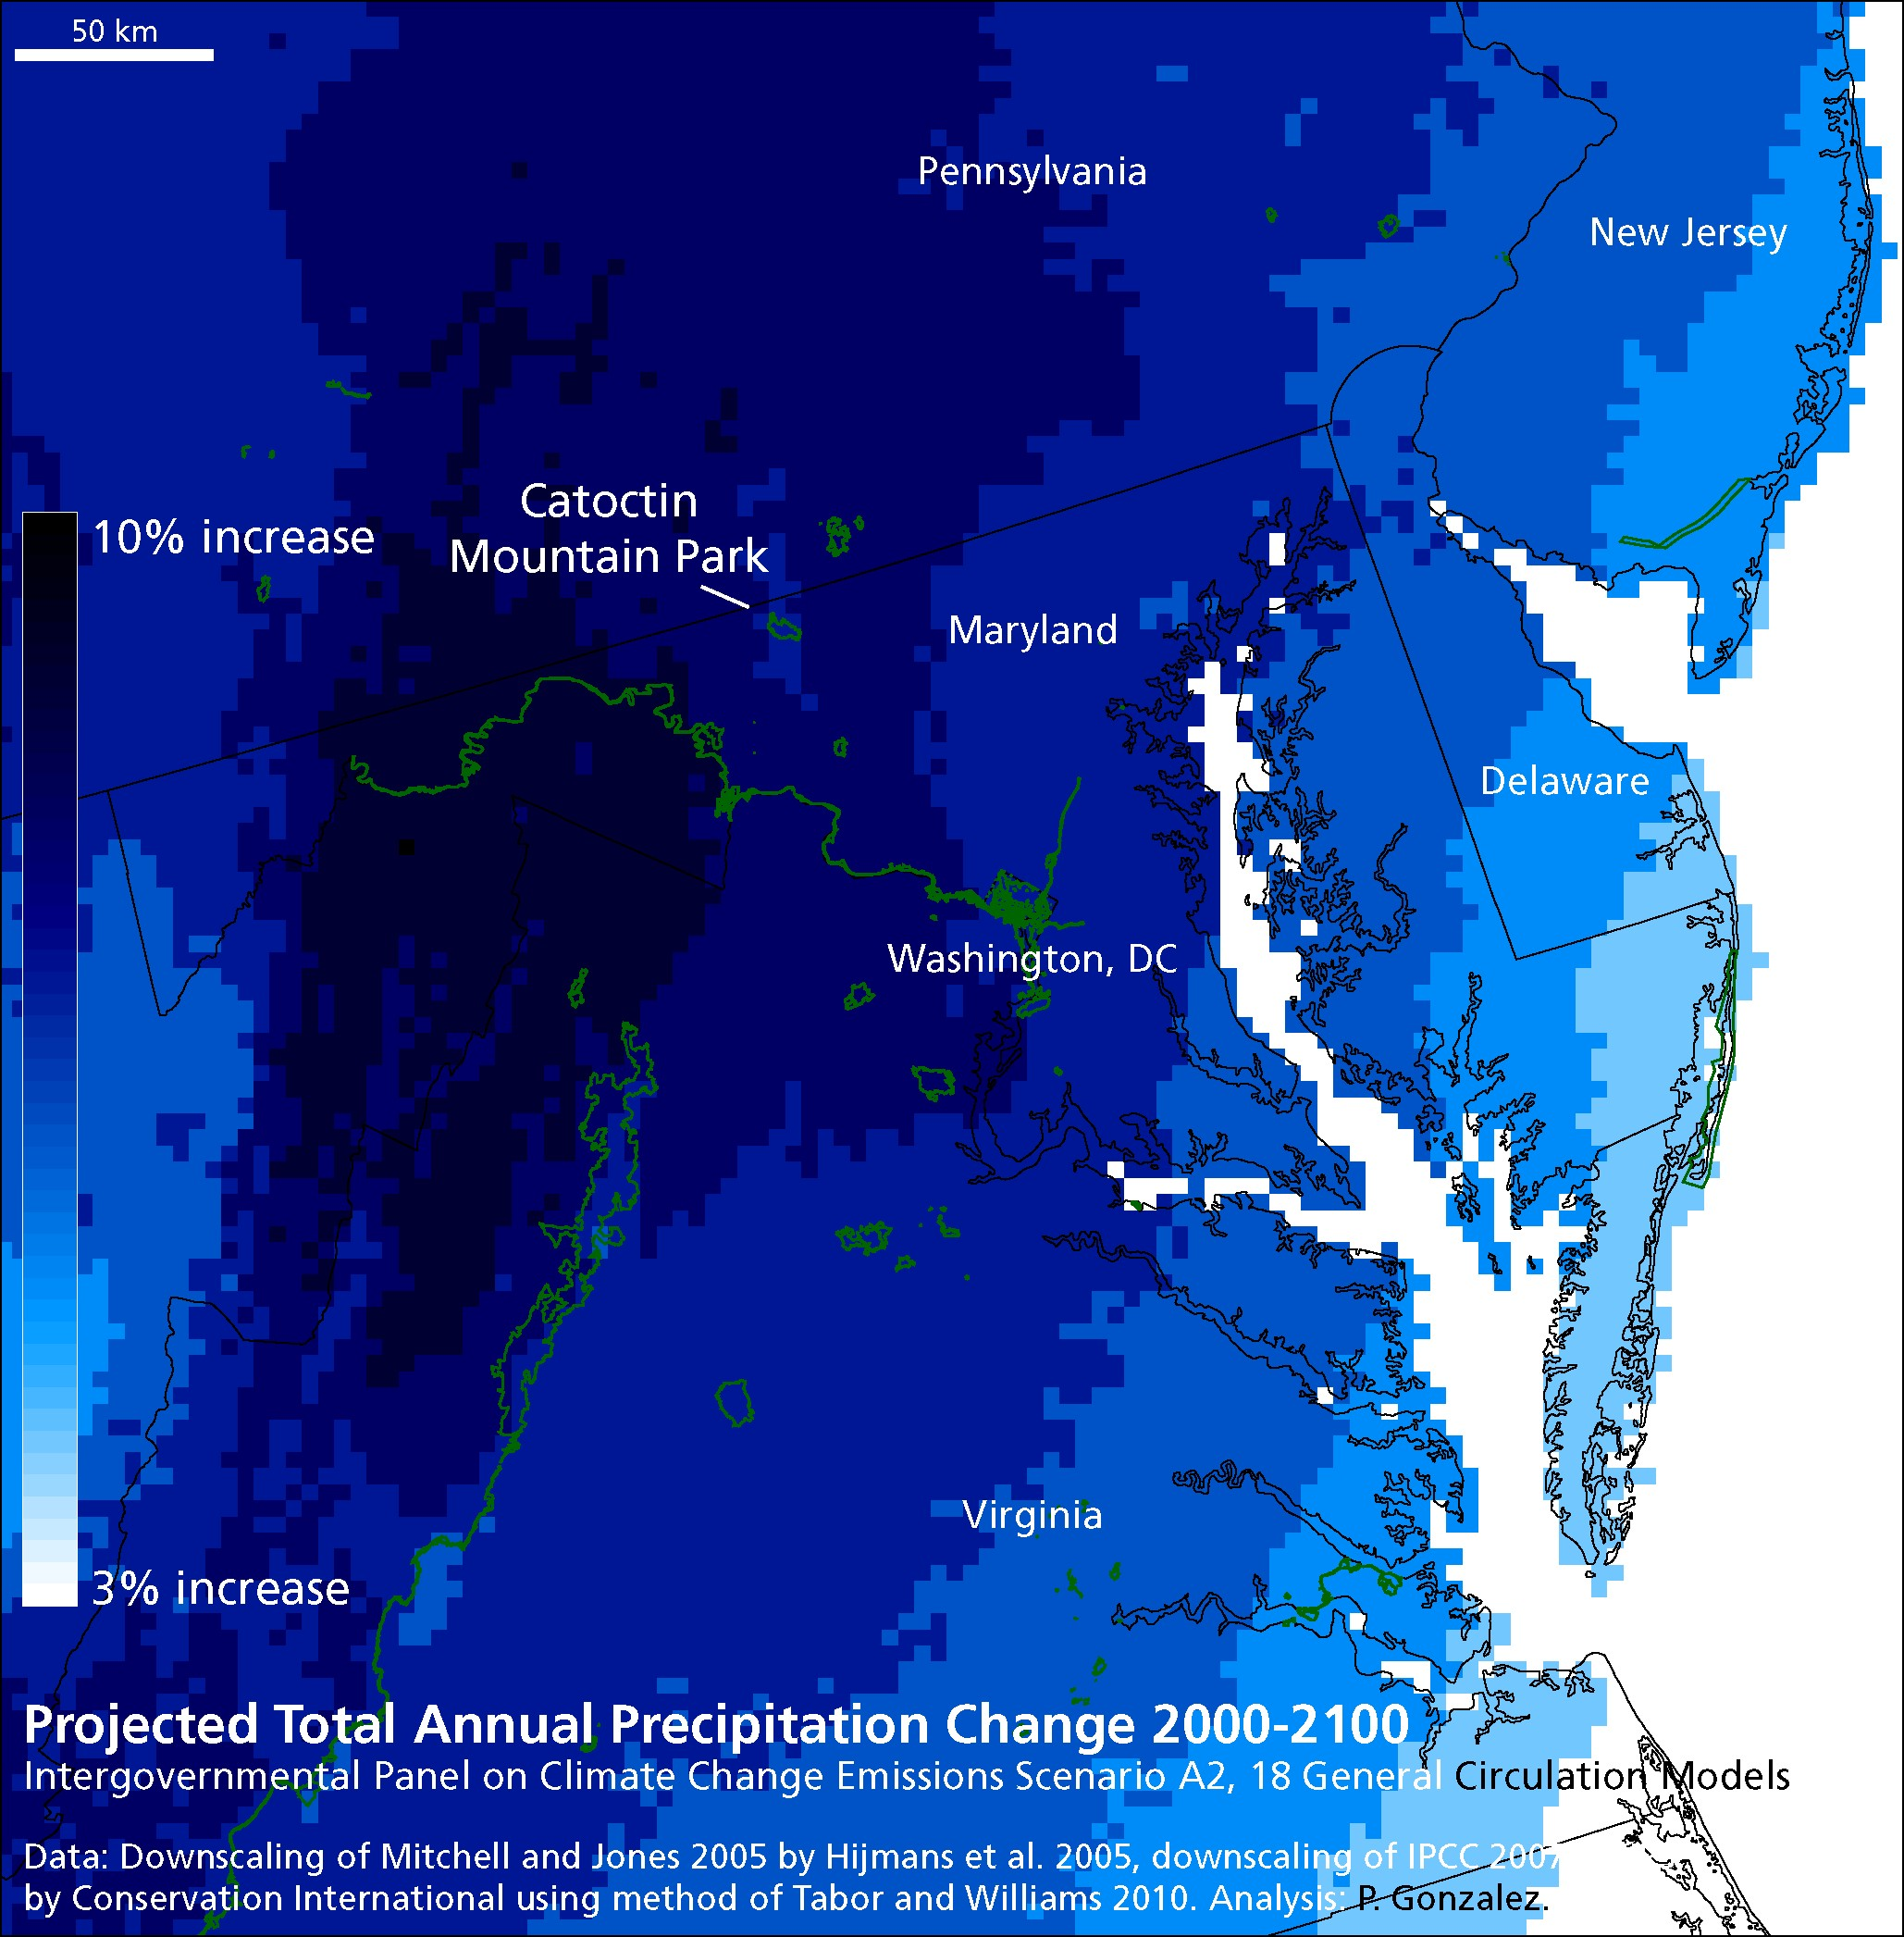

Figure 8.
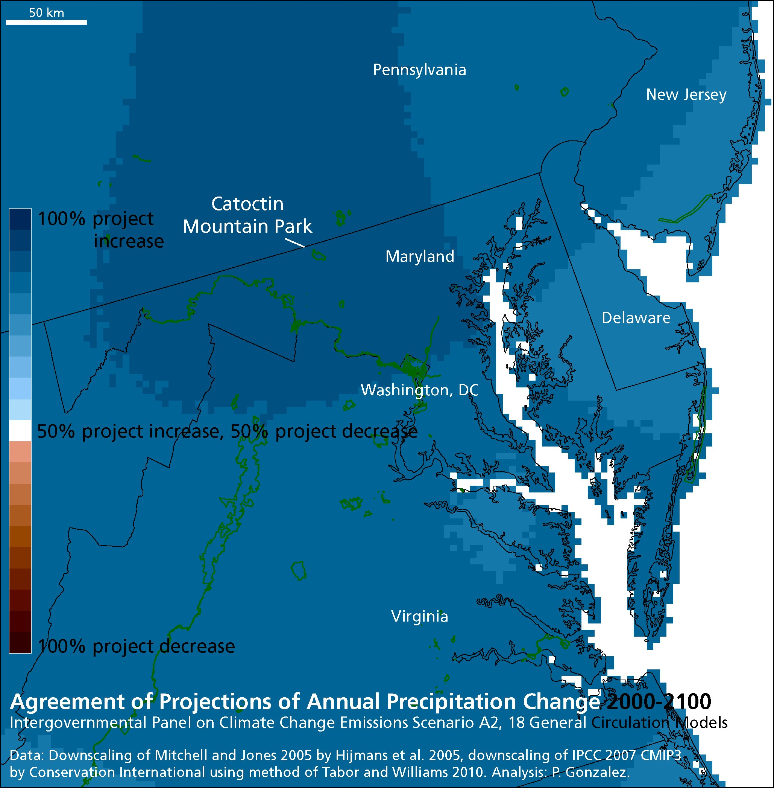

Figure 9.
