Chiricahua
National Monument
Junior Ranger Program

.'·
National Park Service
U.S. Department of the Interior

Draw a picture of yourself.


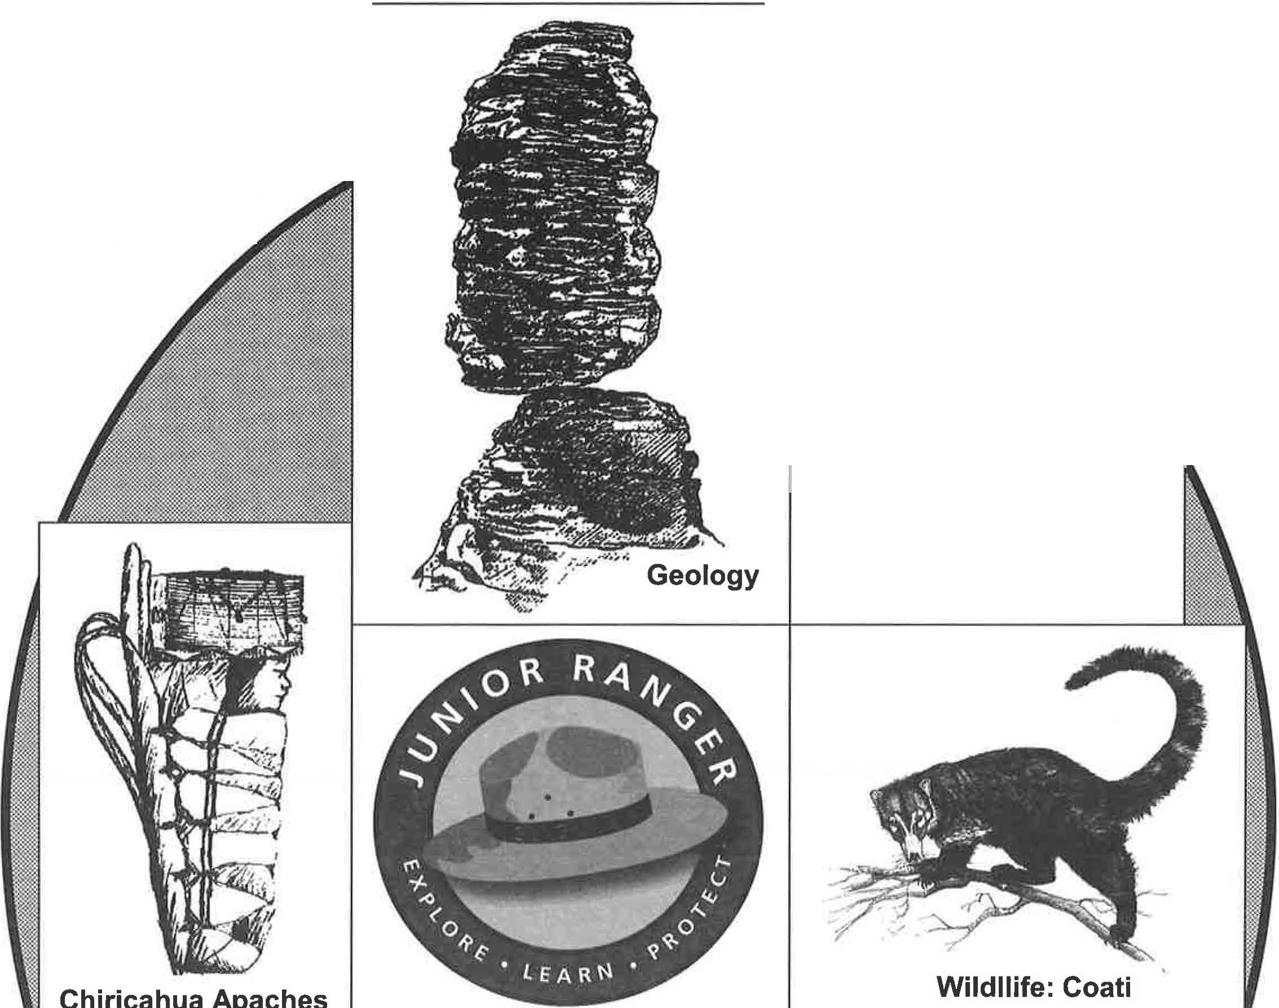
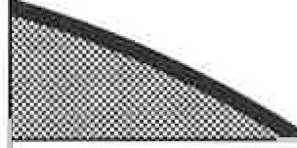
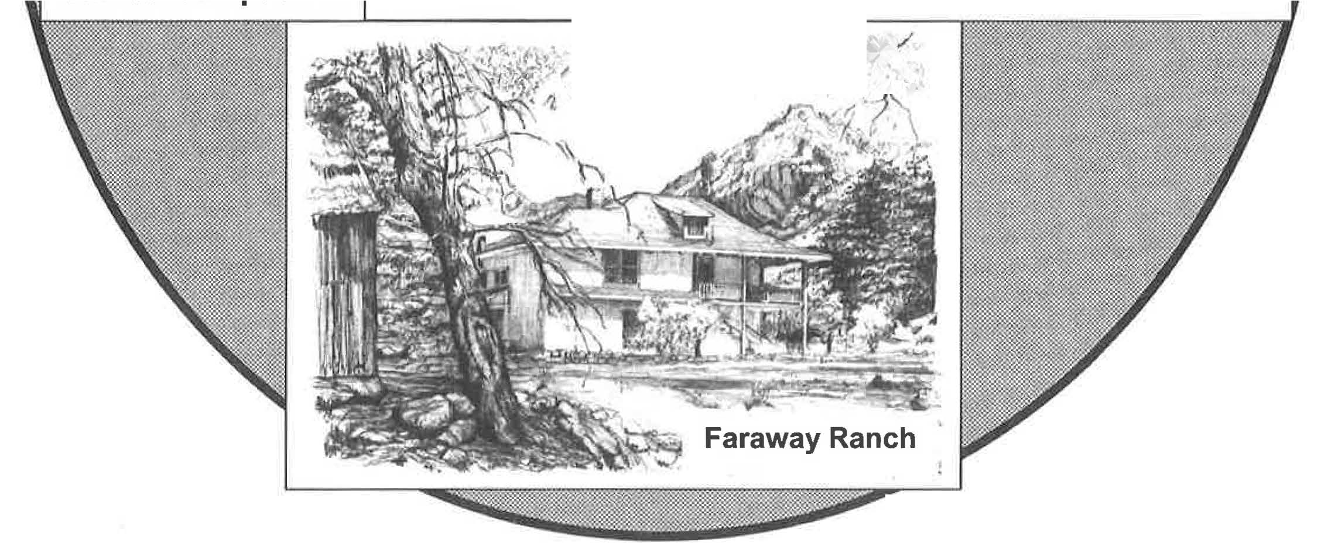
--


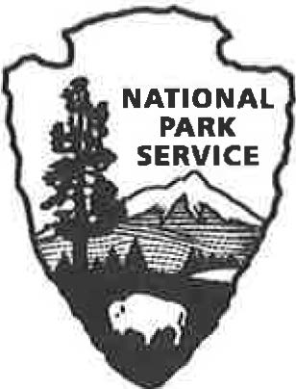
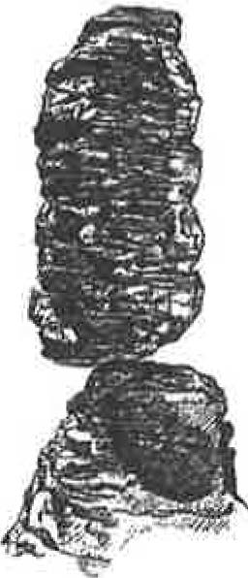
Welcome to Chiricahua National Monument!
You have entered a fantasy world of extraordinary rock formations with a unique mixture of plants and animals. Throughout the ages, a variety of people have explored this awesome territory. Now it's your turn.
As a Junior Ranger you will have the chance to discover the many treasures of Chiricahua National Monument. You are an important partner in protecting this National Park Service site and keeping it beautiful for future generations.

To Become a Junior Ranger:
f Finish the Chiricahua National Monument Story & Chiricahua Bingo Pages.
f Hike a trail: _______________ (trail name).
f Select additional activities from the Junior Ranger Book:

Age Number of Activities
- and Under 2-3
- to 9 4-6
10 and Older 7-9

Other ways to explore Chiricahua National Monument:
Visit the Massai Point Exhibit Building. Walk around Faraway Ranch.
Attend a ranger program____________ (program title).
When you are finished, bring your booklet to the Visitor Center. Share your adventures and discuss the activities with a park ranger to earn your certificate and patch.
* SAFETY RULES *
Stay on the trails. Hike with an adult.
Wear a hat & sturdy shoes.
Drink lots of water. Wear sunscreen.
Don't feed the wildlife.

Remember: Everything is protected at Chiricahua National Monument. Please leave all things here so everyone can enjoy them. Have fun with your adventure!


MY VISIT AT CHIRICAHUA NATIONAL MONUMENT
When explorers visit a new place, they often keep a journal about what they saw and did. Complete this journal page about your experiences at Chiricahua National Monument.
Date: ---------
What was the weather today? (Sunny, Cold, Windy, Rain, Snow, Hot, Cloudy ... )

Where did you go and what did you do? What was your favorite place?

What did you see at Chiricahua that you don't have at home?

Find a quiet spot, stop, and listen for one minute. What sounds did you hear?

Draw a picture of what you want to remember about your visit at Chiricahua.

THE CHIRICAHUA NATIONAL MONUMENT STORY

The pictures below tell the geology story of Chiricahua National Monument, but they are not in the correct order. See the exhibits at the Visitor Center or visit the Massai Point Exhibit Building. Then number the pictures from 1 to 5 in the order they happened.

#__ In 1924 this area was set aside as Chiricahua National Monument to preserve and protect the pinnacles. Today we enjoy their beauty and study this area to learn about future volcanic activity in other places.
#__ During a cooler and wetter climate, frost wedging widens the joints when water seeps into them, freezes and expands. The weaker layers of rhyolite are washed away.

#__ The Turkey Creek Volcano begins erupting an estimated 27 million years ago. It sends huge clouds of ash, gas and pumice high into the air.

- · , · · · ·- : r . :- _· I

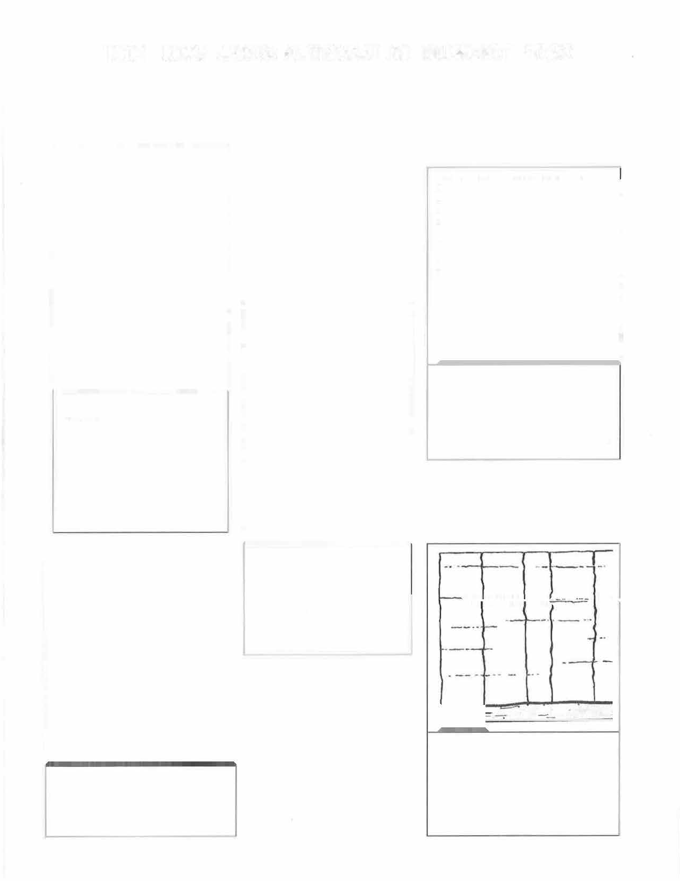
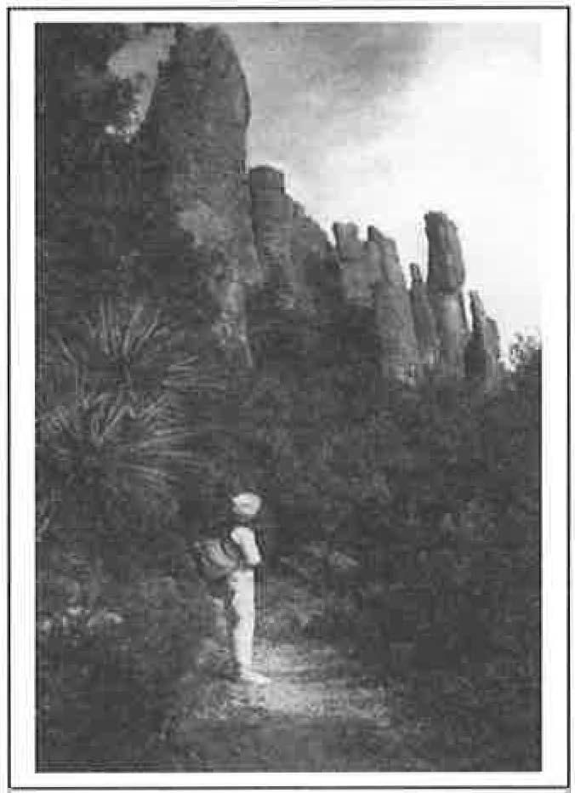
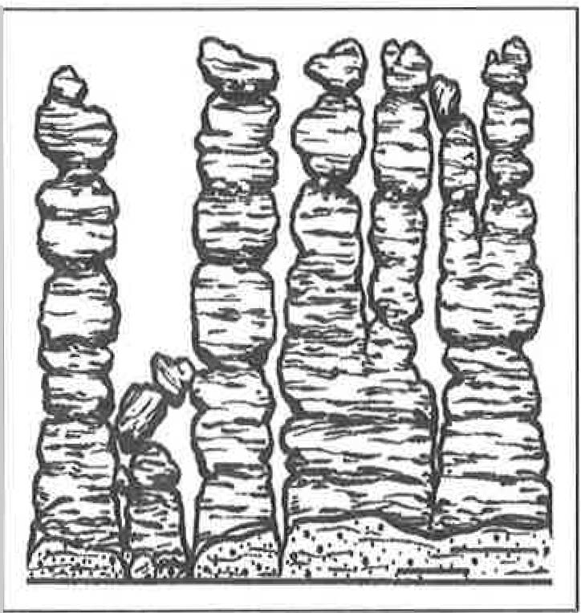
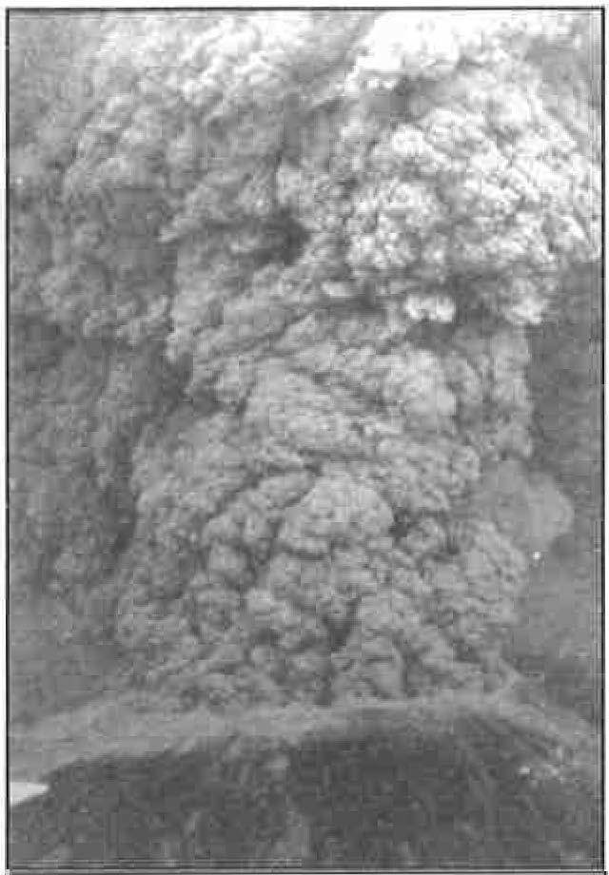
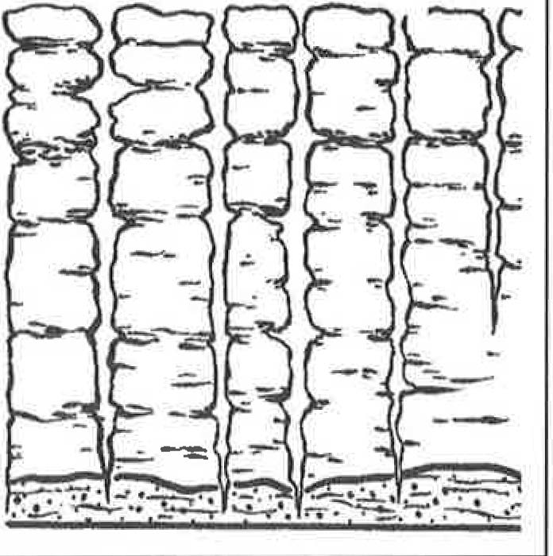
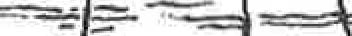
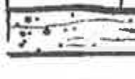

# __ Wind, lichens and more water erosion smoothes and shapes the columns.
# __ As the ash settles, the hot layers melt or weld together. This creates the gray rock called Rhyolite Canyon Tuff. The rhyolite contracts, cracks and forms joints as it cools.


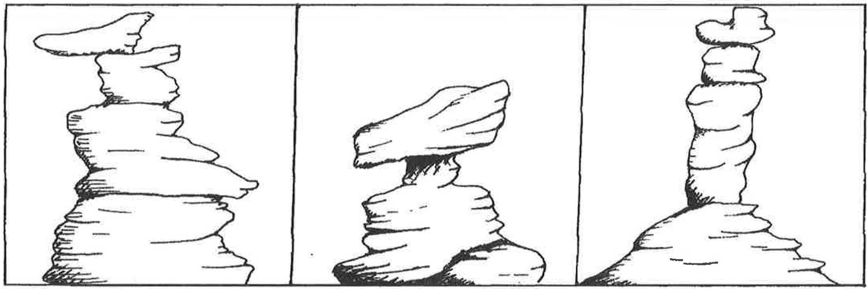
WHO NAMED THE ROCKS?
In the 1930s, President Roosevelt created a young men's work group named the Civilian Conservation Corps, also called the CCC. These hardworking men and their crew foreman, Ed Riggs, were the people responsible for designing and building the wonderful trails at Chiricahua National Monument. Some of the rock formations were so unusual, the CCC men gave them special names such as Sea Captain, Duck on a Rock, Organ Pipe, Wall Street and Totem Pole.
Using your imagination, what would you name these formations?

Now draw and name your own rock formations.

WATCHABLE WILDLIFE
Chiricahua National Monument is home for animals from four different regions or ecosystems: the Rocky Mountains from the north, the Sierra Madre Mountains from the south, the Chihuahuan Desert to the southeast and the Sonoran Desert to the southwest. Draw a circle around each animal you see during your visit. Remember, all the animals at Chiricahua National Monument are wild. Please do not get too close and never feed them. If you did not see any animals during your visit, did you see any
signs of them?____ What were those signs?_________________ _ Did you see any other animals?_____ What were they?_____________ _


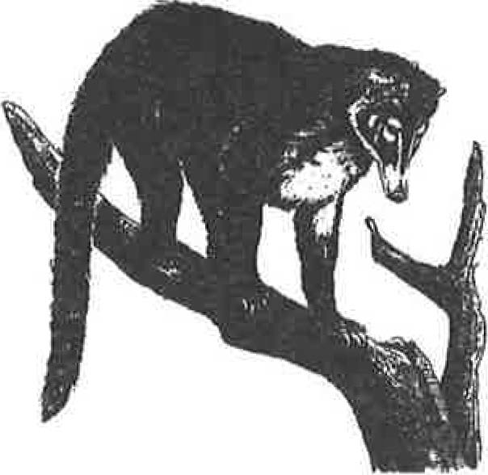
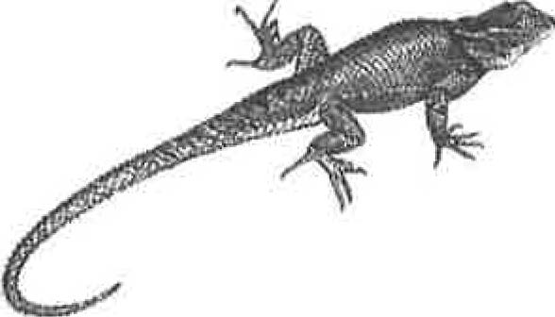
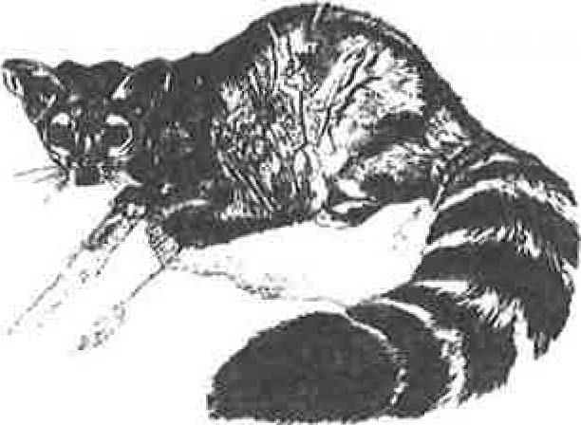
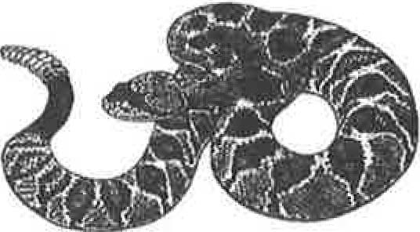
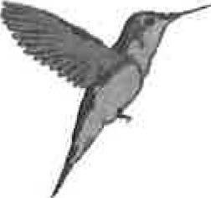
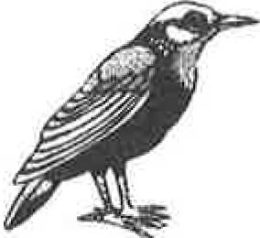
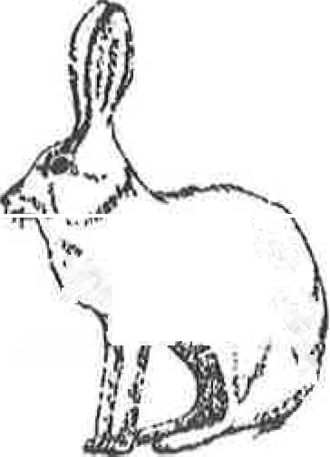
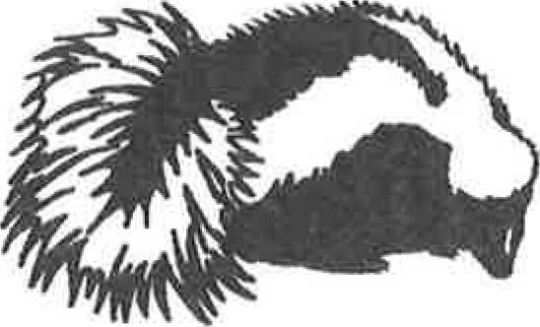
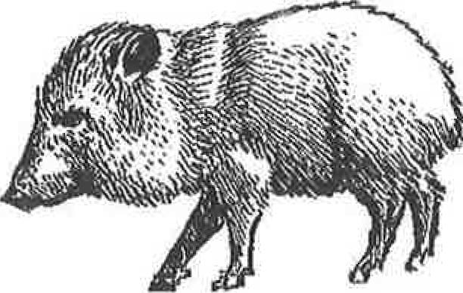
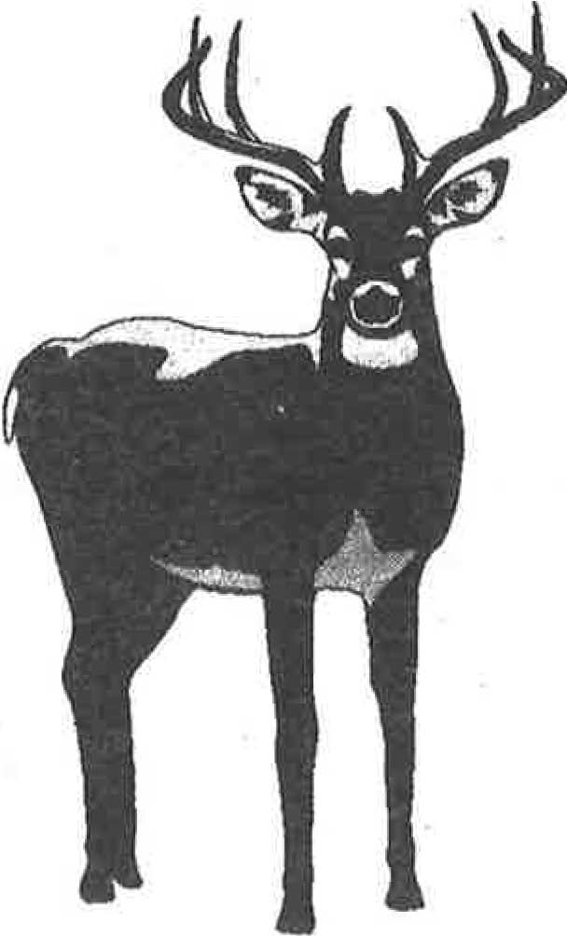
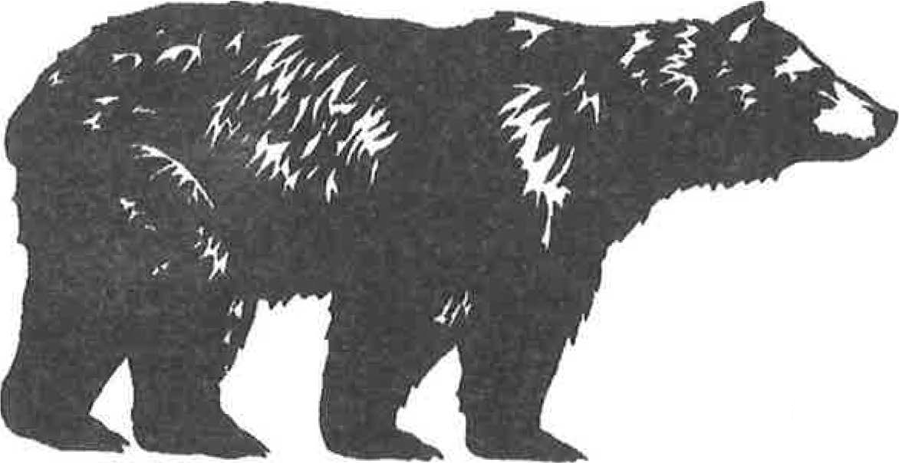
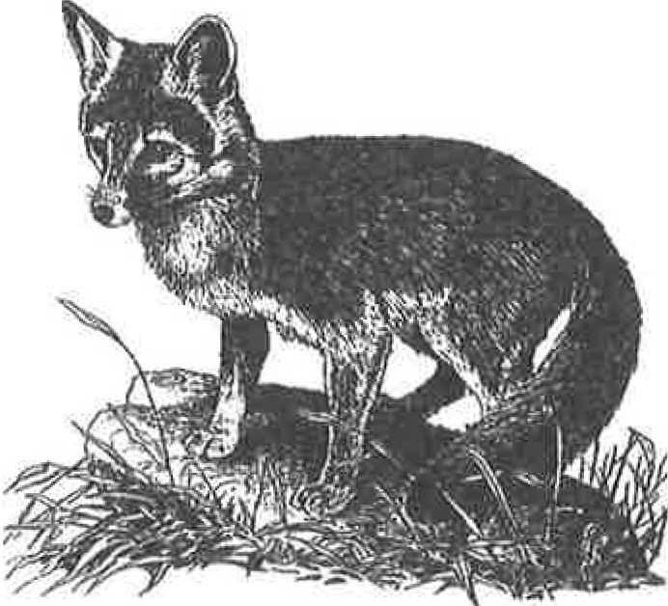
'.
.· t-\\'L: (. .
'
' .. .

··"!
.


CHIRICAHUA BINGO
As you visit Chiricahua National Monument, draw a picture or write where you see the items in each of the squares. See if you can get four squares in a row either up, down, across or diagonally. How many ways can you make Chiricahua Bingo? Remember, don't collect or disturb any of the features listed in the squares so everyone has a chance to enjoy them. Chiricahua National Monument is a special place where all items are protected and preserved.

SMALL PINE CONE | YUCCA | ANIMAL TRACK | BIRD'S NEST
INSECT HOME | CACTUS FEATHER |  | STONE FIREPLACE
BEAR GRASS | ANIMAL HOME | TREE THAT WAS BURNED | PLACE WHERE ANIMALS FIND WATER
BIRD SONG OLD HOUSE |  | BALANCED ROCK | LARGE PINE CONE

ANIMAL ADAPTATIONS

Plants and animals have special tools that help them survive in the areas where they live. For example, the desert is hot and dry, the arctic is cold, or along the coast there can be high winds and salty air. These special tools are called adaptations. Design your own Chiricahua animal or plant. What adaptations will your animal need to find food or escape predators? How will your plant conserve water or survive the hot summers and cold winters? Use the examples to get you started.


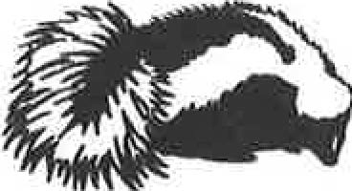
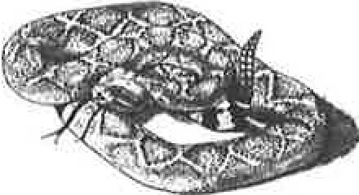
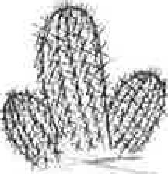
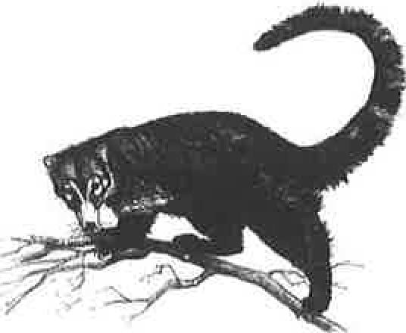
Skunks can release an unpleasant odor when threatened by other animals or people.

Rattlesnakes have unique color patterns that help them blend in with their surroundings. Shaking their rattle warns people and other animals to stay awav.
Cactus have sharp spines to protect them from
being eaten and to provide shade for the pads of the plant.

The coati's long nose and strong claws are good digging tools for findinq food.

CHIRICAHUA IS OUR HOME

Are you a good detective? Solve these riddles about the animals that call Chiricahua National Monument home. The answers are found in the Word Search. The words go up, down, forward, backward and diagonally. Can you find 5 bonus words in the Word Search? Hint: they are not animals. ------------------------------


I can't hear but feel vibrations as you walk along the trails. I shake my tail to warn you to stay away from me. I am a

Most people think I'm a wild pig, but I'm really a white collared peccary. You probably use my Spanish name, which
is -------
I am the largest animal at Chiricahua. I eat both plants and meat, so I'm an omnivore.
My fur is usually black, but it can be brown, blonde or cinnamon (red).
I am a ----
My fur is a bright rusty-red color, and I have a big bushy tail. I only live in the Chiricahua Mountains. My name is Chiricahua fox ------

I use my thick beak and strong neck muscles to drill holes into trees as I search for tasty insects to eat. I am a --·
I am a cousin of the raccoon that
is nocturnal or active only at
night. I am named for the stripes on my tail.
I am a --·
I am the largest carnivore or
meat-eater at Chiricahua. Deer are my favorite prey. I am a member of the feline or cat family. My name is
We are herbivores because we like to eat plants. We use our big white tails to communicate with each other. Buck, doe
and fawn are separate names for -------
Keep a close eye on your food when I'm in the area. My feathers are blue and gray. I am a _____ _
I am a cold-blooded reptile, so you will see me sunning on a rock to get warm. My tail will break off if I'm trying to escape, and it will grow back later. lama --------

I have moved north from Mexico. My pointed nose helps me dig for food, and my long tail improves my balance when I climb trees.
I am a ---------
M | E | X | I | C | A | N | J | A | y | B | s
0 | C | R | I | N | G | T | A | I | L | L | E
u | 0 | H | L | w | 0 | E | V | T | E | A | K
N | A | y | I | H | A | N | E | A | R | C | A
T | T | 0 | z | R | K | I | L | B | R | K | N
A | I | L | A | y | I | p | I | M | I | B | s
I | M | I | R | y | w | C | N | 0 | u | E | E
N | u | T | D | E | E | R | A | T | Q | A | L
L | N | E | s | K | u | N | K | H | s | R | T
I | D | X | 0 | F | y | A | R | G | u | F | T
0 | I | M | A | N | z | A | N | I | T | A | A
N | p | w | 0 | 0 | D | p | E | C | K | E | R

I am the only mammal that can fly. I use echolocation to find tasty insects to eat or to avoid buildings and people. I am a ------
1am a small "desert dog" that sometimes climbs trees to hunt for food. Hollow logs and small caves are where I sleep with my big
fluffy tail wrapped around me a blanket. I am a ---
Like all insects, I have 3 body parts (head, thorax and abdomen), 3 pairs of jointed legs, and 1 pair of antennae. Although we are related, please don't call me a butterfly.
I ama ------

Hognose, spotted, hooded and striped; most people and animals stay away from us because they don't like our smelly defense systems. We are _____ _

CHIRICAHUA BIRD WORD
Many people come to the Chiricahua Mountains to see the large variety of birds. Resident birds like the Mexican Jay live here all year. Migrant birds are here part of the year, like the hummingbirds in the summer and the dark-eyed juncos in the winter. Test your Avian IQ with this crossword puzzle.

2
3
4 s
6

8

9

10 11

12

13

14

15

ACROSS
4. This elegant bird from Mexico sounds like a barking dog.
DOWN
- This raptor has a reddish-brown tail.

- The___
_ is our national bird.
- A ______ drills holes in tree trunks to build its

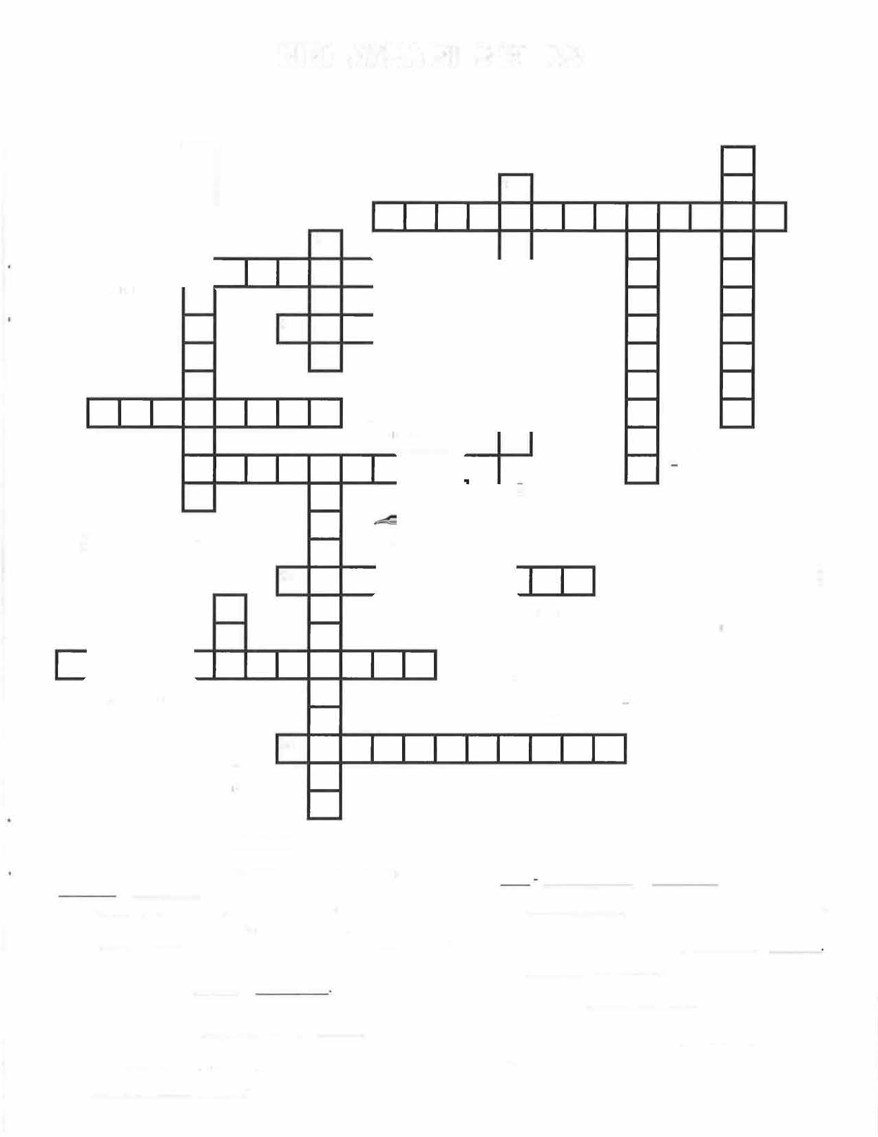
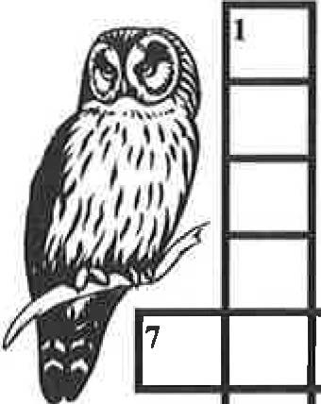
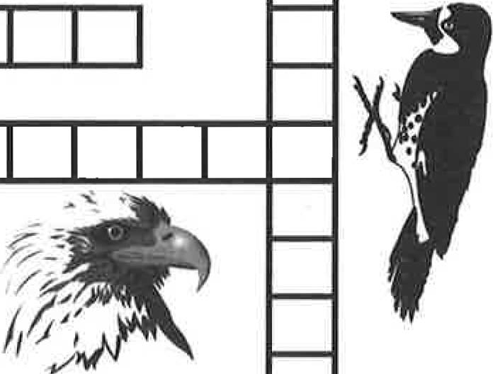
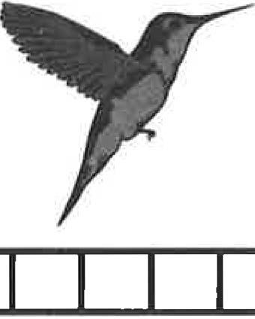
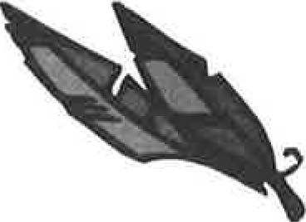
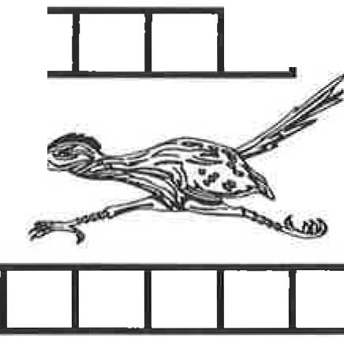
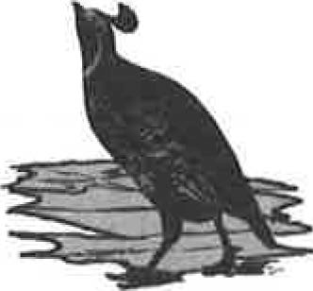
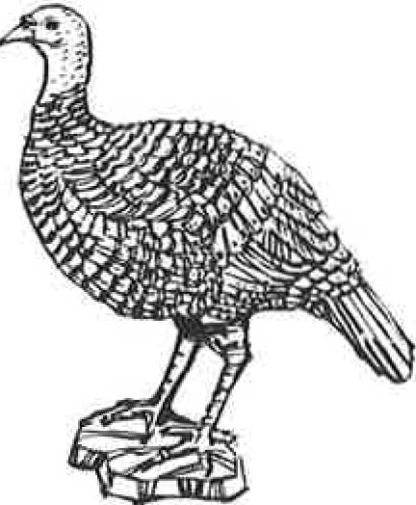
- All birds have this in common. _____ _
- The creeps head first down tree trunks while looking
for tasty insects to eat.

- Chiricahua means: __ _
12. Watch your lunch when this south of the border member of the jay family comes visiting
14. This small, plump, common desert bird has a dark, curved topknot on its head. ______ _
15. A _________ can fly sideways and backwards.
home and to search for insects to eat.
- The state bird of Arizona is a
- A ________ likes to run instead of fly.
- This large black bird is considered to be one of the smartest birds. ______ _
- This large scavenger does not have feathers on its head to make it easier to clean. ___ _
13. An __ has very good eyesight and hearing to help it hunt at night .

CHIRICAHUA: THEN AND NOW
Chiricahua National Monument was named for the Chiricahua Apache and the mountains where they lived. The Chiricahua Apache or Chokonen people lived life very differently than we do. Can you match up our activities of today with those of the Chiricahua Apache 150-400 years ago? Would you like to go back in time and live with the Chiricahua Apache?

NOW
M

fUilW\

7 ,
. 'If<, ·
r'·• · ,

-1,r
..


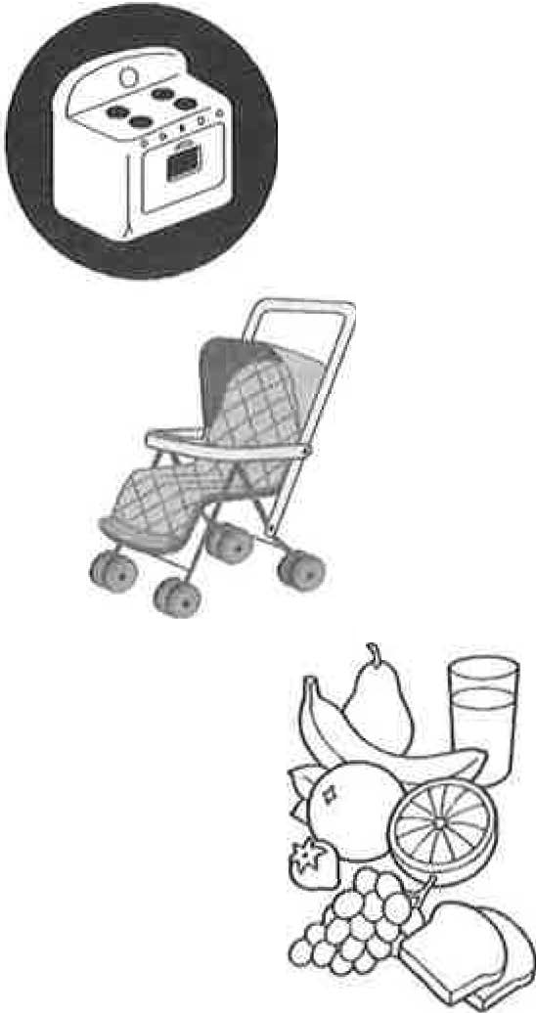
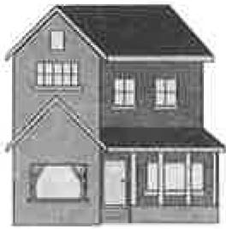
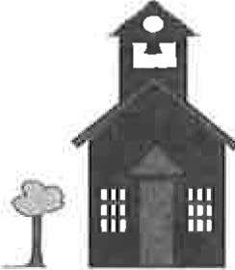
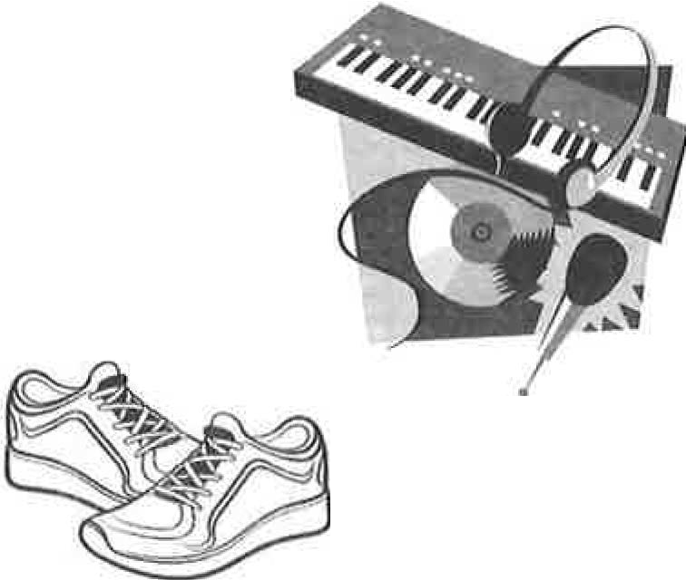
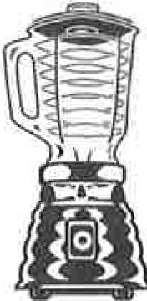
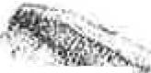
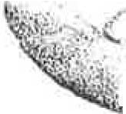
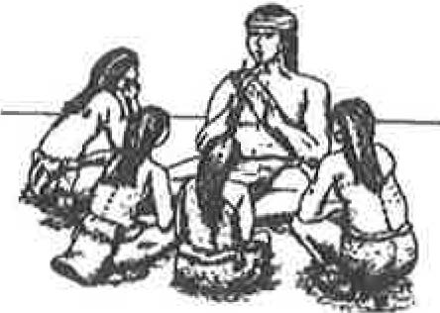
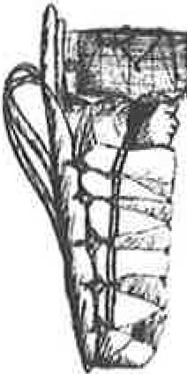
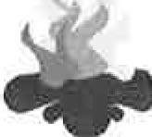
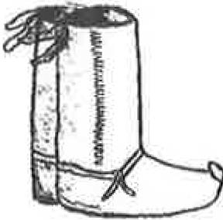
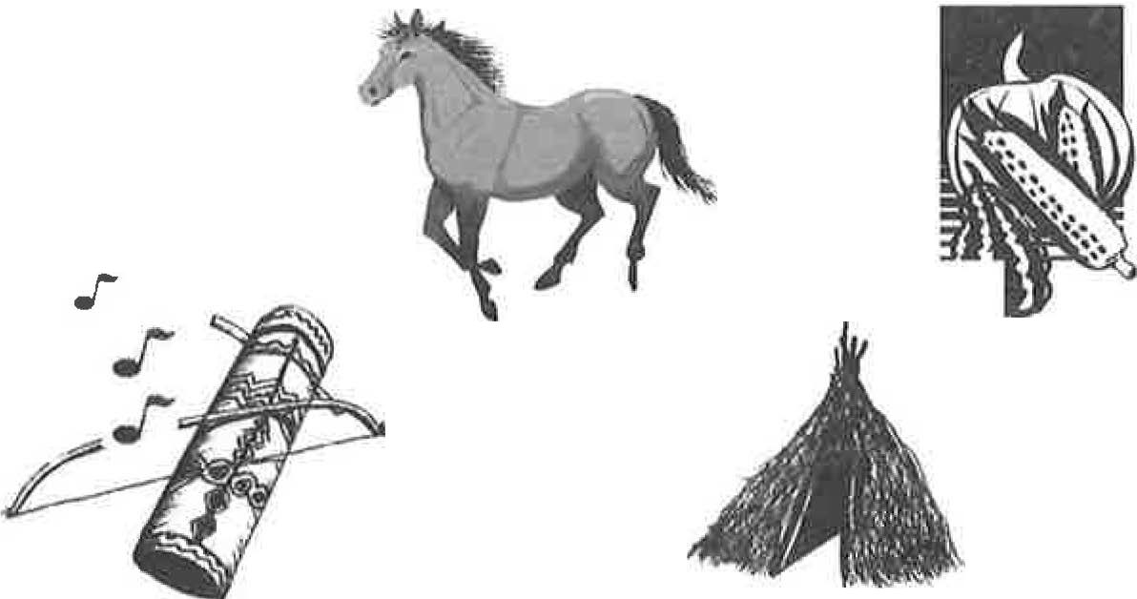
· r. •v•' . i

,

THEN
.,

FARAWAY RANCH SCAVENGER HUNT
Swedish immigrants, Neil and Emma Erickson, settled in Bonita Canyon in the late 1880s. They changed a simple log cabin into the two-story house of Faraway Ranch you see today. Their oldest daughter, Lillian, and her husband, Ed Riggs, turned the homestead and cattle ranch into a successful guest ranch. People came from all across the United States to stay at Faraway Ranch. They would go birdwatching, take guided horseback riding trips among the rock formations, or help with the ranching activities. Would you like to stay at Faraway Ranch?

See of you can locate twelve of these Faraway Ranch objects. When you find an item on the list, put an X
in the box next to it.


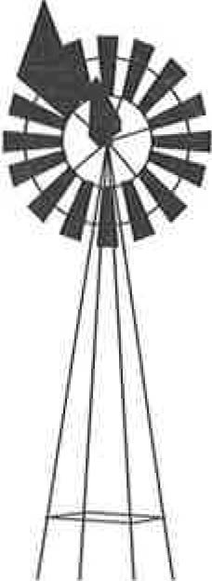
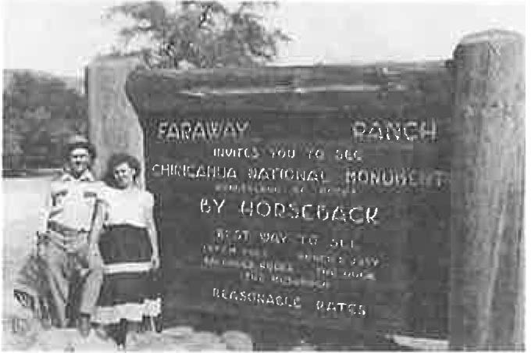
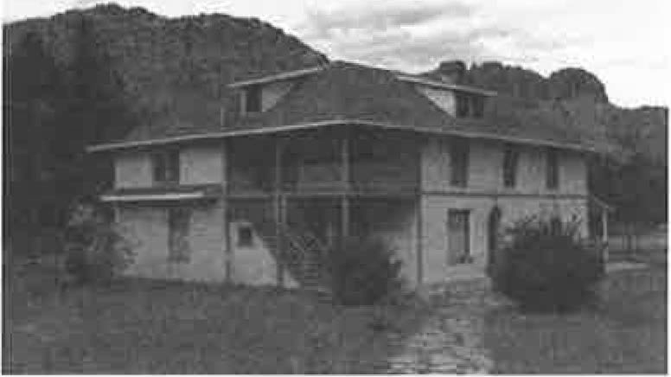
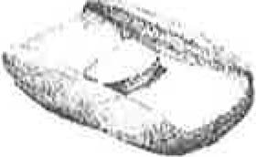
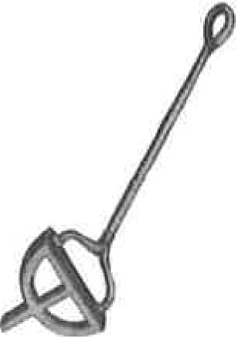
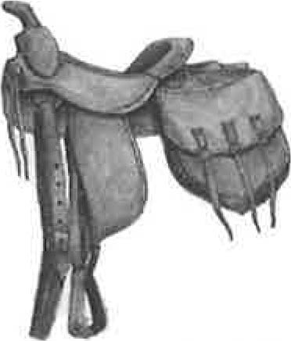
  - A firewood box
  - A fruit tree
  - A stone well
  - A refrigerator
  - A guest cabin
  - A windmill
  - A storage shed
  - A log cabin that Ja Hu Stafford and family built

Find a place where a guest, family member or employee might ...
  - Store their saddle
  - Water their horses
  - Take a swim
  - Wash their clothes
  - Keep their horses
  - Park their cars

Bonita Canyon was home to many other groups of people before the Ericksons arrived. Can you find these things?
- A stone chimney carved with names of the Buffalo Soldiers
- A metate that Native Americans used for grinding seeds, nuts and grain

BONUS: What was the brand Lillian used to mark her cattle?

Lillian's Brand

Mano & Metate

Q
Horseshoe

Branding Iron

Saddle


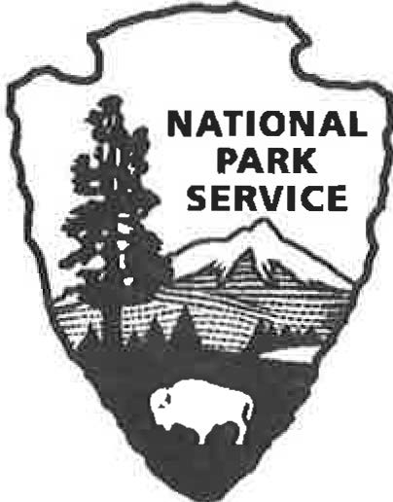
INTERVIEW A PARK RANGER
Park Rangers have many different jobs at Chiricahua National Monument. They do things such as: study wildlife and plants, take care of the roads and buildings, collect trash, answer questions at the Visitor Center, patrol the trails, give tours of Faraway Ranch, collect fees at the entrance station, or work at the headquarters office. During your visit, talk to one of the Chiricahua Park Rangers and find out what they do. Their gray and green uniforms make them easy to find.
Here are a few questions to get you started. Add two questions of your own.
- What is your name and job title? _____________________ _
- How long have you worked at Chiricahua National Monument? __________ _
- What is your job?

- What do you like best about working at Chiricahua National Monument?

- -----------------------------

- -----------------------------

The National Park Service badge was first used on uniforms and signs in 1952. What are 3 things you see on the badge?
Your NPS Badge

Design your own badge. What do you think should represent the National Park Service?


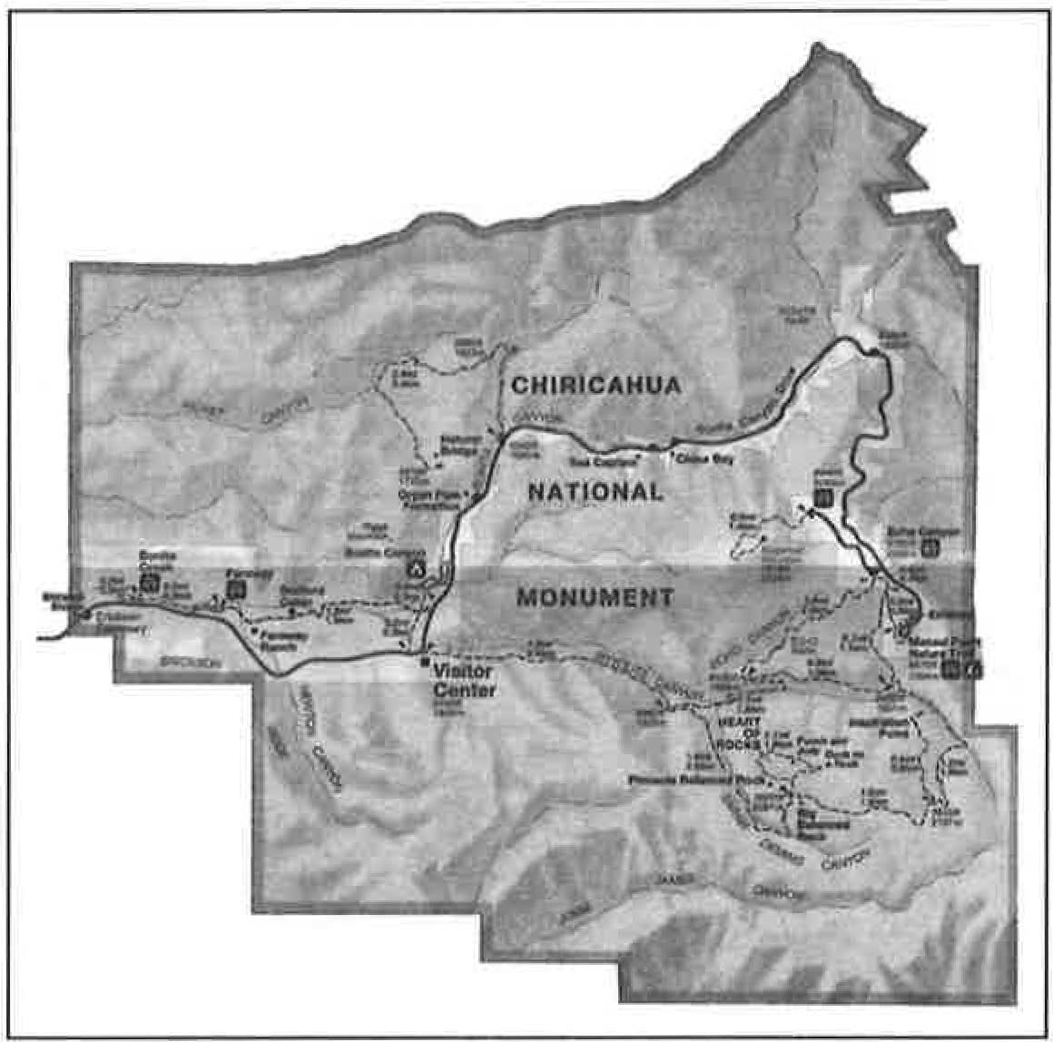
WHAT IS WILDERNESS?

What does wilderness mean to you? Many early civilizations felt wilderness was the unknown and the uncontrolled. Pilgrims who came to America and pioneers who moved west, wanted to control the wilderness by clearing forests, planting crops, and building cities. After 1890, there was less wilderness available. People began thinking it was good and should be saved. President Lyndon Johnson signed the Wilderness Act in 1964 to create the National Wilderness Preservation System. Wilderness meant "an area where earth and its community of life are unchanged by people, where people are visitors that don't remain".

In 1976, most of Chiricahua National Monument became part of the National Wilderness System. The land is protected and managed so that it "appears to have been affected primarily by the forces of nature". When you hike the Echo Canyon Loop Trail or walk to Heart of Rocks, you are in the Wilderness!

  - Look at your Chiricahua brochure and color in the area on this map that is Wilderness.
  - Is the Wilderness Area:
Less than half the monument
Half the monument
More than half the monument
  - What are two things that are not in the Wilderness Area?

- -----------
- -----------

  - When people hike in a Wilderness Area, they must be prepared. Help is often far away. What are four items you should always have with you when you go hiking?

- ____________ _ 3. -------------
- ------------- 4. ____________ _

  - What would you do if you got lost when you were hiking? ________ _

  - What does Wilderness mean to you?_______________ _




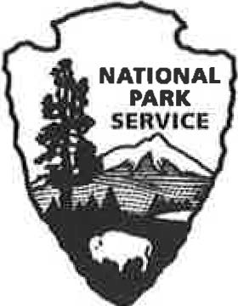
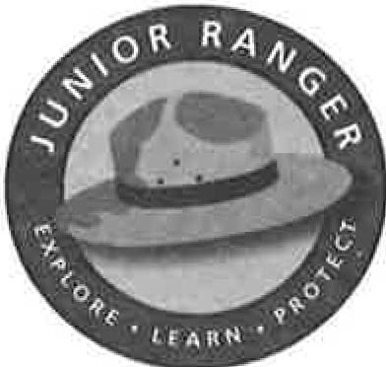
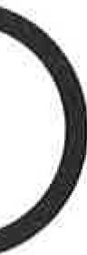

As a Junior Ranger I,

    - Promise to learn something new about each park I visit and share it
with my friends and family.
    - I will help keep parks clean and beautiful.
    - I will remember to be thoughtful to all living things.
    - I pledge to use my senses to have a safe and fun visit as I Discover, Explore and Learn
about any National Park Service place.

Signature and Date

A very special thank you to the many National Park Service Rangers and Volunteers whose hours of creativity, editing, and perseverance led to the completion of the Chiricahua National Monument Junior Ranger Program. If you have any questions, comments or suggestions about this program, please contact:
Superintendent
Chiricahua National Monument 12856 East Rhyolite Creek Road Willcox, AZ 85643
CH IR_Superintendent@nps.gov
6th Edition, 2016

