No Stock Use:

Chiricahua NM:
Heart of Rocks Loop
Massai Nature Trail
Natural Bridge Trail
Sugarloaf Mountain Trail

Fort Bowie NHS:
Parade Ground and Ruins Area

CHIRICAHUA NATIONAL MONUMENT
FORT BOWIE NATIONAL HISTORIC SITE
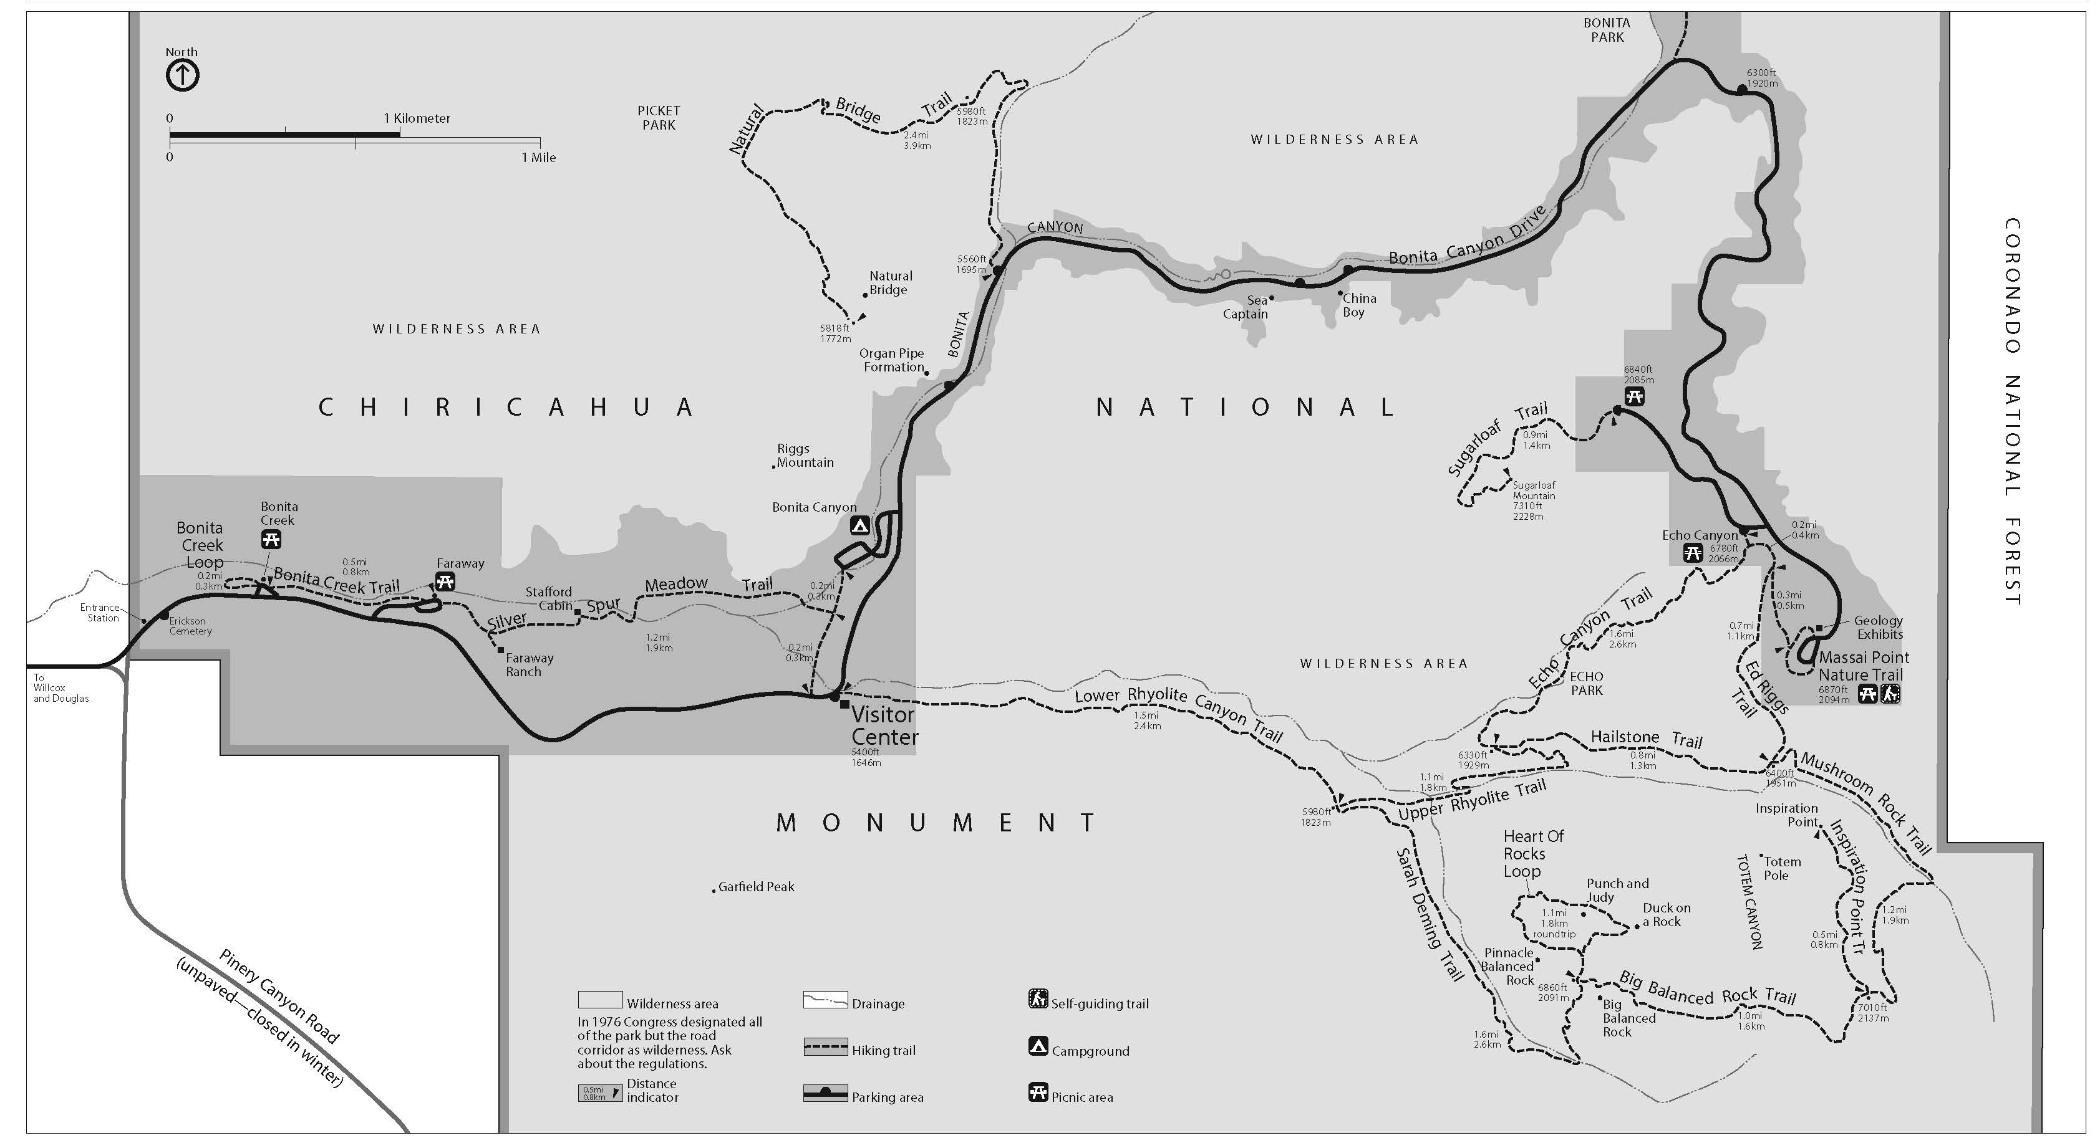
Horse Trailer
Parking Lot

