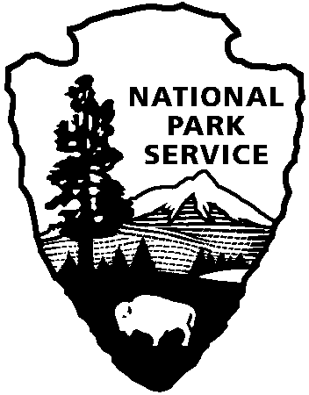
Credit/Debit Card Authorization Form for SUPs/CUAs

Southeast Arizona Group
520-824-3560 Chiricahua NM
520-366-5515 Coronado NMem
520-847-2500 Fort Bowie NHS

National Park Service
U.S. Department of the Interior

If you wish to pay for your permit by debit or credit card and will mail/ship your application to us, complete this authorization and return it with your SUP or CUA application.

If you plan to email your application, then fill in everything EXCEPT the card number and expiration date as your email will not be encrypted. Once the application and card authorization forms are received, we’ll call you for the card number and expiration date.

Name:__________________________

Card Type: ___Visa ___Mastercard ___Discover ___American Express

Card Number: ________________________________________

Expiration Date: ____/____ Amount $ ________

Phone #: _____________________________________________

