National Park Service  U.S. Department of the Interior | Thomas Edison  National Historical Park |  | 211 Main Street  West Orange, NJ 07052  973 736-0550 phone  973 736-6567 fax
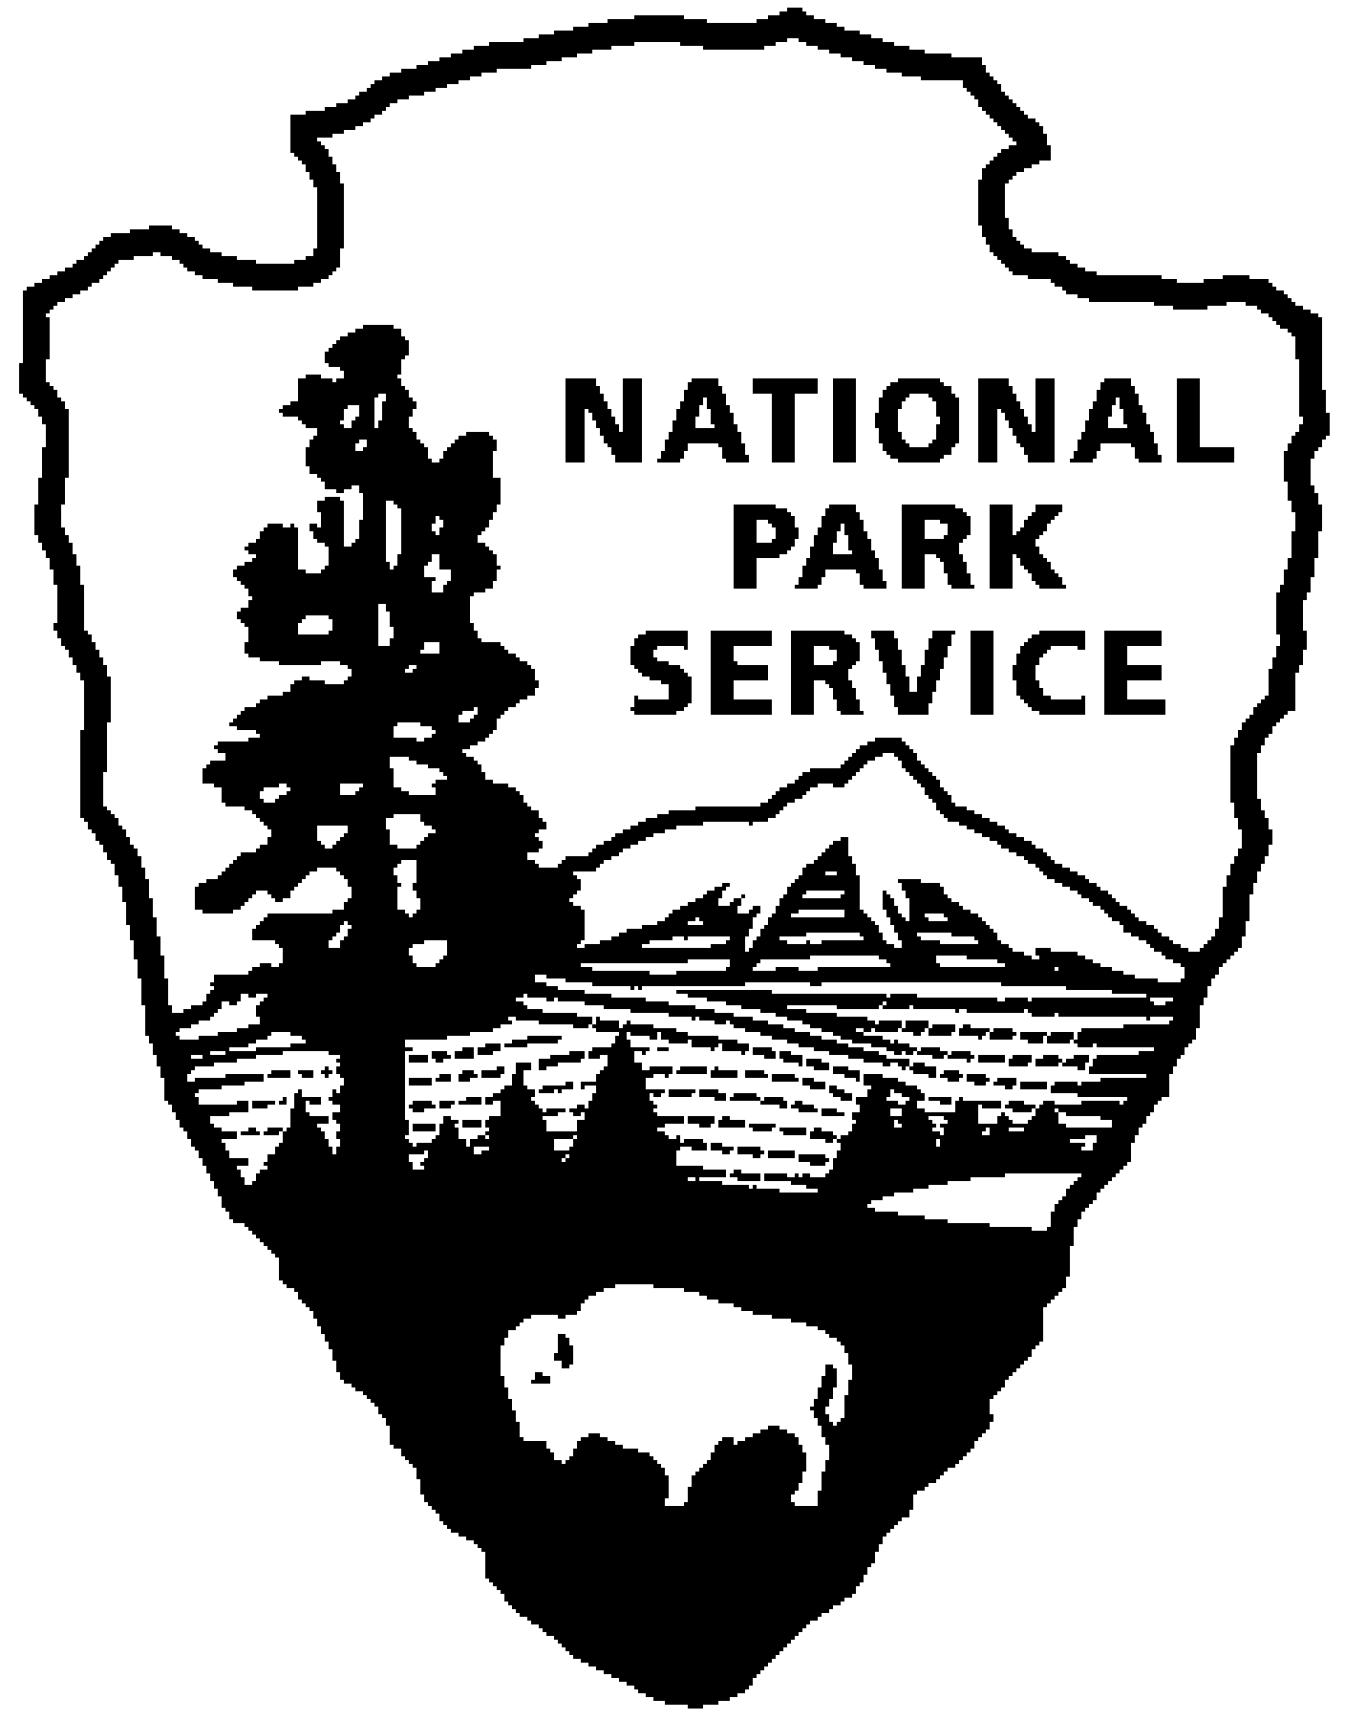

Thomas Edison NHP News Release
For Release: September 29, 2010
Contact: Karen Sloat-Olsen
Phone: 973-736-0550 x17
Reservations: 973-736-0550 x89

Edison’s Last Moments at Glenmont
October 21, 1931 Revisited

WEST ORANGE, NJ - On Thursday evening, October 21, 2010 at 7:00 pm, the National Park Service will offer a rare evening tour of Thomas Edison’s home, Glenmont, in Llewellyn Park. Reservations are required and space is limited. Call 973-736-0550 ext. 89 for reservations and further information. Admission to the program is free.

Edison came to West Orange in 1886 at the age of forty. He was already a successful and wealthy inventor. After 44 years of innovation and admiration from famous friends and family alike, Thomas Edison died on October 18, 1931 at his home in Llewellyn Park. He was 84 years old. Mrs. Mina Edison arranged a public viewing for Edison at his famous laboratory on Main Street, which lasted 2 days and was attended by thousands. She then held a private viewing at the family’s home on October 21, 1931.

Edison’s public profile and global impact lead President Hoover to request a dimming of all lights nationwide that evening. In Thomas Edison’s last public statement he said “My message to you is to be courageous. I have lived a long time. I have seen history repeat itself again and again. I have seen many depressions in business. Always America has come out stronger and more prosperous. Be as brave as your fathers before you. Have faith. Go forward.”

Join us for a rare evening tour of Glenmont to learn more about Edison’s last moments. Hear more about how his family was affected by his passing, and even hear passages from his last will and testament.

For more information or directions please call 973-736-0550 ext. 11 or visit our website at www.nps.gov/edis.
-NPS-

