National Park Service  U.S. Department of the Interior | Thomas Edison  National Historical Park |  | 211 Main Street  West Orange, NJ 07052  973 736-0550 phone  973 736-6567 fax
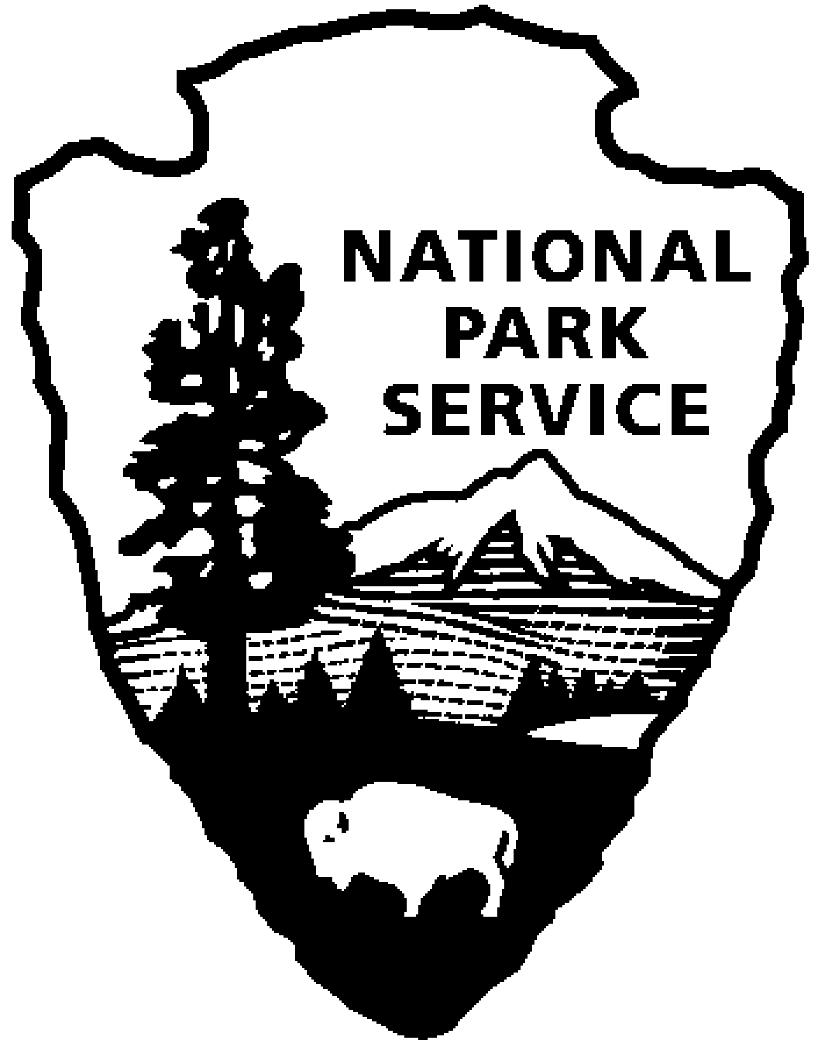
Thomas Edison NHP News Release
For Immediate Release
Contact: Theresa Jung
Phone: 973 736-0550 x 50

Michelle Ortwein Receives Award from
New Jersey Association of Museums
WEST ORANGE, NJ – The New Jersey Association of Museums has named Michelle Ortwein, Supervisory Museum Curator at Thomas Edison National Historical Park, as the 2011 recipient of the John Cotton Dana Award. Named for the founder of the Newark Museum and long-time official of the Newark Public Library, John Cotton Dana is regarded by many as the father of the modern museum.

The Dana Award is presented at the New Jersey Association of Museums annual meeting. It recognizes a museum professional whose work demonstrates outstanding professionalism in their field. Since the inception of the Dana Award in 1989, the list of its recipients has come to represent New Jersey’s outstanding professionals who have made significant contributions to the growth and development of its museums.

Ortwein was selected as this year’s honoree for “advancing the service of museums to the region, for demonstrating visionary and innovative leadership, and for exemplifying the highest standards of professional commitment”.

“Most notably, this award recognizes Michelle’s outstanding leadership in regard to the re-opening and continued operation of Thomas Edison’s Laboratory Complex,” said Greg Marshall, Superintendent of Thomas Edison NHP. “As a result of Michelle’s leadership and collaborative work with others, 20,000 square feet of exhibit space in the main laboratory building were prepared and opened to the public for the first time in the history of the park. This award is well-deserved and the entire staff congratulates Michelle on this well-earned honor”.

As the Supervisory Museum Curator since 2006, Michelle supervises a staff of nine who take care of the many thousands of artifacts and archives. She oversees several projects that bring conservators and other experts on-site to provide special care for the collections or prepare detailed reports on buildings and landscapes. Michelle is also responsible for the park’s volunteer program, coordinating the activities of over fifty volunteers.

Before moving to New Jersey, she was Curator at Valley Forge National Historical Park, and prior to that, she worked at the Northeast Region Museum Services Center where she worked at national parks from Maine to Virginia. She received a Master’s Degree in Preservation Studies from Boston University, a Certificate in Museum Studies from Tufts University and an undergraduate degree in Finance from Central Connecticut State University. She is originally from Connecticut and currently resides in Woodbridge, NJ.

Thomas Edison National Historical Park is a National Park Service site dedicated to promoting an international understanding and appreciation of the life and extraordinary achievements of Thomas Alva Edison by preserving, protecting, and interpreting the Park’s extensive historic artifact and archive collections at the Laboratory Complex and Glenmont, the Edison family estate. The Visitor Center is located at 211 Main Street in West Orange, New Jersey.

The Laboratory Complex is open Wednesday through Sunday from 9:00am to 5:00pm. Glenmont, Edison’s home, is open Friday through Sunday from 11:30am to 5:00pm. Tickets for Glenmont must first be obtained at the Laboratory Complex visitor center before going to Glenmont. For more information or directions please call 973-736-0550 ext. 11 or visit our website at www.nps.gov/edis.

Note to Editors:
An image of Ms. Ortwein is available upon request.

-NPS-

