National Park Service  U.S. Department of the Interior | Thomas Edison  National Historical Park |  | 211 Main Street  West Orange, NJ 07052  973 736-0550 phone  973 736-6567 fax
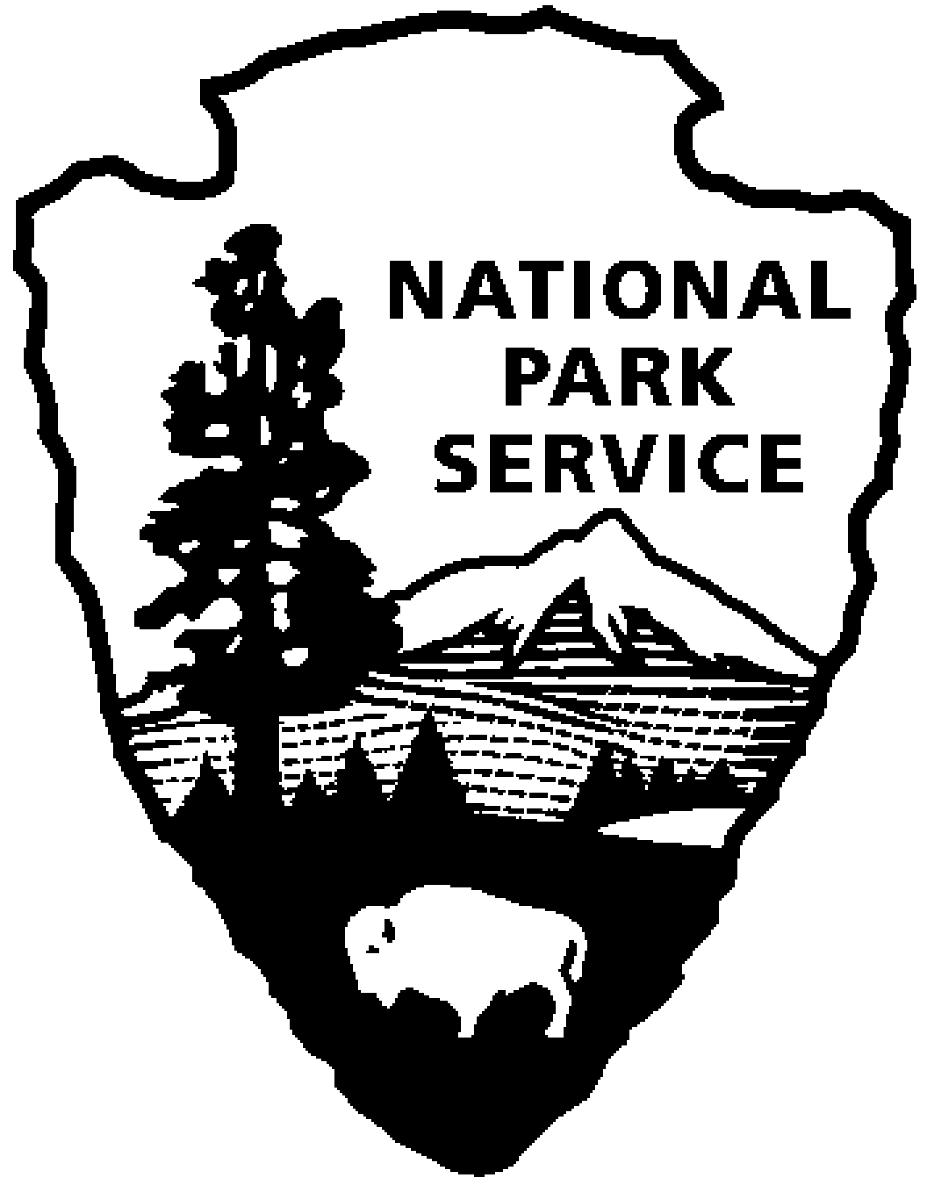
Thomas Edison NHP News Release
For Release: September 9, 2009
Contact: Terri Jung
Phone: 973 324-9974 x1

Visit the New Thomas Edison National Historical Park –

Laboratory Complex Opens With Expanded Exhibits

WEST ORANGE, NJ – The National Park Service is welcoming visitors to the new Thomas Edison National Historical Park. A variety of special programs and events – free of charge and open to all – will be held October 10 through 12. Festivities will be at the Laboratory Complex on Main Street and the Glenmont Estate in Llewellyn Park from 9:00 a.m. until 5:00 p.m. each day with extended hours on Saturday until 8:00 p.m.

“This is your opportunity to be among the first visitors to walk through the Main Street gate and explore the new site,” said Greg Marshall, Superintendent at Thomas Edison National Historical Park. “The original music recording studio, Thomas Edison’s private laboratory, and a photography studio will be open to the public for the first time in the history of the site.” The original furnishings have been moved back into many rooms and the vast and unique museum collections will be available for all to see, hear, and experience. Installation of a new elevator and stair tower adjacent to the main laboratory building allows new public access to the upper floors of the laboratory that now feature new exhibits.

The $13 million partnership project with the Edison Innovation Foundation and Charles Edison Fund of Newark, New Jersey also includes new heating and cooling systems, new fire detection and suppression systems, and structural repairs to the historic building’s roofs, foundations, and windows. “This project was absolutely necessary to preserve the Edison Legacy and the treasures associated with the life and work of Thomas Edison, the “Man of the Millennium” who changed the world,” says John P. Keegan, Chairman and President of the Edison Innovation Foundation and Charles Edison Fund.

“The new Thomas Edison experience offers visitors from around the world and around the neighborhood the ability to explore the park in many different ways: self-guided audio tours, cell phone tours, films, grounds walks, school workshops and traditional Ranger-guided programs,” Marshall added.
- more -

“The renovation of the Edison home at the Glenmont Estate and the Laboratory Complex on Main Street are truly a celebration of the contributions of our important partnerships,” said Marshall. “The opening of a NEW Thomas Edison National Historical Park experience gives all of us a vision for a bright future,” Keegan added.

Thomas Edison National Historical Park is a unit of the National Park Service that preserves and interprets the West Orange Laboratory and Home of inventor Thomas Alva Edison. Information is available at: www.nps.gov/edis.

The Edison Innovation Foundation is a nonprofit organization that supports the Edison Legacy and encourages students (including women and minorities) to embrace careers in science, technology and engineering and is committed to educating the next generation of great innovators while using Edison and his Invention Factory as the foundation. For information on the Foundation, visit: www.thomasedison.org.

- NPS -

