National Park Service  U.S. Department of the Interior | Thomas Edison  National Historical Park |  | 211 Main Street  West Orange, NJ 07052  973 736-0550 phone  973 736-6567 fax
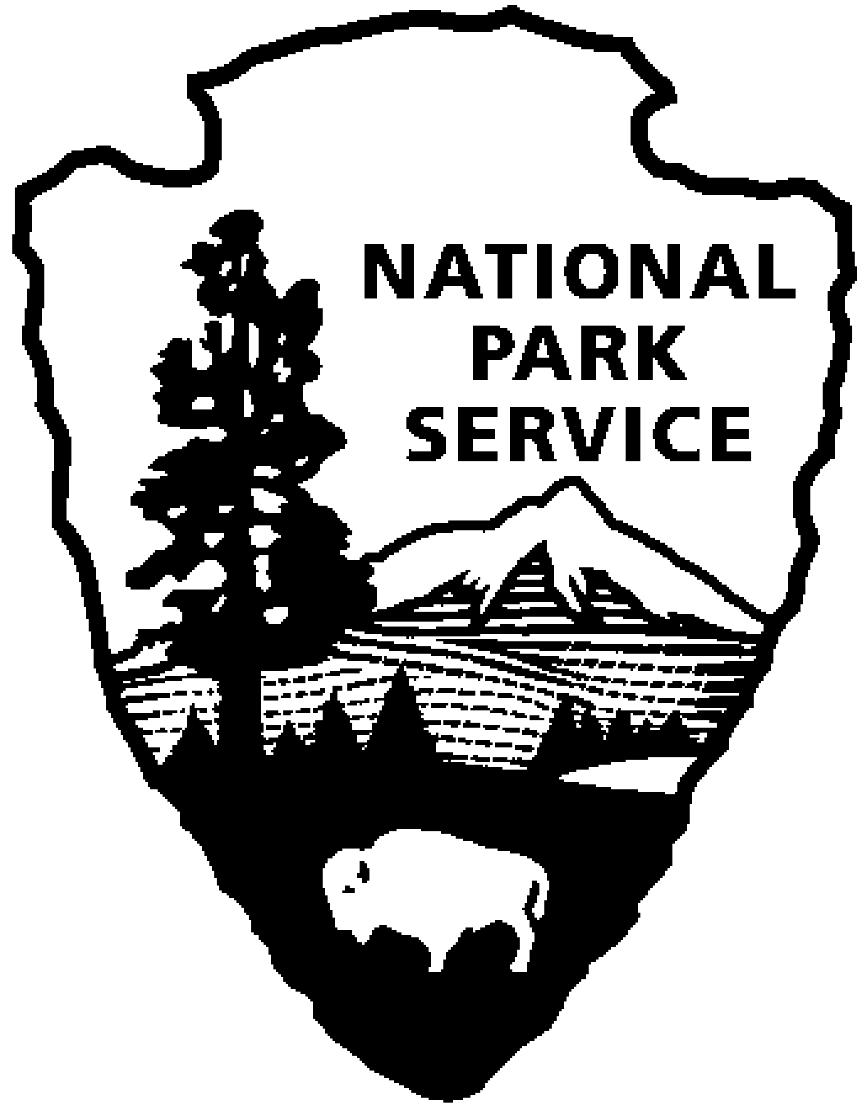
Thomas Edison NHP News Release
For Release: November 24, 2009
Contact: Karen Sloat-Olsen
Phone: 973 736-0550 x17

Holiday Tours at Thomas Edison’s Home, Glenmont

WEST ORANGE, NJ – The sights and sounds of the season will greet visitors when they come to Thomas Edison’s home in Llewellyn Park during “Holidays at Glenmont,” starting on November 27, 2009 and continuing through January 3, 2010.
Glenmont will be decorated much as it was while the Edison family lived there. Favorite musical pieces will be playing and greenery and red poinsettias will deck the mantles above the fireplaces. Staircases will be ringed with boughs and red ribbon bows and wreaths will hang in every window. In the Den, the majestic 10 foot tree will be lit and the presents underneath will be waiting as if the Edison children Madeleine, Theodore and Charles, will soon come running down the stairs from their rooms - after they’ve checked their stockings in the upstairs Living Room! Family china will be displayed on the Dining Room table and the scene will be completed with holiday cards that were received by the Edison’s.

The Edison home, Glenmont, is located on a fifteen-acre estate in Llewellyn Park, the country’s first private residential community. Built in 1880, the twenty-nine room mansion contains the original furnishings and family items used by the Edison’s. The estate grounds include gardens, a greenhouse, barn, and the poured concrete garage containing the family’s automobiles. Thomas and Mina Edison are buried on the grounds of the estate.

The Holidays at Glenmont tours will be offered on Fridays, Saturdays and Sundays from 11:30 a.m. until 4:00 p.m. through January 3, 2010. Additional holiday tours will be offered on Wednesday and Thursday, December 30th and 31st.

Car passes and tour tickets must be purchased at the Laboratory Complex Visitor Center at 211 Main Street. Admission is $7.00, and includes the Glenmont Estate and the Laboratory Complex. Children under age 16 are free.

The Laboratory Complex on Main Street is open Wednesday through Sunday from 9:00 a.m. to 5:00 p.m. Group tours may be scheduled by calling the Group Tour Coordinator at 973-736-0550 extension 71. Visit our website at www.nps.gov/edis for additional information.

- NPS -

