National Park Service  U.S. Department of the Interior | Thomas Edison  National Historical Park |  | 211 Main Street  West Orange, NJ 07052  973 736-0550 phone  973 736-6567 fax
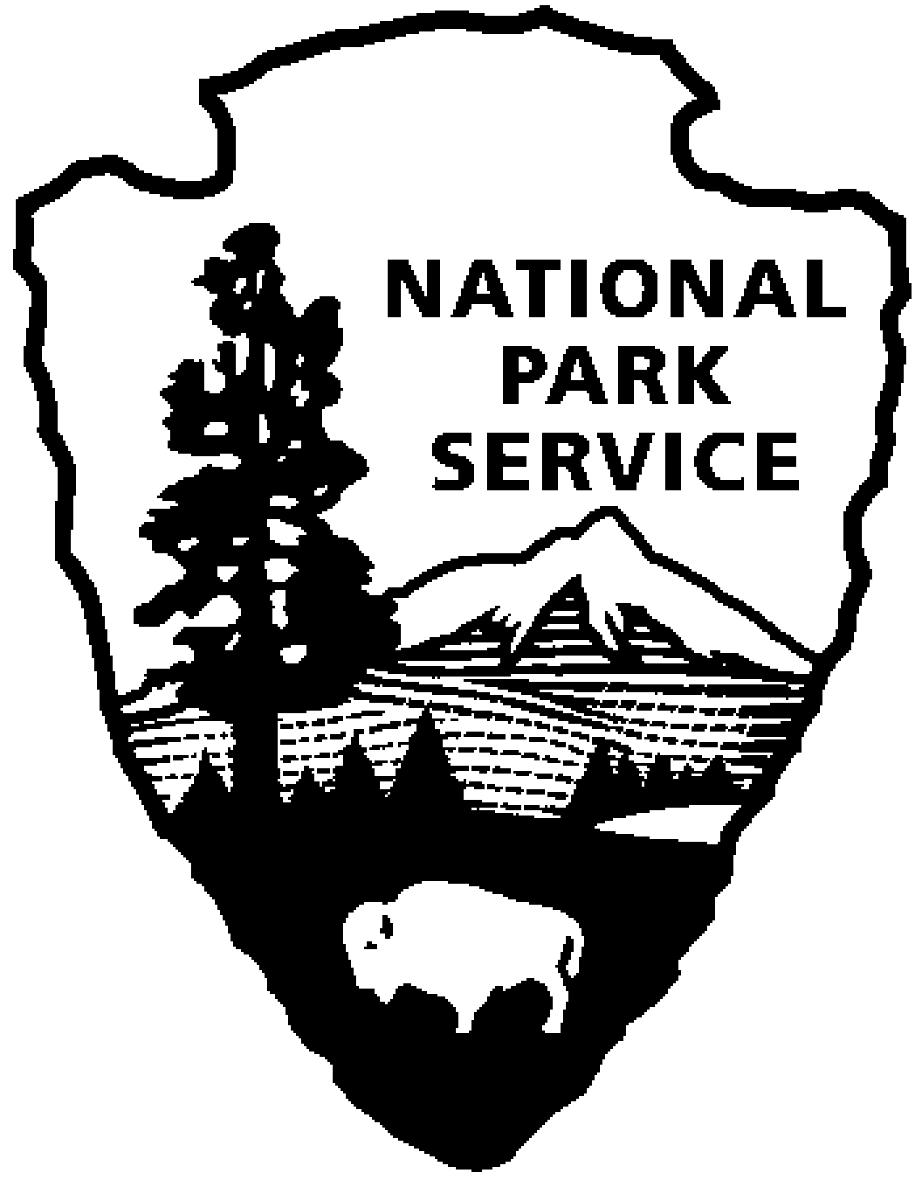
Thomas Edison NHP News Release
For Release: May 26, 2010
Contact: Theresa Jung
Phone: 973 736-0550 x 50

EDISON LABORATORY RECEIVES HISTORIC PRESERVATION AWARD

WEST ORANGE, NJ – The project to preserve the historic buildings and the artifact and archival collections at the Laboratory Complex at Thomas Edison National Historical Park was recognized on May 25 with a 2010 New Jersey Historic Preservation Award. The award was presented by Bob Martin, Commissioner, New Jersey Department of Environmental Protection and Sophia Jones, New Jersey Historic Sites Council at the 20th annual awards reception in Trenton.
In operation for more than forty years, the park is home to the invention of the motion picture camera, improved phonographs, sound recordings, silent and sound movies, and the nickel-iron alkaline electric storage battery. It has been open to the public since the 1950s, providing visitors with a unique glimpse into the famous inventor’s workplace. However, the facilities had fallen into disrepair resulting in the park being placed on the National Trust for Historic Preservation’s most endangered list. The original historic furnishings and documents were beginning to deteriorate because of lack of adequate heating and cooling systems. They were at risk of loss or damage from fire because of old, outdated alarm and sprinkler systems. The vast majority of the artifact collection was inaccessible to visitors and researchers while stored on the upper floors of the historic main laboratory building.

The $13 million project with the Edison Innovation Foundation and the Charles Edison Fund of Newark, New Jersey was completed over six years. The project was designed with careful consideration of the historic character of the laboratory buildings. Repairs were completed and new systems installed with minimal disruption to the original structure.

A new elevator and stair tower were installed adjacent to the main laboratory providing for the first time public access to new exhibits on the second and third floors of the building. These exhibits include the original music room, Edison’s private laboratory, a photography studio and new gallery displaying the valuable collection of phonographs. The visitor experience has been further enhanced by the return of the original furnishings to many of the rooms, new exhibit panels and a self-guided audio tour.

The Laboratory Complex reopened in October 2009. A testament to the project’s success is the experience of visitors who often describe that upon entering the laboratory buildings, it is as if Edison and his colleagues had just stepped out to lunch.

“The National Park Service is appreciative of the recognition by the New Jersey Historic Preservation Awards program of the renovation project at the Thomas Edison National Historical Park,” stated park superintendent, Greg Marshall. “This restoration was so much more than simply showing Edison artifacts to the public,” added John P. Keegan, Chairman and President of the Edison Innovation Foundation and Charles Edison Fund, “it was absolutely necessary to preserve the Edison Legacy and the treasures associated with the life and work of Thomas Edison, the “Man of the Millennium” who changed the world.”

About the project:
The $13 million project was a joint partnership of the Charles Edison Fund and Edison Innovation Foundation of Newark, New Jersey, with significant contributions from General Electric Company, Sony Corporation, Save America’s Treasures, and the Friends of Thomas Edison National Historical Park.

Project Team:
Project Management: National Park Service, Denver Service Center, Denver, CO
Architect: Beyer Binder Belle Architects & Planners LLP, New York, NY
Structural Engineer: Robert Silman Associates, P.C., New York, NY
MEP/Civil Engineer: HF Lenz Company, Johnston, PA
General Contractor: Troop Construction and Electric Inc., Perth Amboy, NJ
Exhibit Designer: Ralph Appelbaum Associates Inc., New York, NY

Project Partners:
The Thomas Edison National Historical Park is a unit of the National Park Service that preserves and interprets the West Orange Laboratory and Glenmont home of inventor Thomas Alva Edison. Information is available at: www.nps.gov/edis.

The Edison Innovation Foundation is a nonprofit organization that supports the Edison Legacy and encourages students (including women and minorities) to embrace careers in science, technology and engineering and is committed to educating the next generation of great innovators while using Edison and his Invention Factory as the foundation. For information on the Foundation visit: www.thomasedison.org.

Thomas Edison National Historical Park is a National Park Service site dedicated to promoting an international understanding and appreciation of the life and extraordinary achievements of Thomas Alva Edison by preserving, protecting, and interpreting the Park’s extensive historic artifact and archive collections at the Laboratory Complex and Glenmont, the Edison family estate. The Visitor Center is located at 211 Main Street in West Orange, New Jersey.

The Laboratory Complex is open Wednesday through Sunday from 9:00am to 5:00pm. Glenmont, Edison’s home, is open Friday through Sunday from 11:30am to 5:00pm. Tickets for Glenmont must first be obtained at the Laboratory Complex visitor center before going to Glenmont. For more information or directions please call 973-736-0550 ext. 11 or visit our website at www.nps.gov/edis.

-NPS-

