National Park Service  U.S. Department of the Interior | Thomas Edison  National Historical Park |  | 211 Main Street  West Orange, NJ 07052  973 736-0550 phone  973 736-6567 fax
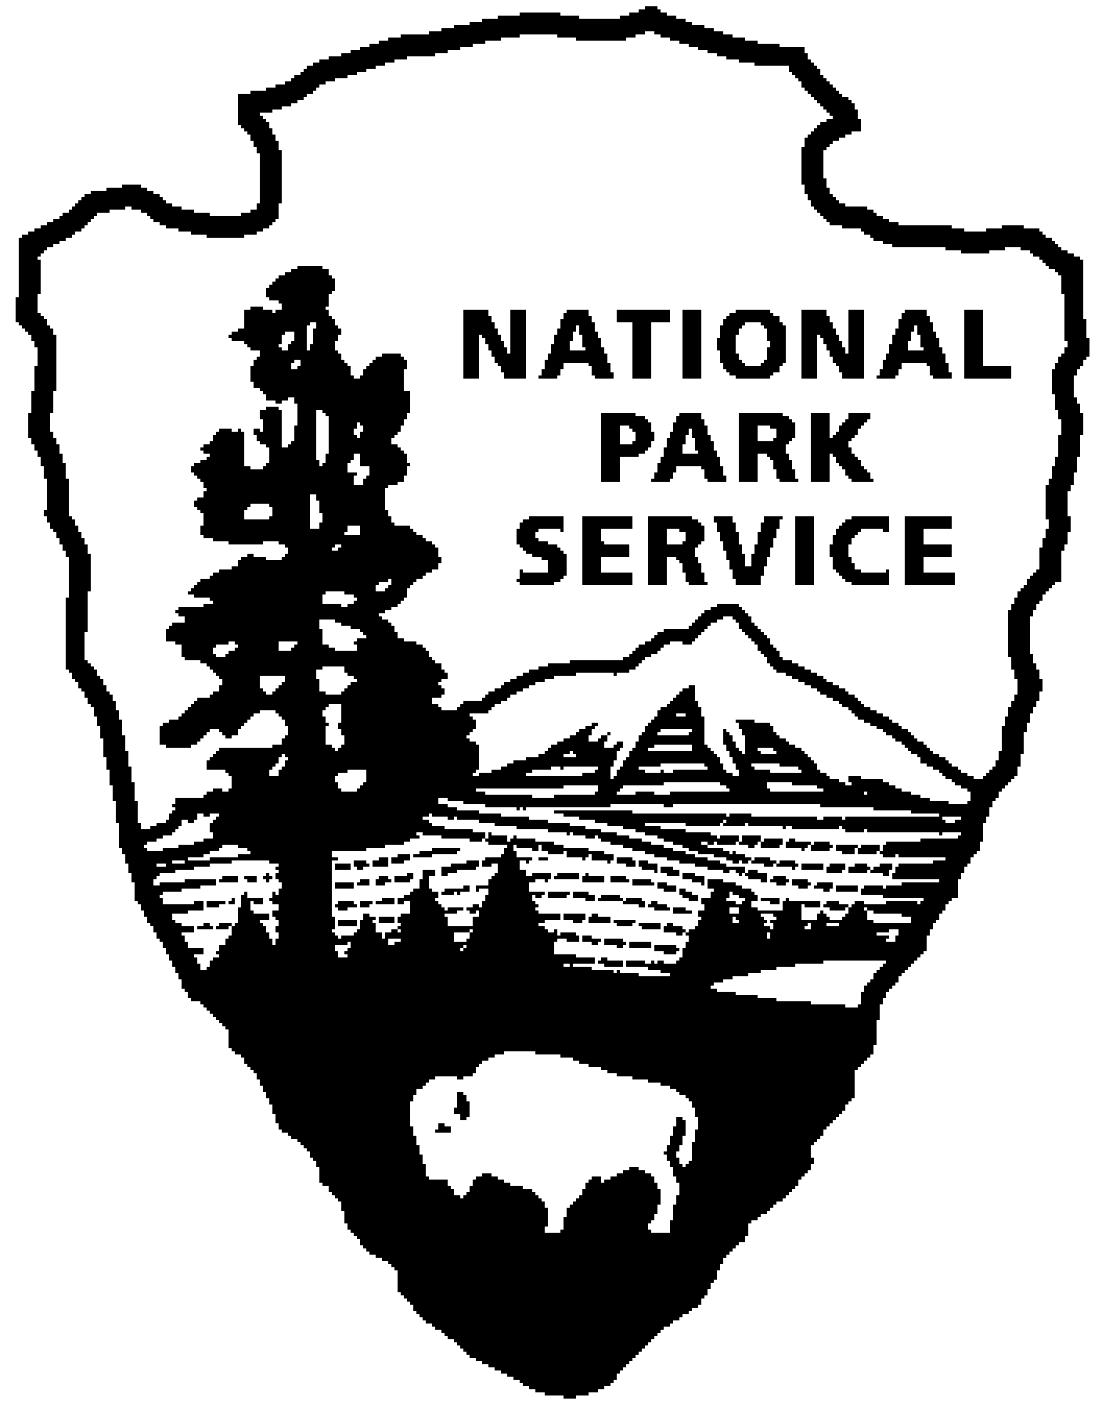
Thomas Edison NHP News Release
For Release: August 3, 2010
Contact: Karen Sloat-Olsen
Phone: 973 736-0550 x17

Visit Thomas Edison National Historical Park –

Free on August 14 and 15

WEST ORANGE, NJ – If you haven’t had the chance to visit Thomas Edison National Historical Park in West Orange since its reopening, then August 14 and 15 are the ideal times. Secretary of the Interior Ken Salazar recently announced that the National Park Service will waive entrance fees on Saturday, August 14 and Sunday, August 15 to encourage all Americans to visit our national parks.

“This fee-free weekend provides an opportunity for individuals and families alike to take an affordable vacation or to explore a nearby park they have never visited before,” Salazar said. “I encourage everyone to take advantage of the free admission to visit not only our greatest natural wonders but also our nation’s historic and cultural icons.”

Thomas Edison National Historical Park in West Orange, NJ, is just one of the 392 national parks that will be offering free admission on August 14 and 15. The park encompasses two sites – the Laboratory Complex and the Glenmont Estate, former home to Thomas and Mina Edison.

After undergoing extensive renovations, the Laboratory Complex reopened in October 2009. The original music recording studio, Thomas Edison’s private laboratory, and a photography studio are now open to the public for the first time in the history of the park. The original furnishings have been moved back into many rooms and the vast and unique museum collections are available for all to see, hear, and experience. Installation of an elevator and stair tower adjacent to the main laboratory building allows public access to the upper floors of the laboratory that now feature new exhibits.

Visitors can also take a tour of Edison’s former home at the Glenmont estate, located in the nearby Llewellyn Park. Glenmont is a twenty-nine room, Queen Anne style mansion built in 1880 and surrounded by fifteen acres of landscaped grounds. Along with tours of the home’s furnished rooms, visitors will also be able to learn about the home’s geothermal heating and cooling system on a special behind-the-scenes tour. We will offer a variety of children’s programs including games the whole family can play! Children can earn a Junior Ranger badge.

The Laboratory Complex is open Wednesday through Sunday from 9:00am to 5:00pm. Glenmont, Edison’s home, is open Wednesday through Sunday from 11:30am to 5:00pm. The entrance fee is usually $7 for adults, children under 16 are free. All visitors will be admitted free on August 14 and 15. Tickets for Glenmont must first be obtained at the Laboratory Complex visitor center before going to Glenmont. For more information or directions please call 973-736-0550 ext. 11 or visit our website at www.nps.gov/edis.
-NPS-

