Fort Davis
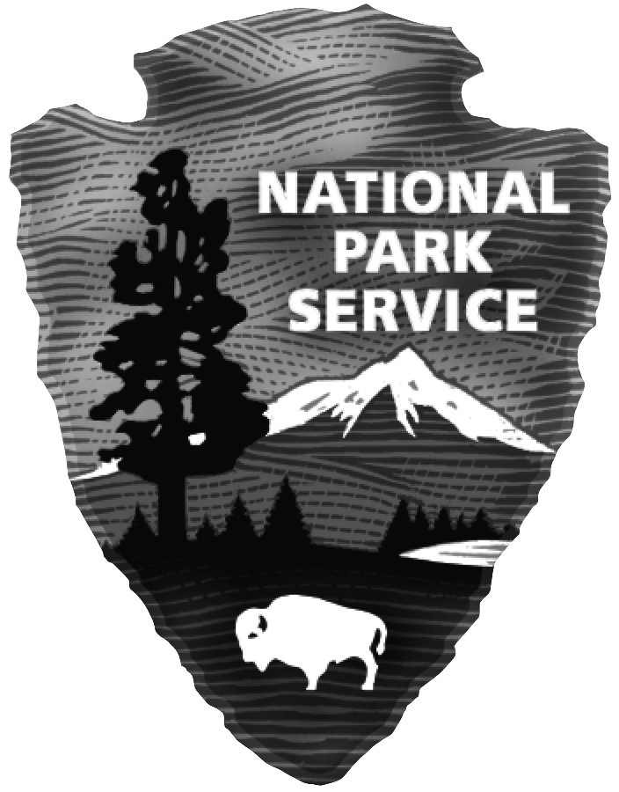

National Historic Site
National Park Service
U.S. Department of the Interior

BLACK RECIPIENTS OF
THE MEDAL OF HONOR

FROM THE FRONTIER INDIAN WARS

The Medal of Honor is the highest award that can be given to a member of the Armed Services of the United States. It is presented by the president, in the name of Congress, to an individual who while serving his country “distinguished himself conspicuously by gallantry and intrepidity at the risk of his life above and beyond the call of duty.” The Medal of Honor was authorized in 1862 and first presented in 1863 to soldiers and sailors who demonstrated extraordinary examples of courage in the Civil War.

Devotion to Duty

Between 1865 and 1899, the Medal of Honor was awarded to 417 men who served in the frontier Indian Campaigns. Eighteen of the medals were earned by men of African-American descent. Of this number, eleven were presented to enlisted men of the Ninth U. S. Cavalry, two to members of the Twenty-fourth U. S. Infantry, one to a trooper of the Tenth U. S. Cavalry, and four to Seminole-Negro Indian Scouts. Although no medals were awarded to men for actions directly involving Fort Davis, Texas, several recipients served at the post during their military careers.

Fort Davis Troopers

Emanuel Stance was a 19-year-old farmer when he joined the newly organized Ninth Cavalry in 1866. Assigned to Company F, the young private was stationed at Fort Davis from July 1867 to February 1869. In May 1870, Stance, then a sergeant, was in charge of a scouting party that left Fort McKavett, Texas, in pursuit of a number of Apaches who had stolen several horses. The troopers gave chase and were successful in recovering the horses. The following day, near Kickapoo Springs, Stance and his detachment observed several Apaches about to fire upon two government wagons. Stance immediately ordered his men to attack, causing the Apaches to abandon their horses and retreat. On
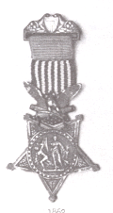
July 9, 1870, just six weeks after the engagements with the Apaches, Emanuel Stance was awarded the Medal of Honor.

George Jordan served at Fort Davis with the Ninth Cavalry from April 1868 to May 1871. During this time, he was often in the field scouting for the elusive Apaches and Comanches who were raiding in western Texas and southeastern New Mexico. On one occasion he was part of a two-hundred-man force detailed to track a party of Mescalero Apaches in the Guadalupe Mountains. The experience Jordan gained proved invaluable. On May 14, 1880 Sergeant Jordan, in command of a small detachment of soldiers, defended Tularosa, New Mexico Territory, against the Apache leader, Victorio, and his warriors. Ten years later, Jordan was awarded the Medal of Honor for bravery demonstrated at the Battle of Tularosa. He retired in 1897 with over thirty years of devoted service.

Another Ninth Cavalry trooper to earn the coveted medal was Sergeant Thomas Shaw, who served as a private at Fort Davis in 1870 and 1871. A runaway slave from Kentucky who had joined the Union Army during the Civil War, Shaw was one of the best marksmen in the regiment. In August of 1881, Shaw was part of a small detachment in pursuit of the Apache leader, Nana, and a number of his warriors. The Apaches had attacked a number of small settlements and ranches in southern New Mexico Territory. The outnumbered soldiers surprised the Apaches in Carrizo Canyon on the west side of the Mimbres Mountains. Sergeant Shaw was awarded the Medal of Honor for “extraordinary courage under fire” in preventing the Apaches from surrounding the command.
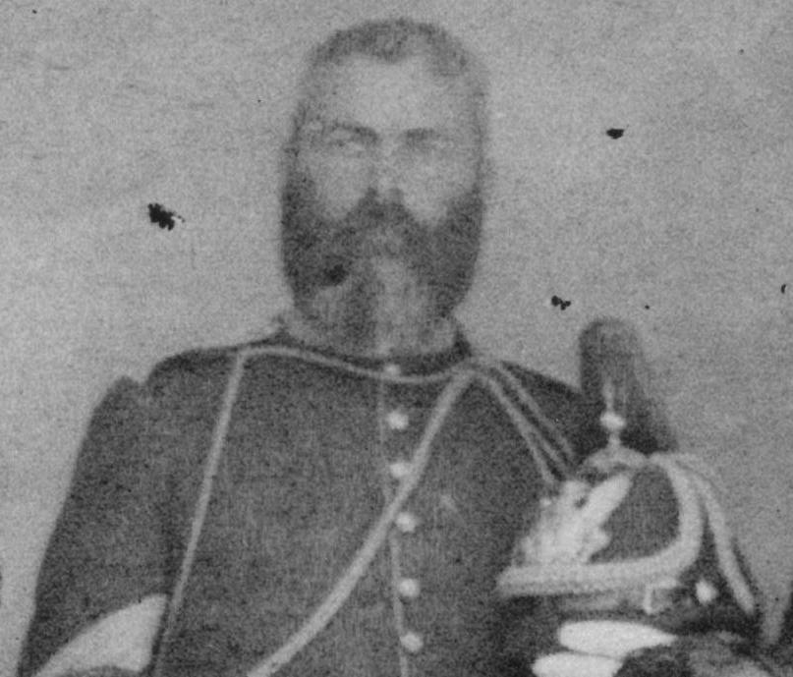
Sergeant Thomas Shaw

Tenth Cavalry Sergeant

Sergeant William McBryar was the sole member of the Tenth U. S. Cavalry to receive the Medal of Honor for bravery during the Indian Campaigns. Enlisting in 1887, two years after the Tenth left Fort Davis, McBryar was more educated than most recruits, having attended three years of college and being proficient in Spanish. In the spring of 1890, McBryar was a member of a small detachment tracking a band of Apaches in southeastern Arizona

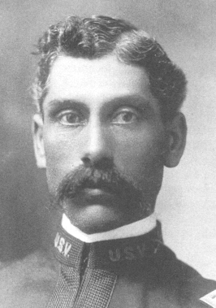
Sergeant William McBryar

Territory. As the troopers entered a canyon near Fort Thomas, the Apaches attacked. The ensuing conflict was short but decisive for the army. Sergeant McBryar was honored with the Medal of Honor for demonstrating “coolness, bravery, and good marksmanship” under extremely difficult circumstances.

Soldiers of the Twenty-fourth Infantry

The only black infantrymen to receive the Medal of Honor for bravery in the frontier Indian Wars were Sergeant Benjamin Brown and Corporal Isaiah Mays. In May of 1889, they were

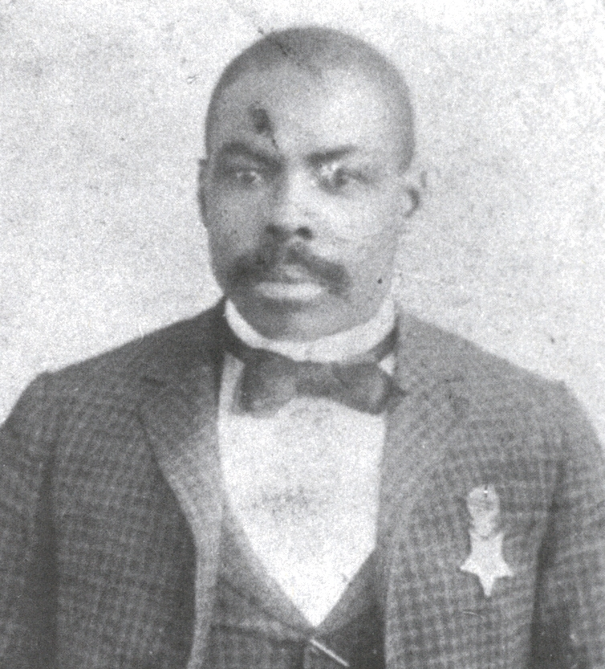
Corporal Isaiah Mays

members of a small detachment ordered to guard a government convoy carrying over $28,000 in gold coins from Fort Grant to Fort Thomas in Arizona Territory. The soldiers were attacked near Cedar Springs and the gold taken. For courageously defending the paymaster, Major Joseph Wham, and the other enlisted men involved, Brown and Mays were awarded Medals of Honor.

Seminole-Negro Indian Scouts

In 1870, the U. S. Army began recruiting Seminole Negroes from Mexico as scouts. The Seminole Negroes were descendants of escaped slaves who settled among the Seminole Indians in Florida. In the 1840s, the government moved them to present-day Oklahoma. Fearing that they might become enslaved, some fled to Mexico.

Never numbering more than fifty at one time, the Seminole-Negro Indian Scouts were known for their incredible tracking skills. They amassed an impressive combat record on the frontier. Four of the scouts received the Medal of Honor, the highest number awarded to a single fighting unit.

Private Adam Paine received his medal for “gallantry in action” during the Red River War of 1874-1875. The first of the Seminole-Negro Indian Scouts to be so honored, Paine was praised for rendering “invaluable assistance” to Colonel Ranald Mackenzie against the Southern Cheyenne at the Battle of Canyon Blanco.

Private Pompey Factor, Trumpeter Isaac Payne, and Sergeant John Ward received Medals of Honor for rescuing their commander, Lieutenant John Bullis, at the Battle of the Pecos River in 1875.

Bullis and the three scouts had come upon a party of twenty-five to thirty Comanches. After waging battle for almost an hour, the scouts were forced to retreat.
Bullis, however, had become separated from his mount. While Payne and Factor provided cover, Ward went back and pulled the lieutenant up onto his horse and rode to safety.

The Last to Receive the Medal

The last soldier of African-American descent to receive the Medal of Honor for heroism during the Indian Campaigns on the western frontier was Corporal William O. Wilson of the Ninth Cavalry. In late December, 1890, following the Battle of Wounded Knee, a band of Sioux warriors fired on a government supply train north of the Pine Ridge Agency in South Dakota. Corporal Wilson, one of the cavalrymen escorting the train, volunteered to ride to the agency for help. Pursued by a number of Sioux, Wilson made good his escape, and troops from the agency soon rescued the besieged soldiers. Wilson was awarded the Medal of Honor for “qualities of the most conspicuous bravery and gallantry.”

Epilogue

The fourteen black soldiers and four Seminole-Indian Scouts who received the Medal of Honor for heroism during the frontier Indian Wars represent the thousands of African Americans who displayed valor and bravery in the face of adversity. These men brought honor to their regiments and recognition to their race. Fort Davis is proud to be a part of their heritage.

PROUDLY THEY SERVED

Recipients of the Medal of Honor

Ninth U. S. Cavalry

Sergeant Thomas Boyne
Sergeant John Denny
Corporal Clinton Greaves
Sergeant Henry Johnson
Sergeant George Jordan
Sergeant Thomas Shaw
Sergeant Emanuel Stance
Private Augustus Walley
Sergeant Moses Williams
Corporal William O. Wilson
Sergeant Brent Woods

Tenth U. S. Cavalry

Sergeant William McBryar

Twenty-fourth U. S. Infantry

Sergeant Benjamin Brown
Corporal Isaiah Mays

Seminole-Negro Indian Scouts

Private Pompey Factor
Private Adam Paine
Private Isaac Payne
Sergeant John Ward

