Fort Davis National Historic Site | National Park Service  U.S. Department of the Interior | 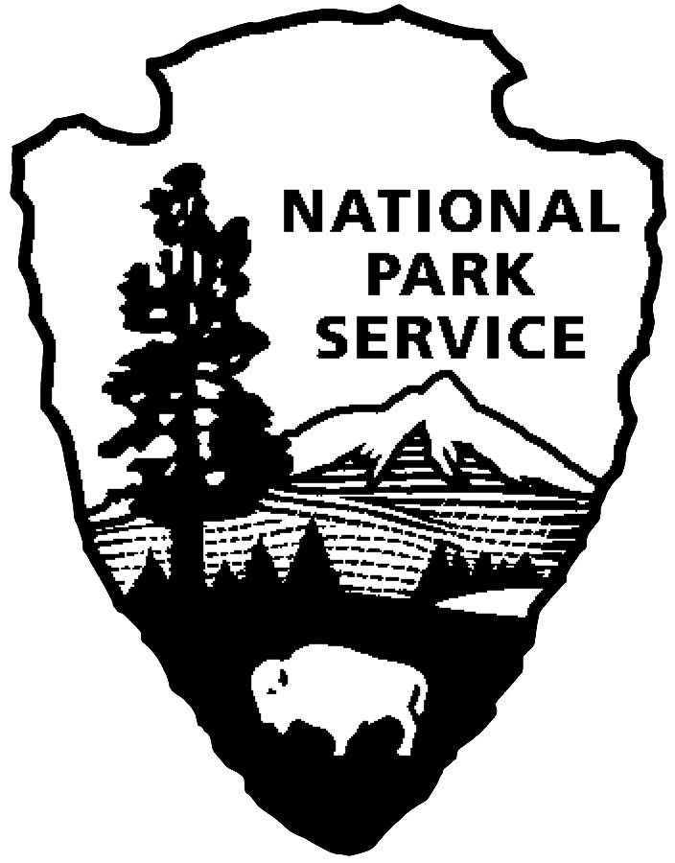
Curriculum Materials Grades 6-8 Student Activity: Do You Want to Be an Archaeologist?

Do You Want to Be an Archaeologist?

Historical archaeology is the scientific study of people by recovering, documenting, and analyzing material remains, including artifacts. Wow, that’s a complicated definition, but it tells us a lot. So what is an artifact? An artifact is something made or used by people. This can be anything from an old coin to the soda pop can you recycled after yesterday’s lunch. It’s a staggering thought—the pizza cartons we leave behind today could be important clues to our cultural identify sometime in the distant future. And the sleuths or detectives who will decipher such clues will be the archaeologists!

Since Fort Davis National Historic Site was opened to the public in 1963, archaeological research has been undertaken to locate and study artifacts that were left behind by people who lived at the fort. This research has helped locate foundations of buildings and uncover artifacts of all kinds—some of which you will see in the park museum displays. The study is an on-going process.

In 2004, parts of the post commissary (the building where the army stored the food supply for the fort) had deteriorated so significantly that the floor was unstable and posed a safety hazard for visitors. As a first step to repairing the floor, it was decided to remove the old flooring and to excavate the soil beneath the floor. Because the soil was thought to contain historic artifacts, an archaeological excavation was undertaken, and it resulted in the discovery of thousands of amazing things. Imagine being a soldier or civilian living in the 1870s—what kinds of things could you have dropped that might have fallen through the floorboards? Or think of yourself as a rodent burrowing under the floor—what might you have carried there?

How to Conduct an Archaeological Dig

The first step in an archaeological dig (excavation) is to grid the site. Gridding is a lot like taking a huge piece of graph paper and placing it over the site. By dividing the site into grids or units, you can be sure that the entire site will be properly excavated. By using the grid and by labeling the coordinates, you can accurately keep a record of where each artifact you dig up was found. This is important as you later try to piece the puzzle together.

The next step in the dig is the removal of the soil itself. The ground is arranged in layers, similar to a layer cake. These are called the strata. The lowest layer is the oldest, while the top or first layer is the most modern. The color and texture of the soil will change with each layer that you unearth. Archaeologists use trowels or small shovels, brushes, and even tweezers to uncover artifacts. As the soil or dirt is removed, it is sifted through a screen to catch the tiniest artifacts. Artifacts from each unit or layer are bagged and labeled.

Detailed notes, drawings, maps, photographs, and sometimes videos are made during the excavation to record everything that was found. One of the most important drawings of an archaeological dig is called a profile sketch. A profile or cross section is drawn of each unit to show the layers and features found. All maps, drawings, and profiles are carefully drawn to scale so that the archaeologist can use the information.

When the excavation is completed, the archaeologist back fills the unit so it can be returned to the way it was before the dig was undertaken. The notes and artifacts are taken to the lab for analysis. It is like putting together thousands of puzzle pieces to get the big picture. The archaeologist then puts together a report telling about the finds and what they might mean.

The Post Commissary Dig at Fort Davis

At the commissary, the soil beneath the sub-floor was excavated to leave a 12 to 14-inch air space between the earthen sub-floor and the wooden floor joists. Each unit or grid was 1-meter square and was excavated in 10-centimeter vertical levels with the soil screened through ¼ inch mesh to make sure that all artifacts were recovered. Artifacts from each unit and layer were bagged and labeled. Detailed notes, sketches, and photographs were made of each artifact. The photographs on this page were taken during the 2004 dig at the post commissary.

* * * * *

QUESTIONS:

1. The brooch (a lady’s pin) pictured to the left was found under the commissary floor. Who do you think might have lost it? How do you think the owner might have felt when it was discovered missing? Why would it be important to know in which layer it was found and with what other artifacts?

2. Would you like to study archaeology and participate in an archaeological dig like the one that was conducted at the post commissary at Fort Davis National Historic Site?

3. Why should park visitors not randomly dig up or pick up artifacts that they see laying around or sticking out of the ground?

