Fort Davis National Historic Site | National Park Service  U.S. Department of the Interior | 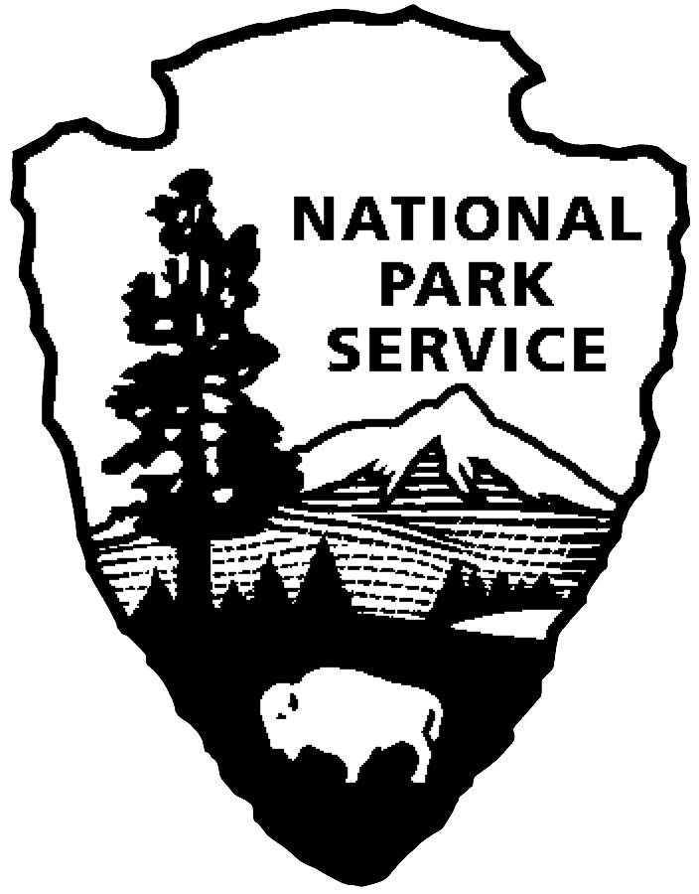
Curriculum Materials Grades 6-8 Teacher Notes: Overview Using Park Literature

Overview Using Park Literature

Topic: Students will begin to acquire background information on Fort Davis with this activity. By using the full-color park brochure and articles from the park website, students will learn about Fort Davis’s place in history. Being able to utilize information that is found at places such as historic sites, businesses, museums, or the work place is a necessary real-world skill. These activities are multidisciplinary—covering art, reading for content skills, reading comprehension, writing activities.

Objectives and Standards: Provided with Unit Introduction

Materials Needed:
- Request from the park up to five color park brochures for group use.
- Copies of “Welcome Recruit” handout for students
- Have students read or print out articles from the park website. Go to www.nps.gov/foda, then click on the link “History & Culture” on the sidebar at right. At that site, articles for this lesson are entitled: “The First Fort Davis”
“African Americans in the Frontier Army”
“Black Recipients of the Medal of Honor”
“Post Hospital”
“Officers’ Wives”
3. Discussion questions

Lesson Activities:
Historic readings/background information:
- The “Welcome Recruit” handout can be read individually or as a class. The goal of this handout is to encourage students to develop and use content area reading strategies.
- Provide students with the opportunity to study the color park brochure and to read articles included to answer the discussion questions individually, as a small group, or as a whole class. The class can be divided into groups. Each group can be assigned one brochure/article and set of questions. Upon completion they can summarize and report to the rest of the class.
- Teacher may choose the articles to be read. If time is short, not all topics need to be read.

Wrap-up and Assessment:
Discuss with students the information they have learned. Answer keys are included for the teacher.

Answer Keys
Discussion Questions for “Overview Using Park Literature”

The First Fort Davis 1854-1862

1.Fort Davis was initially established in _____1854_____. It was named in honor of ____Jefferson
Davis _____ who was _________Secretary of War___________.
2. What was the purpose of the fort? to protect the San Antonio to El Paso Road
3. What event made travel on the San Antonio-El Paso Road important? discovery of gold in California
4. What type of soldiers staffed the first Fort Davis? infantry or foot soldiers
5. Why do you think it was difficult for infantry soldiers to protect the road from Indian raids. The Indians
had horses and moved quickly, and there were great distances between San Antonio and El Paso.
6. Why did the U.S. Army bring camels to the Southwest? They were adapted to a desert climate, could
carry more than a mule, and required less water and food.
7. What happened to the experiment? It was discontinued with the start of the Civil War.
8. When did the Federal troops leave Fort Davis? Why? in the Spring of 1861 because the Civil War had
begun
9. How long did the Confederate troops occupy the fort? for a little over a year
10.Why do you think the fort was rebuilt in the flat area east of the canyon instead of the original site back
in the canyon? Accept all reasonable answers. Two possible answers: (a) the post would be easier to
defend, or (b) the 2nd Fort Davis was bigger than the 1st Fort Davis, so they needed more room and had
to move it out of the small canyon.

African Americans in the Frontier Army

- What did the 1866 “Act to Increase and Fix the Military Peace Establishment of the United States”
do? It created thirty new regiments; six of these were to be “composed of colored men.” It established
black regiments.
2. Name the black regiments established by the Act. 9th & 10th Cavalry; 38th , 39th, 40th, & 41st Infantry
3. Which regiment was stationed at Fort Davis in 1867? 9th Cavalry Were the regiment’s officers also
black? No, officers of the 9th Cavalry were all white.
4. Which black regiment played a vital role in the Victorio and Geronimo campaigns? 10th Cavalry
5. Company I of the 25th infantry constructed what essential service for the southwestern forts? They
constructed 91 ½ miles of telegraph line from Fort Davis to Eagle Springs.
6. What was another name for the black regiments? Buffalo Soldiers
7. Design a bookmark to highlight the accomplishments of the African American Regiments in the
Southwest? Accept designs that demonstrate an understanding of the Buffalo Soldiers’ part in Fort
Davis History.

Black Recipients of the Medal of Honor from the Frontier Indian Wars

1. What is the Medal of Honor and why is it given? The Medal of Honor is the highest award that can be
given to a member of the Armed Services of the United States. It is presented by the president, in the
name of Congress, to an individual who while serving his country “distinguished himself
conspicuously by gallantry and intrepidity at the risk of his life above and beyond the call of duty.”
2. Summarize the reasons these soldiers received the Medal of Honor:
- Private Emanuel Stance He protected government wagons from several Apaches.
- Sergeant George Jordan He received it for bravery at the Battle of Tularosa.
- Sergeant Thomas Shaw He exhibited “extraordinary courage under fire in preventing the Indians from surrounding the command.”
- Sergeant William McBrayar He received it for demonstating” coolness, bravery, and good marksmanship under extremely difficult circumstances.”
e. Sergeant Benjamin Brown and Cpl. Isaiah Mays He received it for courageously
defending other soldiers.
f. Private Adam Paine He provided “invaluable assistance to Colonel Mackenzie at the
Battle of Canyon Blanco.”
g. Private Factor, Trumpeter Isaac Payne, Sgt John Ward for rescuing their commander
3. Which Medal of Honor winner(s) would you like to meet? What questions would you ask them about
their heroism? Write your answer on the back of the paper. Accept appropriate answers.

The Post Hospital at Fort Davis
1. Why was it important to have good medical care on the frontier? It was important that soldiers were
healthy and able to do their jobs. Injuries and illness were common on the frontier.
2. What type of rooms were part of the hospital? patient wards, surgeon’s office, dispensary, kitchen,
dining room hospital steward’s room, linen room, isolation ward, and storeroom
3. Where did some of the Fort Davis post surgeons get some of their medical experience? during the
Civil War
4. List the duties of the post surgeon. inspection of the fort for sanitary conditions, treat the wounded and
sick, collect natural history specimens and weather statistics
5. List the other members of the hospital staff. hospital steward (head nurse), nurses, cooks, and matrons
(hospital laundresses)
6. If you had lived at the time, would you have wanted to be treated by a Fort Davis surgeon? Why or
why not? Accept appropriate answers.

Moving with the Frontier Army: Tenth Cavalry Officers’ Wives Follow the Guidon
1. Why did Mrs. Alice Grierson regret leaving Fort Davis in 1885? She would be leaving a son behind at
Fort Davis.
- Which of the ladies described in the article would you consider the most adventuresome? Why?
Helen Fuller Davis left behind letters that described her trip.
- If you were a wife and mother at that time, which would you choose: to travel by train or to travel
with the regiment in wagons or pack animals? Give your reasons. Accept appropriate answers.

