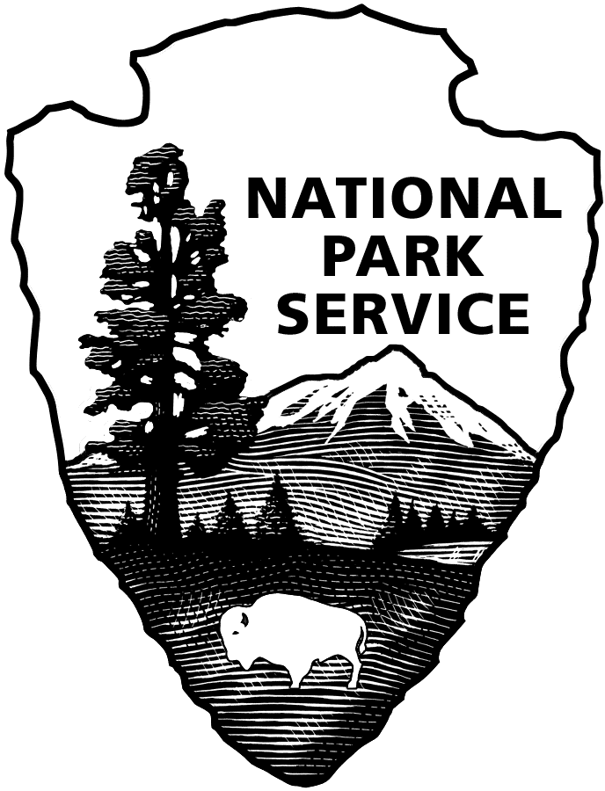 United States Department of the Interior

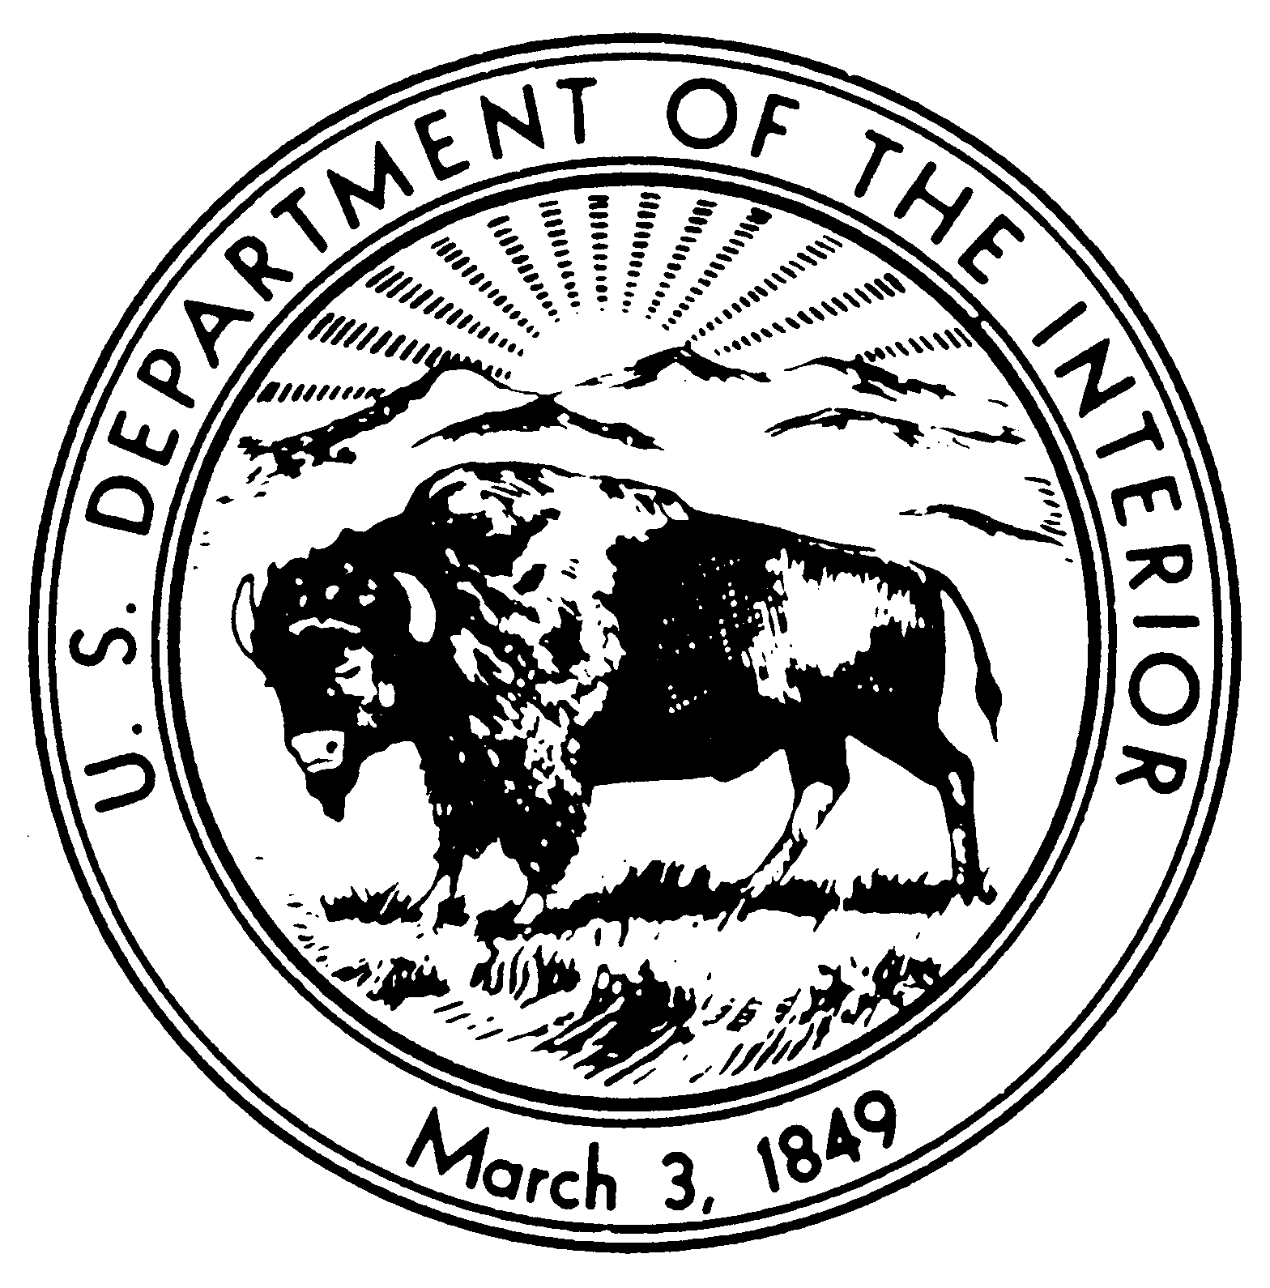

NATIONAL PARK SERVICE

Glacier Bay National Park & Preserve

P.O. Box 140

Gustavus, Alaska 99826-0140

Tel: (907) 697-2230

RECRUITMENT BULLETIN: **GLBA-25-011**

ISSUE DATE: March 24, 2025

CLOSING DATE: April 04, 2025

##### JOBS AVAILABLE THROUGH THE ALASKA LOCAL HIRE PROGRAM--PUBLIC LAW 96-487

**Glacier Bay National Park and Preserve** is accepting applications for one, temporary (not-to-exceed 1039 hours), full-time, Student Trainee (Automotive Mechanic Helper), WG-5801-05 position. More than one position may be filled via this bulletin.

________________________________________________________________________________

**POSITION**

**STUDENT TRAINEE (AUTOMOTIVE MECHANIC HELPER), WG-5801-05**

$27.65 to $32.23 per hour

**DUTY LOCATION**

Bartlett Cove, AK

**APPOINTMENT INFORMATION**:

Temporary, full-time approximately May through end of November.  The appointment may be extended for an additional period (not to exceed 1039 hours total employment).  Persons selected may be eligible for rehire in future years.  Schedule may involve weekend work or performance of duties before or after “normal” working hours.  Government housing is not available.  More than one position may be filled from this posting.

**BENEFITS:**

Temporary, seasonal, and intermittent employees on appointments expected to last at least 90 days, and expected to work a schedule of 130 hours or more a calendar month, will be eligible to enroll in a Federal Employee Health Benefit (FEHB) health plan upon notification from their employing office. Eligible employees will be responsible for the employee share of the premium while on the official agency roles, which will be deducted from bi-weekly earnings.

**DUTIES:**

You will work as a Student Trainee (Automotive Mechanic Helper), WG-5801-05 at Glacier Bay National Park and Preserve. Duties include but are not limited to the following:

This position is located in the Maintenance Division of Glacier Bay National Park and Preserve and is supervised by the Maintenance Mechanic Supervisor. Assists Automotive and Marine mechanics with the maintenance and repair of Automotive, Marine, Heavy Equipment and small engine equipment.

* Assists journeyman mechanics with routine tasks, preparing and delivering necessary tools, equipment, and parts.
* Learns to read work orders, follow specifications, and use tools and diagnostic equipment under close supervision.
* Performs tasks such as lubricating, changing fluids, replacing filters, lights, windshield wipers, tires, and conducting safety inspections.
* Inspects components like spark plugs, fan belts, and hoses, making adjustments or replacements as needed.
* Manages tools and equipment, cleans the work area, and returns tools to proper storage after each task. Prepares records of actions taken and obtains necessary signatures.
* Follows safety procedures and maintains a clean, safe work environment.

**PHYSICAL DEMANDS**: The incumbent is required to make repairs which often require them to work in tiring, awkward, and uncomfortable positions, and the work performed frequently involves standing for long periods of time, bending, stooping and crawling under vehicles, and making repairs in other tight spaces. The incumbent frequently lifts, handles, and carries parts and equipment weighing up to 18 kilograms (40 pounds), and occasionally moves moderately heavy items weighing up to 23 kilograms (50 pounds) with assistance or with mechanical devices.

**WORK CONDITIONS**: Work is usually performed inside on concrete surfaces where there is exposure to drafts, noise, and fumes from vehicles. Occasionally the work may be performed outside under adverse weather conditions. The incumbent is continually exposed to dirt, dust, and grease, and to the potential for burns, chemical irritations, shocks, bruises, cuts, and strains. To reduce the dangers and irritations from these conditions, the incumbent follows prescribed safety practices and uses safety equipment such as safety shoes and glasses and respirators.

**WHO MAY APPLY:** Any U.S. citizen who has acquired special knowledge or expertise regarding the natural or cultural resources of Glacier Bay National Park and Preserve, by reason of having either lived or worked in or near the park. To be eligible, applicants must have lived or worked in or near the area long enough to encounter and become familiar with a full range of typical conditions that affect the work to be accomplished. Applicants’ resumes should reflect periods of time having lived or worked in or near the area of consideration.

Areas considered “near” Glacier Bay National Park and Preserve is the area within the State of Alaska that extends from Dixon Entrance on the south to Icy Bay on the north.

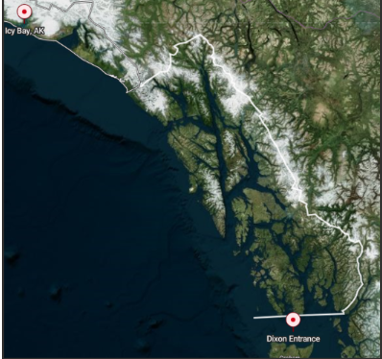

**POSITION REQUIREMENTS:** Requirements will be determined by evaluating experience in your resume and /or in the interview and selection process. All position requirements must be met by the closing date of this job posting. Knowledge or expertise concerning the park’s or preserve’s natural and/or cultural resources and the management thereof is required. Local knowledge of the resources and the typical conditions that affect the work to be accomplished will be applied in the performance of the duties. In determining eligibility, applicants' resume must indicate periods of time of having lived and/or worked in or near the above listed areas of consideration. Failure to do so may result in non-referral of your application.

Following are four competencies identified for this position. Applicants are not required to address these competencies in a separate document, but are encouraged to include in their resumes information related to these competencies.

1. Uses efficient learning techniques to acquire and apply new knowledge and skills; uses training, feedback, or other opportunities for self learning and development
2. Knowledge of machines and tools, including their design, use, benefits, repair, operation, and maintenance.
3. Ability to bend, lift, climb, stand, and walk for long periods of time; ability to perform moderately heavy laboring work.
4. Knowledge of motor vehicle engines, parts, and systems, including their designs, uses, repair, and maintenance.

**CONDITIONS OF EMPLOYMENT:**

* U.S. Citizenship required.
* Appointment subject to background investigation with favorable adjudication before starting work.
* Selectee will be required to participate in the Direct Deposit Electronic Funds Transfer Program.
* Must be 16 years of age or older.
* Males must meet Selective Service Registration Act requirement. Verify registration at sss.gov.
* Must have the ability to lift as much as 50 pounds.
* Government housing is not available.
* You will be required to wear a uniform and comply with the National Park Service uniform standards. A uniform allowance will be provided.
* You may be required to work on-call, evenings, weekends, holidays, overtime, and shift work.

**HOW TO APPLY**:

***PLEASE READ THE FOLLOWING INSTRUCTIONS CAREFULLY!***Incomplete submissions may result in non-referral of your application. ***Please note:***An application consists of your resume and any other required forms or documents outlined below. There is no application form to complete.

**Assistance may be obtained by e-mailing glba_hr@nps.gov.**

All applications must be postmarked or received via email by the closing date of the announcement.

**If mailed via USPS, your application must be addressed to: Park Headquarters, Glacier Bay National Park and Preserve, P. O. Box 140, Gustavus, AK 99826.**

If your application is postmarked on the closing date, it must be received in a sealed envelope at Glacier Bay National Park and Preserve no later than seven calendar days after the closing date. ***Emailed applications must be received by 11:59 AKST on the closing date of the job posting.***

**It is the applicant’s responsibility to verify their application has been received via email by the deadline specified above.**

**You may email your application to: glba_hr@nps.gov. Emailed applications must not be sent (CC) to this position’s supervisor or any other individual staff member.**

**If you email your application, include the bulletin number in the subject line.** If you apply for more than one position, send a separate email with application for each position.

**Note:** Information provided in the body of the email will not be considered part of your application. Include all information you want to share in your resume or include a cover letter.

**Be sure to not include any photographs of yourself or any PII** (Personally Identifiable Information), such as your Social Security Number, driver’s license number, or passport number.

**Hand-delivered applications cannot be accepted.** DO NOT SEND your application via UPS or FedEx. We do not accept faxed applications or applications mailed in postage-paid government envelopes or through an internal government mail system.

**REQUIRED FORMS to send via USPS or email:**

* **Resume** that provides detailed information about your work experience. Also include: *the recruitment bulletin number of the position for which you are applying*; and for each period of employment: the dates worked (for example, June 2009 through August 2010), the position title, employer’s name, phone number and address.
  + Emailed resumes and cover letters need to be sent as **attachments.**
* **DD-214** if claiming points of Veterans’ Preference; if claiming 10 points of Veterans’ Preference, also include the SF-15 and verification documents described on the back of the SF-15. The SF-15 may be obtained through the Internet at [www.opm.gov/forms](http://www.opm.gov/forms).

It is the applicant’s responsibility to provide documentation/proof of claimed status for veterans’ preference, qualifications, and education. Applicants will not be solicited for further data if that provided is found to be inadequate, illegible, or incomplete.

Application materials will not be returned; therefore, do not submit original documents that you may need in the future, or extra materials such as letters of recommendation, photographs, or award certificates.

If you make a false statement in any part of your application, you may not be hired or you may be fired after you begin work, or you may be subject to fines, imprisonment, or other disciplinary action.

**Veterans’ Preference (for qualifying veterans):** To receive Veterans’ Preference, your application package must include a copy of the DD-214, “Military Discharge,” that shows the type of discharge from service (usually the Member 4 copy), or Report of Separation from Active Duty if separation was prior to July 1, 1979. If claiming 10-point Veterans’ Preference, you also must provide a completed SF-15 (www.opm.gov/forms) and verification documents listed on the SF-15. If you are separated and as yet do not have a DD-214, you may use an official statement of service from your command indicating that you have completed active service and are being discharged under honorable conditions, or provide other official documentation (e.g. documentation of receipt of a campaign badge or expeditionary medal) that proves your military service was performed under honorable conditions. You will not receive Veterans’ Preference if you do not provide this documentation.

**Reasonable Accommodations:** The agency provides reasonable accommodations to applicants with disabilities where appropriate. If you need a reasonable accommodation for any part of the application and hiring process, please notify the park office listed on this announcement. Determinations on requests for reasonable accommodations will be made on a case-by-case basis.

**Privacy Act Information** The application you submit for this position contains information subject to the privacy act of 1974 (PL-93-579, 4 USC 552a). We are required to provide you with information regarding our authority and purpose for collecting this data, the routine uses which will be made of it and the effects, if any, of non-disclosure. You are entitled to the same information as it pertains to disclosure of your social security number. Any questions you may have regarding the Privacy Act regulations and the rights it extends can be answered by contacting the park office.

**Equal Employment Opportunity** Appointments are made without regard to race, color, age, sex, sexual orientation, religion, political affiliation, national origin, marital status, non-disqualifying handicap condition or any non-merit factor.