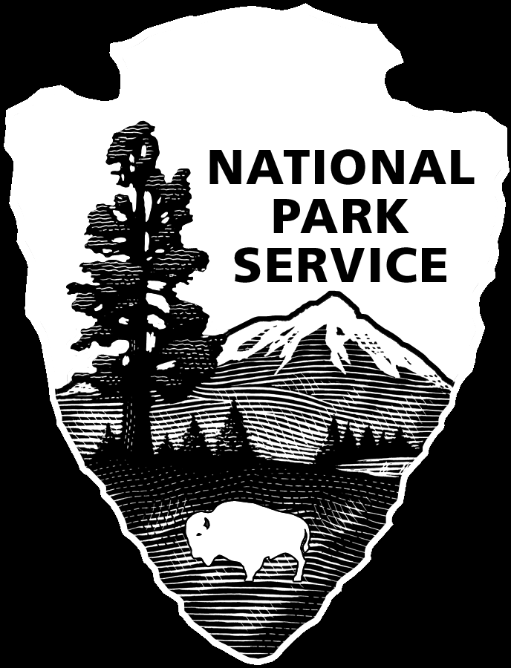
FEE WAIVER
Academic Study at Lava Beds National Monument

Name and address of institution:
_________________________________________________________________________
_________________________________________________________________________

_________________________________________________________________________

Instructor Name: ____________________________ Dates of visit: ____________ to ____________

Phone: ______________________________ Fax: _______________________________

E-mail: ____________________________

Number in group: ______ Number of vehicles:________ Grade: ____________

Groups must submit three pieces of documentation to support your request. Please check to indicate that you are submitting the following:

Proof that your group is an academic institution, such as a letter of accreditation or an educational tax exemption letter. A tax-ID number is not sufficient.

A copy of your lesson plan that includes national, state, or district standards, and a statement indicating how visiting Lava Beds National Monument is relevant to your lesson plan.

A trip itinerary.

Please send completed form and supporting documentation to:
Lava Beds National Monument, PO Box 1240, Tulelake, CA 96134
or email LABE_fee_waiver@nps.gov

- If approved, a signed copy will be emailed or mailed back to the address you listed above.
- Upon receipt of the approved form, make copies for each of the vehicles in your group, and be sure to bring them with you.
- This fee waiver is valid for entrance fees only. All other fees, including camping fees, must also be paid.
- If you have any questions, feel free to contact us at 530-667-8113.
- If you are interested in a ranger guided education program please contact 530-667-8112 or clint_augustson@nps.gov
- If you are interested in staying in the group campsite please call 530-667-8113.

National Park Service Approval

Chief Ranger’s Signature: ______________________ Date: ______________
Requires signature to be valid.

