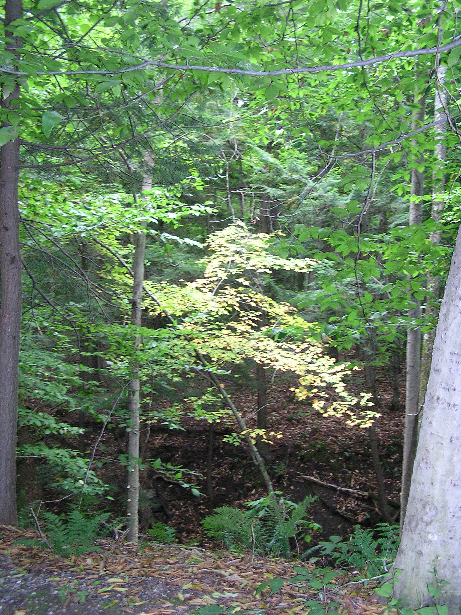


Marsh-Billings-Rockefeller National Historical Park

Alphabetical List of Hiking Trails
This list is best used in conjunction with the Walk Woodstock map.
Trail | Distance | Rating
Acer Loop | 1.2 miles, 2 km | moderate
Ashes, Ashes | 0.3 miles, 0.5 km | moderate
Cemetery Road | 0.5 miles, 0.8 km | moderate
Faulkner Trail (switchback) | 1.25 miles, 2 km | difficult
Hilltop Trail | 0.15 miles, 0.25 km | easy
King Farm Loop | 0.6 miles, 1 km | moderate
Larch Trail | 0.4 miles, 0.7 km | moderate
Lower Link | 0.25 miles, 0.5 km | moderate
Stewardship Trail | 0.5 miles, 0.8 km | easy
Mackenzie Farm Trail | 0.2 miles, 0.4 km | easy
Maple Grove Loop | 0.2 miles, 0.4 km | easy
Maple Trail | 1.2 miles, 2 km | moderate
McKenzie Rd | 0.8 miles, 1.5 km | easy
Middle Pass Trail | 0.5 miles, 0.8 km | difficult
Mount Tom Road (to South Peak) | 1 mile, 1.6 km | easy
Mountain Road | 1.2 miles, 1.9 km | moderate
North Peak Trail | 1 mile, 1.6 km | moderate
North Ridge Loop | 1.3 miles, 2.1 km | moderate
North Slope Trail | 0.5 miles, 0.8 km | moderate
One Less Traveled Trail | 0.8 miles, 1.5 km | moderate
Pogue Brook Trail | 0.3 miles, 0.5 km | moderate
Pogue Loop | 0.7 miles, 1.1 km | moderates
Precipice Trail (use caution) | 0.5 miles, 0.8 km | difficult
Prosper Trail | 0.6 miles, 0.9 km | difficult
Ravine Trail | 0.25 miles, 0.5 km | moderate
Red Pine Loop | 0.5 miles, 0.8 km | moderate
Spring Lot Trail | 0.1 miles, 0.16 km | easy
Sugar House Road | 0.1 miles, 0.16 km | easy
Summer Pasture Road | 0.4 miles, 0.7 km | easy
Upper Link | 0.25 miles, 0.5 km | moderate
Upper Meadow Road | 0.4 miles, 0.6 km | moderate
West Ridge Trail | 1.1 miles, 1.7 km | difficult
White Pine Trail | 0.3 miles, 0.4 km | moderate

