NATIONAL CAPITAL REGION

HISTORIC WEAPONS GUIDELINES

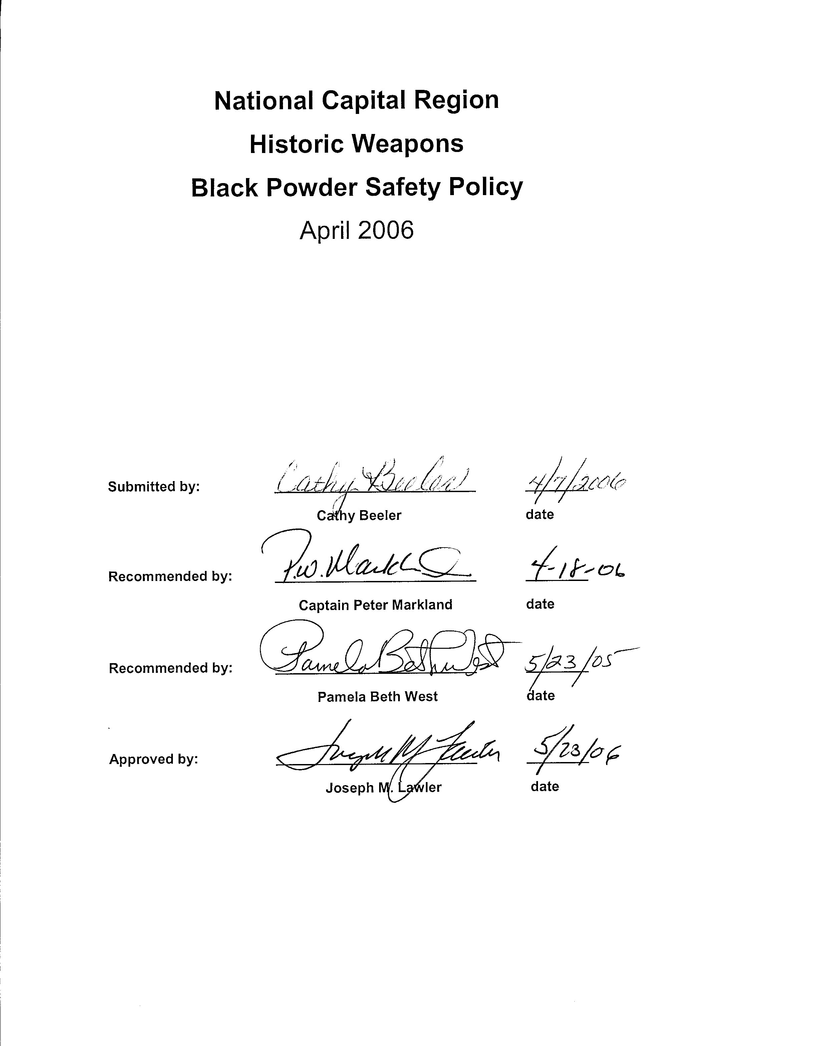

The following sets forth the guidelines of the National Capital Region for historic weapons as well as the storage and handling of black powder and weapons safety. These guidelines supplement the National Park Service Historic Weapons Demonstration Policy and Safety Standards (Director’s Orders). It is the responsibility of the Park Superintendent to ensure that all Historic Weapons activities in the Park program are in compliance with applicable law, the Director’s Orders, Regional Directives, and Policies. The Superintendent must designate in writing a lead program coordinator to assume responsibility for all aspects of black powder use and the use, firing and display of any historic weapon demonstrations in that park. These are minimum standards for NCR. Each Park Superintendent may compile additional or stricter or tighter requirements if warranted. Consistent with applicable law, NPS regulations and policy, the choice of weapons to interpret and the method of interpreting those weapons will be the purview of the individual parks in the region.

To insure adherence to these standards and appropriate manuals parks can expect Regional inspections at any time. Usually but not always the regional inspections will be arranged with the park in advance. All questions on safety issues relating to historic weapons, along with the storage and handling of black powder and explosive devices must be directed to, and fall under the aegis and responsibility of Pamela West, Director, Museum Resource Center, National Capital Region who has been designated as the National Capital Region Point of Contact (NCRPC).

Pursuant to NPS 2001 Management Policies 7.5.7 , “original NPS museum weapons will not be used; no exemptions will be granted. Requests by outside groups or individuals [including employees] to use non-NPS original weapons will follow the exemption request procedure prescribed in Reference Manual 6, and will be granted or denied in writing by the [NCRPC.]”

Regional Inspectors

Each Park Superintendent must insure that all historic weapons activities are in compliance with the directives, policy and various weapons manuals. Regional Inspectors assist the Superintendent and the designated lead program .

The National Capital Region Safety Inspector (NCRSI), and only the NCRSI, is tasked by the (NCRPC) to answer questions and offer guidance pertaining to historic weapons and black powder storage and handling policies and guidelines within the National Capital Region. All questions regarding historic weapons issues in the National Capital Region must be referred to the NCRSI.
Currently there is one historic weapons safety inspector in the National Capital Region: Cathy Beeler, Chief, Resource Education & Visitor Services, and Monocacy National Battlefield.

Black Powder Storage and Handling

In recognition of the Park Superintendents responsibility for all public and employee safety in the parks, the National Capital Region policy is to assist and help guide the Park Superintendent to ensure compliance in areas of storage and handling of black powder. This advisory roll is the responsibility of the NCRPC. Every magazine, both indoor and outdoor, will be inspected bi-annually by the NCRSI. Only magazines approved by the NCRPC and NCRSI are authorized for use in the National Capital Region. Parks instituting a new historic weapons program, Beach Apparatus Drill, or installing a new magazine, or parks replacing an old magazine, will coordinate with the NCRSI before the purchase, construction, or installation of a new magazine. Black powder magazines must conform to Bureau of Alcohol, Tobacco, and Firearms (BATF) Explosives Law and Regulations (ATF P 5400.7 [2000] and the National Park Service Black Powder Storage Policy. Any deviation from NPS policies and guidelines, if it is allowed at all, must be approved in writing by the NCRPC.

Live ammunition is never allowed in historic weapons demonstration programs in the National Capital Region. However, there may be rare instances, such as staff training, where live ammunition might be stored in a park magazine for a brief period. Any historic weapons supervisor desiring to store live ammunition in a park magazine will submit a written request, at least sixty (60) days in advance to the NCRSI, who will notify the NCRPC within 10 days, stating the purpose for using live ammunition and the timeframe for which the live ammunition will be stored. Live ammunition will never be stored in a park magazine without the express written permission of the NCRPC. When permission is received from the NCRPC, live ammunition will be stored in a separate, locked container clearly marked “live ammunition” in two-inch red letters.

Normally, storing black powder in the original one pound can is still the safest method. Blank small arms ammunition made up in quantity, as with all other powder in storage, must be strictly accounted for on an inventory log. Paper cartridges, when prepared, must be kept in dated containers and stored no more than one season or 90 days maximum whichever is shorter. An excess of 6 months of powder in any form should be avoided and in no cases kept more than two years.

Weapons, Lyle Guns and Inspections

Reproduction black powder weapons, or Lyle guns, pertinent to the historic period prescribed in the park’s interpretive themes are the only items authorized for interpretive firing demonstrations at National Capital Region parks. Parks having themes encompassing both the flint and percussion eras must have a supervisor certified in each period. The same historic weapons supervisor may be certified in both periods but, if so, that individual must attend the Servicewide historic weapons training course every two (2) years in order to receive full certification in one period, either flint or percussion, at each course. No park supervisor who only attends the Servicewide training every four (4) years will be certified in both the flint and percussion eras.

Only those weapons listed on the historic weapons supervisor’s certification may be fired during interpretive demonstrations. If the park sponsors an event utilizing an reproduction historic weapon not encompassed in the certification of the park’s supervisor, or otherwise wishes to fire a weapon not listed on the supervisor’s certification, an historic weapons supervisor with a certification inclusive of that weapon must be present when that weapon is discharged (to secure the services of a certified historic weapons supervisor from another park, see “Outside Groups” section, paragraph one [1]). The discharge of other than historic black powder weapons is not the responsibility of the park’s certified historic weapons supervisor. The firing of modern (non-law enforcement) cartridge weapons, modern artillery, pyrotechnic devices, or any other type of ordnance not covered within the black powder supervisor’s certification will be at the direction and discretion of the superintendent under the auspices of a special use permit.

All small arms and artillery pieces, Lyle guns, along with implements to be utilized in black powder demonstrations, will be inspected by the park’s supervisor at the beginning of each season utilizing the checklists provided in the NPS black powder guidelines and bi-annually by a NCRSI. Additional weapons inspections will be performed by the park’s historic weapons supervisor periodically throughout the year. Each weapon and Lyle gun will also be inspected visually before each demonstration. The discovery of any defect that might compromise the safety of the demonstrator or visitors will result in the weapon or implement being “tagged-out” and secured. The defective weapon or implement will not be used thereafter until such time as it is repaired or deemed safe for use by the historic weapons supervisor. Any defect, anomaly, or unusual occurrence experienced with a black powder weapon or implement that could have wider ramifications will immediately be reported to the NCRPC (see Appendix A).

Weapons Firing

Flashguards and hammerstalls will be installed on flintlock muskets and rifles used during firing demonstrations in the National Capital Region, regardless of whether or not the weapon is fired as part of a single or multiple weapons demonstration. In rare situations, some hunting rifles do not allow for the installation of a flashguard. In such cases the weapon may be used, but only by an individual demonstrator and not when firing in line or with multiple weapons demonstrators, and only after receiving written permission from the NCRPC. Under no circumstances will projectiles be fired during an historic weapons demonstration, and under no circumstances will visitors be allowed to handle a loaded weapon. Visitors are allowed to handle a musket or rifle only if the demonstrator has at least one hand on the weapon and maintains physical control of the weapon at all times. Visitors will never be allowed to handle pistols or edged weapons. The one exception to firing projectiles is the Lyle Gun, where demonstrators are allowed to fire a reproduction shot. The lines used with the Lyle gun shot must be inspected prior to and following each demonstration.

The amount of powder used in small arms, artillery cartridges, and Lyle Guns during firing demonstrations in the National Capital Region will fall within the regional Table of Maximum Loads (see appendix B).

Every park conducting black powder demonstrations in the National Capital Region will have an approved documented misfire drill for each type of weapon fired during demonstrations (artillery piece, musket/rifle, and pistol). Misfire drills will be approved by one of the NCRSI and the documented drills will be on file with the NCRPC.

Every park in the National Capital Region conducting artillery programs must at some point during the ten minute time between firings check the vent to be positive that it is not obstructed by part of a broken primer from the previous firing. This is not in the artillery manual; however, the quality of the primers today is not near as good as the military used, this can result in a possible vent obstruction by part of the primer being broken off and staying in the vent. This is to be done discreetly just after the firing or sometime during the 10 minute lull so as not to detract from historic accuracy. This is necessary as a safety precaution to avoid ramming a charge and them discovering that the vent has an obstruction.

*NON-FIRING DEMONSTRATIONS

Flint or percussion weapons used in non-firing demonstrations or interpretive programs are to be under the supervision of an NCR Class II Historic Weapons Supervisor (see Appendix C).

Use of Saber and Saber Knot (along with other edged weapons)

The sword fulfilled a dual function: (1) as a weapon for enlisted men and (2) as a badge of rank for all officers. The saber, for cavalrymen, was essentially a weapon with the saber knot being the means of attaching it to the cavalry trooper’s body. The saber knot was always used and constructed so the knot would break easily, preventing any trooper from ever being dragged by a horse. Therefore, properly constructed sword knots are to be used as originally required, without exception, in the demonstration of cavalry tactics manuals. (On drawing the saber, the first motion is to slip the right hand through the knot and grasp the handle.) Swords or sabers are not to be demonstrated any closer than 9 feet between demonstrators; they must always be demonstrated behind the same line as firing demonstrations are conducted. If mounted troops wish to demonstrate the use of a saber, it should be done standing on the ground.

Other edged weapons, such as bayonets, may be demonstrated following the proper military manual. Remember that all weapons must always be pointed away from the audience and rifles should be treated as if loaded at all times. Bayonet and sabre drills must also be conducted behind a safety barrier. At no time will an edged weapon ever be handed to a visitor. It must always be under the physical control of the demonstrator.

Employee Safety

Natural fiber clothing and ear protection will be worn during all small arms and artillery demonstrations. Demonstrators who wear prescription eyeglasses will be required to have safety lenses. Designated gun crew members on artillery pieces will wear heavy gauntlets during firing demonstrations and the artillery crew member who tends the vent will have a thumbstall in place during each firing demonstration.

Only approved materials will be used on weapons, accoutrements, and artillery implements (e.g., leather and wood cartridge boxes, leather or natural fiber musket and rifle slings, leather thumbstalls, wool or 100 percent natural fiber carpet for sponge heads, etc.).

Any personal injury or unusual weapons malfunction experienced during a living history demonstration, or any anomaly that could feasibly affect safe operations at other parks, must be immediately reported to the NCRPC (see Appendix A).

Outside Groups

Parks conducting special events where the ratio of demonstrators/artillery pieces per historic weapons supervisor (more than 40 small arms demonstrators or more than two artillery pieces) requires more than one supervisor. If for this or any other reason an additional historic weapons supervisor is required, the park historic weapons supervisor will convey that need to the NCRPC at least thirty (30) days in advance. The NCRPC will be responsible for selecting additional historic weapons supervisors to attend National Capital Region special events.

When outside groups conduct firing demonstrations at a National Capital Region park, that park’s certified historic weapons supervisor will have sole responsibility for the safety of those demonstrations, regardless of the number of historic weapons supervisors attending that event, unless otherwise designated in writing by the Superintendent. Whenever more than one historic weapons supervisor is present at an event, those supervisors will convene before the start of said event; and the supervisor in charge will designate a chain of command, delegate individual responsibilities, and establish procedures for conducting that event.

Any outside group conducting firing demonstrations will be provided with a copy of the NPS black powder regulations fourteen (14) days prior to their arrival at the park. The park must have on file a written agreement that the regulations will be complied with before an outside group is permitted to perform firing demonstrations. All outside groups will have their weapons inspected by an NPS historic weapons supervisor and weapons must have flashguards and hammerstalls before they can be discharged. Members of outside groups must be able to demonstrate their proficiency in the drill they use. Outside groups will also be required to adapt their firing drill to comply with NPS safety guidelines. Individuals having weapons in a generally debilitated condition or weapons with missing or broken parts will not be allowed to participate in firing demonstrations and no original weapons will be used in firing demonstrations. An NPS historic weapons supervisor will personally observe every firing demonstration presented by outside groups. Outside groups will never be allowed to bring bulk powder to a park and those outside groups who bring prepared cartridges will store the cartridges in the park's magazine.

Outside groups with artillery pieces will have the tubes, carriages, implements, and ammunition inspected by an NPS historic weapons supervisor using the NPS inspection checklist prior to the pieces being fired. The Park must keep on file a completed paper copy of each inspection checklist for every artillery piece inspected. Artillery ammunition will be stored in the park's magazine until just prior to being used. Outside gun crews will have the necessary safety items and misfire implements required for guns and gun crews. The crew must demonstrate their proficiency with their particular drill and be familiar with NPS misfire procedures. The park's historic weapons supervisor will personally observe every firing demonstration presented with an outside artillery piece.

Off-Site firing Demonstrations

The Park Superintendent will be submitted for review a list by the Park Historic Weapons supervisor yearly of the trained individuals that will be taking part in the program that year. At the review the Superintendent could require at a minimum written certification of the training with dates, duration of training, and identity of the instructor. The Superintendent will have final approval and certify those on the list by signing it. Prior to placing any name on the list the person must be checked for any record of domestic violence, or other violations of Federal, State, or local law would prohibit the issuance of a firearm. NPS weapons will be issued to and used in firing demonstrations by volunteers only after the volunteer or volunteers have been trained and certified by the park’s permanent Historic Weapons supervisor. On-site firing demonstrations will not necessarily require the immediate presence of the Historic Weapons supervisor once the volunteer has been trained to the supervisors’ satisfaction and has been certified by passing a written and practical test. However, liability issues dictate that park volunteers will not participate in off-site firing demonstrations utilizing government owned or association owned weapons unless a certified permanent Historic Weapons supervisor is present to supervise the demonstration and approve the range. Seasonal employees may participate in unsupervised off-site firing programs as long as the individual is trained and certified, and written documentation is on file from the park’s Historic Weapons supervisor authorizing the off-site firing program. Such off-site programs pertain to small arms only. All off-site artillery programs must be under the supervision of a permanent Historic Weapons supervisor. If uncertain as to the policy, contact the NCRPC or the NCRSI.

Animals in Historic Weapons Programs

Prior to use of any animals in the historic weapons program, they must be fully trained with the small arms or artillery to insure public and employee safety. Any animals being used in connection with historic weapons program in the park must be tested by the lead historic weapons supervisor to insure that the sound of the artillery or small arms will not scare them. The artillery or small arms must be fired at least once in the presence of the animals at the same distance from the weapon as in the actual programs. This is to be in a non-public firing with the Historic Weapons supervisor present to help insure that any potentially – dangerous situation will not occur. The best way to use horses or mules in any artillery program is to unlimber, unhitch, and move the animals 30 to 40 yards behind the limber. When used in connection with artillery programs, horses or mules are always to be held by horse holders. Should any animals used in the program start to display signs of stress or to act up in any way, the program must be stopped and the animals moved a safe distance away prior to the program resuming. Normally in artillery programs horses or mules should be kept 30 to 40 yards away and tied to a tether line as well as held by horse holders.

Appendix A

INCIDENT REPORTING PROCEDURES

Every accident or safety related incident involving historic weapons or black powder safety and handling will be reported to the Regional Point of Contact at the earliest opportunity. Serious incidents will be documented on a Case Incident Report. Information concerning an accident or incident will include, but not be limited to, the following:

 Date, time, and exact location of the incident.

 A concise and complete statement of facts surrounding the incident. This should include the name, address, telephone number, and date of birth of all involved, including witnesses.*

 Statements of persons involved and witness statements.

 Details as to whether a regulation or guideline was violated.

 Description of personal injury or property loss or damage.

 Weather and conditions at the scene (visibility, wind direction and speed, wet, slippery, loose gravel, etc.).

 Photographs and/or diagrams of the scene if they will assist with clarifying the narrative.

* Should an incident occur, visitors will immediately be removed to a safe distance from the scene. Park staff, demonstrators, volunteers, members of outside groups, and/or visitors will be instructed to make no remarks or comments regarding the incident until interviewed by the staff member investigating the incident. The Superintendent or his/her representative is the only individual authorized to make statements to the press or to the public concerning historic weapons accidents or incidents.
Appendix B

NATIONAL CAPITAL REGION TABLE OF MAXIMUM LOADS

Loads shown represent the absolute MAXIMUM amount of powder that will be used with any individual charge or weapon. Maximum loads will be used only where range circumstances permit (open space, proximity of private property, etc.). Using less than the maximum load is recommended and often desirable.

SMALL ARMS

Weapon Type Caliber Maximum
Blank Load
________________________________________________________________
17th Century

Matchlock .60 to.75 (varies) 125 grains ffg

18th and 19th Century Flint Firearms

“Brown Bess” Musket .75 125 grains ffg
Charleville/Springfield Musket & variants .69 125 grains ffg
Pennsylvania/Kentucky Rifle & variants Varies 90 grains ffg
Pistols and Horse Pistols Varies 75 grains ffg

19th Century Percussion Firearms

U.S. Musket .69 75 grains ffg
U.S. Rifle, M1841 and 1855 .54 and .58 60 grains ffg
U.S. Musket, M1842 .69 75 grains ffg
(Also Rifled Musket)
U.S. Rifle Musket, M1855-64 .58 60 grains ffg
British Enfield Rifle Musket, P1853 .577 60 grains ffg
(Also Rifle, P1858 and Musketoon)

Percussion Revolver .36 20 grains fffg
Percussion Revolver .44 28 grains fffg

19th Century Metallic Cartridges

U.S. Springfield Rifle .50 70 grains ffg
Sharps Carbine .50 70 grains ffg
U.S. Springfield Rifle .45 70 grains ffg
U.S. Springfield Carbine .45 55 grains ffg

Colt’s Revolver, M1873 .45 28 grains fffg
Smith and Wesson Schofield Revolver .45 28 grains fffg

ARTILLERY

Weapon Type Caliber Maximum
Blank Load
________________________________________________________________
18th Century

Swivel Gun 2 pounder 3 ounces fg

“Grasshopper” 3 pounder 6 ounces fg

British Light Gun 6 pounder 12 ounces fg
British Field Howitzer 5.8 inch 10 ounces fg

Iron Gun 3 pounder 6 ounces fg
Iron Gun 4 pounder 8 ounces fg
Iron Gun 6 pounder 10 ounces fg
Iron Gun 9 pounder 16 ounces fg
Iron Gun 12 pounder 20 ounces fg
Iron Gun 18 pounder 28 ounces fg
Iron Gun 24 pounder 32 ounces fg

Howitzer 8 inch 36 ounces fg
Howitzer 8.76 inch 16 ounces fg

19th Century

M1841 Gun 6 pounder 10 ounces fg
M1841 Field Howitzer 12 pounder 10 ounces fg
M1841 Mountain Howitzer 12 pounder 8 ounces fg
M1857 Gun-Howitzer (“Napoleon”) 12 pounder 20 ounces fg

Parrott Rifle 3 inch 10 ounces fg
Ordnance Rifle 3 inch 10 ounces fg

Lyle Gun --- 2 ounces fg

Note: Maximum blank loads for weapons not identified on this chart shall not exceed 3.5 ounces of fg powder for every 1-inch of chamber diameter.
Appendix C

Historic Weapons Class II Supervisor

The National Capital Region is unique in that it is the only region within the National Park Service Historic Weapons Program that recognizes a second level of training/certification. In order to ensure safety and accountability in the non-firing use of historic weapons (flint and percussion periods ONLY), the addition of Class II supervisors are now incorporated into the operation of the NCR Historic Weapons Program.
- The supervisors must be an officially trained and certified career, career-conditional or term employees, 21 years of age or older, whom the superintendent has designated in writing to be responsible for the enforcement of all safety regulations and precautions related to the use of historic weapons in non-firing interpretive programs.
- Each supervisor will be authorized to supervise non-firing use of historic weapons in National Capital Area parks only.
- Class II supervisors will be held to the same accountability and control, implementing the same guidelines presently used in NCR parks.
- Class II certification will be valid for no more than 4 years. Each supervisor must successfully complete the NCR Class II Certification Training Course.

Training
The NCRSI will conduct a 4-hour training course every 2 years. Training may be held more frequently if demand necessitates.

*The implementation of this level of certification has eased the financial burden of the benefiting parks for the reimbursement cost of having an NPS Historic Weapons Supervisor (Class I) onsite for non-firing weapons demonstrations. While we will never compromise safety for the sake of cost, we feel that this has been a viable step to ensure safe quality programs.

Post-1898 weapons are not defined as “antique firearms” by the Bureau of Alcohol, Tobacco and Firearms (BATF) and also fall outside the guidelines of the NPS Historic Weapons Program. NCR Parks outside the District of Columbia may use pre-1898 reproduction weapons in interpretive programs. In the District of Columbia, however, DC Code Ann. 7-2502.01 (2001) generally prohibits the possession of a “firearm.” A “firearm” is defined by DC Code Ann. 7-2501(9) (2001) as “any weapon which will, or is designed or redesigned, made or remade, readily converted or restored, and intended to, expel a projectile…(but does not include pre-1898 “antique firearms” or its replica, unless designed to fire a modern cartridge. DC Code 7-2501.01(3) (2001)). Equally important, courts have interpreted the District of Columbia’s prohibition against “operable firearms” to also include “inoperable weapons that may be redesigned, remade or readily converted or restored to operability.” This District of Columbia prohibition essentially includes all post-1898 firearms, as well as reproductions of this, or of any other period, that can fire modern cartridges.

