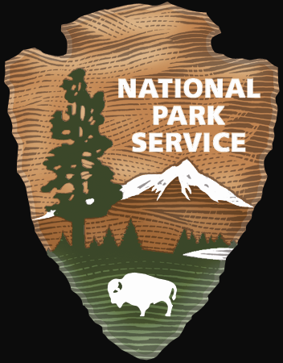

National Capital Parks-East
Office of Concession Management
1900 Anacostia Drive, SE
Washington, D.C. 20020

National Park Service
U.S. Department of the Interior

Washington, D.C.

APPLICATION SUBMITTAL CHECKLIST

All Commercial Use Authorization (CUA) Applicants Must Submit the Following Documents:
□ One complete CUA application - A complete typed or neatly written CUA (Form 10-115) with all required fields filled out. Authorized service includes boat repair and limited mechanical and hull service. The CUA Applicant must provide a detail of what is being requested as your CUA will include only allow you to do what you have requested
□ A Certificate of Insurance that names the US Government as additionally insured that meets both General and Automobile Liability Insurance requirements (if applicable)
□ Proof of applicable licenses, registrations or certificate of training (i.e. valid driver’s license or business license or others).
□ After filling out CUA application please sign the last page and return the completed signed document to our office with the Certificate of Insurance, Safety Plan, and all certificates/licenses to the address above.

Payment
□ Application/Administrative fee of $300.00 must be included with your application by check or money order.
□ Make payable to the National Park Service.

Processing Time
□ Allow a minimum of 4 weeks for processing a complete application. This will include NPS seeking concurrence from the marina (unless received by applicant).
□ Applications are processed in the order in which they are received.
□ All required documents must be submitted in one application packet.
□ Incomplete applications are placed on hold until all required documents are received.
□ Application requests cannot be expedited.

Once processed a draft copy of the CUA authorization will be emailed to you for your review and signature. This form can be returned to this office electronically or via mail. After the authorization is signed by you and returned to this office for the Superintendent’s signature a final approved authorization will be emailed to you (unless you request that a hardcopy be mailed to you).

If you have multiple vehicles you will need to make a copy of the complete authorization (all pages, including conditions) for each vehicle since a complete copy of the CUA must be with you each time you are at James Creek Marina.

Thank you for your corporation and interest in Anacostia Park. If you have any questions please contact Wanda L. Washington at (202) 690-5158 or nace_commercial_services@nps.gov.

