National Park Service
U.S. Department of the Interior

San Juan Island
National Historical Park

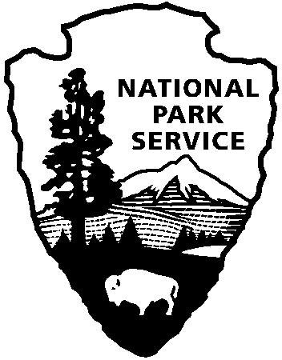

SAJH Horseback Riding Information

No permits are necessary for non-commercial horse riding within the park. Commercial horse tours are not authorized.

Group Size and Locations:
Groups will be limited to 4 horses. See the attached maps for the approved riding trails.

Permittee is authorized to ride horses in the following areas:

- American Camp: Visitor Center access road; old County Road connecting Visitor Center parking lot and Redoubt parking lot; Redoubt Road; Pickett’s Lane; and the beach east of Pickett’s Lane up to the extreme high tide line marked by large driftwood piles.

- Mount Finlayson Trail from Jakle’s Lagoon parking lot to park boundary. Adjacent Department of Natural Resources land is not accessible to horses. Do not go past the sign that says, “No horses beyond this point.”

- Jakle’s Lagoon Trail (Service Road only) from Jakle’s Lagoon parking lot to park boundary. No access to side trails except Nature Loop Trail. Adjacent Department of Natural Resources land is not accessible to horses. Do not go past the sign that says “No horses beyond this point.”

- Nature Loop Trail connecting Jakle’s Lagoon Trail with Mount Finlayson Trail.

- Main trail up the back side of Mount Young to area short of summit. Do not go past the sign that says, “No horses beyond this point.”

- English Camp Service Road from West Valley Road to edge of parade ground (the open grassy area where the historic buildings are). Do not go past the sign that says, “No horses beyond this point.”

- Mitchell Hill unit trails.

Your permit will include, but is not limited, to these terms and conditions:

- A horse party is limited to four horses. One person in each party must hold a valid Special Use Permit for horse riding. The permittee is responsible for ensuring that members of each party obey these permit conditions.

- The permittee must be within eyesight of their entire party at all times.

- At American Camp, the permittee will load, unload and park horse trailers at the main paved parking area at the end of Pickett’s Lane. Horse trailer parking is not available at English Camp.

- Please remove horse manure from the parking area prior to departure. The manure must be removed from the park.

- Use of the trails in San Juan Island NHP by the public releases agents and employees from all liabilities and claims for damages and/or suits for or by reason of any injury, injuries, or death to any person or persons or property of any kind whatsoever, whether to the person or property of the Permittee, its agents or employees, or third parties, from any cause or causes whatsoever while in or upon said premises or any part thereof during the term of this permit or occasioned by any occupancy or use of said premises or any activity carried on by the Permittee in connection herewith, and the Permittee hereby covenants and agrees to indemnify, defend, save and hold harmless the United States, its agents, and employees from all liabilities, charges, expenses and costs on account of or by reason of any such injuries, deaths, liabilities, claims, suits or losses however occurring or damages growing out of the same.

Additional Information:
Additional information about San Juan National Island Historical Park may be found on our website at www.nps.gov/sajh.

You may also contact the Administrative Officer at 360-378-2240 ext. 2221 or the American Camp Visitor Center at 360-378-2240 ext. 2233.

