**OPTIONAL. NOT REQUIRED.**

Use only **if requested by the consulting parties** for human remains or associated funerary objectswith **cultural affiliation** AFTER publication of a notice of inventory completion under [43 CFR 10.10(e)](https://www.ecfr.gov/current/title-43/part-10/section-10.10#p-10.10(e)) *Step 5 – Submit a notice of inventory completion.*

No later than 90 days after receiving a request to amend a notice, use this template to ADD or REVISE the Indian Tribes or Native Hawaiian organizations with cultural affiliation to **human remains** or **associated funerary objects**.

**Insert the following four pieces of information** in the appropriate places in this template, indicated by {#. Required information and *additional instructions*}. Provide ONLY the information requested.

1. Museum or Federal Agency. *Full name can be abbreviated or referred to by initials after the first instance, i.e. Museum of Natural Science (MONS).*

2. Publication date of original notice of inventory completion. *In the abstract section, add the full citation for the original notice. Include information found in the Document Details tab on Federalregister.gov. Include Document Citation and Publication Date which MUST be in the specific, required format. From the image below, as an example, 89 FR 77184, 9/20/2024.*

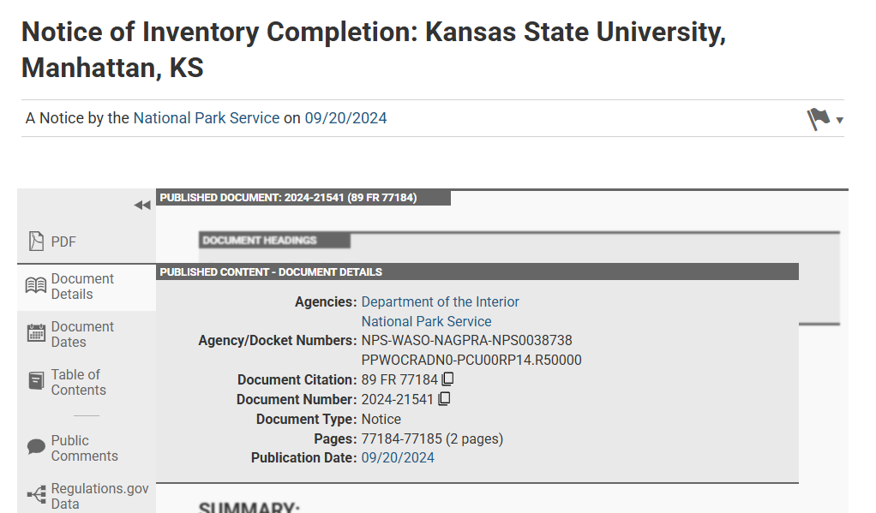

3. Authorized representatives’ name and addresses for delivery of written documents. *Documents are timely based on the date sent* ([43 CFR 10.1(f)(2)](https://www.ecfr.gov/current/title-43/part-10/section-10.1#p-10.1(f)(2)))*.*

4. The Indian Tribes or Native Hawaiian organizations with cultural affiliation.

**DO** **NOT** make any changes to the font (Times New Roman 11pt), line spacing (double), margins, or headings. **DO** **NOT** change the brackets [INSERT DATE 30 DAYS AFTER DATE OF PUBLICATION IN THE **FEDERAL REGISTER**]. This instructs the *Federal Register* to calculate the date upon publication. The notice must conform to the mandatory format of the *Federal Register* and include the required information listed above. Deviation from the template may result in the return of the notice for edits and delayed publication.

**VERIFY** all information, especially any numbers or internal addition. The National NAGPRA Program does not review or validate the content of your notice and is not responsible for the determinations or errors in the notice. **REMOVE** these instructions, highlighting, italics, and {braces} before submission.

**Submit a notice** by sending it to any consulting party and to the Manager, National NAGPRA Program, (nagpra_info@nps.gov) for publication in the *Federal Register.* National NAGPRA will verify receipt within one business day. No later than 21 days after receiving a notice, the Manager, National NAGPRA Program, will either:

* Approve it for publication in the *Federal Register*, or
* Return it to the museum or Federal agency. No later than 14 days after the submission is returned, the museum or Federal agency must resubmit the notice to the National NAGPRA Program.

**The notice will publish in the *Federal Register* 5-10 days** after it is approved by the Manager, National NAGPRA Program. You will receive an email from the National NAGPRA Program once it is published.

**4312-52**

**DEPARTMENT OF THE INTERIOR**

**National Park Service**

**[NPS-WASO-NAGPRA-DTSNUMBER; PPWOCRADN0-PCU00RP14.R50000]**

**Notice of Inventory Completion Amendment:** **{1. Museum or Federal Agency, City, State Abbreviation}**

**AGENCY:** National Park Service, Interior.

**ACTION:** Notice; amendment.

**SUMMARY:** In accordance with the Native American Graves Protection and Repatriation Act (NAGPRA), the {1. Museum or Federal Agency} has amended a notice of inventory completion published in the *Federal Register* on {2. Month Day, Year}. This notice amends the Indian Tribes or Native Hawaiian organizations with cultural affiliation.

**DATES:** Repatriation of the human remains and associated funerary objects may occur on or after [INSERT DATE 30 DAYS AFTER DATE OF PUBLICATION IN THE **FEDERAL REGISTER**].

**ADDRESSES:** Send written requests for repatriation of the human remains and associated funerary objects to {3. Authorized representative’s Name, Museum or Federal Agency’s Name, Street Address, City, State Abbreviation Zip Code, email [*XXXX@XXXX.XXX*](mailto:XXXX@XXXX.XXX)}.

**SUPPLEMENTARY INFORMATION:** This notice is published as part of the National Park Service’s administrative responsibilities under NAGPRA. The determinations in this notice are the sole responsibility of the {1. Museum or Federal Agency}, and additional information on the determinations in this notice, including the results of consultation, can be found in its inventory or related records. The National Park Service is not responsible for the determinations in this notice.

**Amendment**

This notice amends the determination of cultural affiliation published in a notice of inventory completion in the *Federal Register* ({3. Identify notice by {Document Citation as Vol. FR Page No.}, {Publication Date as MM/DD/YYYY}). Repatriation of the human remains or associated funerary objects in the original notice of inventory completion has not occurred.

**Determinations**

The {1. Museum or Federal Agency} has determined that:

* There is a connection between the human remains and associated funerary objects described in the original notice and {4. list Indian Tribes with cultural affiliation in alphabetical order per the most recent Secretary’s list of federally recognized Indian Tribes, as published in the *Federal Register*, or list Native Hawaiian organizations with cultural affiliation}.

**Requests for Repatriation**

Written requests for repatriation of the human remains and associated funerary objects in the original notice must be sent to the authorized representative identified in this notice under ADDRESSES. Requests for repatriation may be submitted by:

1. Any one or more of the Indian Tribes or Native Hawaiian organizations identified in this notice.

2. Any lineal descendant, Indian Tribe, or Native Hawaiian organization not identified in this notice who shows, by a preponderance of the evidence, that the requestor is a lineal descendant or an Indian Tribe or Native Hawaiian organization with cultural affiliation.

Repatriation of the human remains and associated funerary objects described in the original notice to a requestor may occur on or after [INSERT DATE 30 DAYS AFTER DATE OF PUBLICATION IN THE **FEDERAL REGISTER**]. If competing requests for repatriation are received, the {1. Museum or Federal Agency}must determine the most appropriate requestor prior to repatriation. Requests for joint repatriation of the human remains and associated funerary objects are considered a single request and not competing requests. The {1. Museum or Federal Agency} is responsible for sending a copy of this notice to the Indian Tribes and Native Hawaiian organizations identified in this notice and any other consulting parties.

**AUTHORITY:** Native American Graves Protection and Repatriation Act, 25 U.S.C. 3003, and the implementing regulations, 43 CFR 10.10.

Dated:

**Melanie O’Brien,**

*Manager, National NAGPRA Program.*