**OPTIONAL. NOT REQUIRED.**

Use only for **human remains** or **associated funerary objects** with **NO cultural affiliation** AFTER publication of a notice of inventory completion under [43 CFR 10.10(e)](https://www.ecfr.gov/current/title-43/part-10/section-10.10" \l "p-10.10(e)) *Step 5 – Submit a notice of inventory completion*.Under [43 CFR 10.10(k)](https://www.ecfr.gov/current/title-43/part-10/section-10.10#p-10.10(k)) *Transfer or reinter human remains or associated funerary objects,* a museum or Federal agency, **at its discretion**, may agree to transfer or decide to reinter only after initiating consultation, completing an inventory, and publication of a notice of inventory completion.

No later than 30 days after agreeing to transfer or deciding to reinter, use this template to complete the notice required by [43 CFR 10.10(k)(2)](https://www.ecfr.gov/current/title-43/part-10/section-10.10#p-10.10(k)(2)) *Step 2 – Submit a notice of proposed transfer or reinterment*. The museum or Federal agency may include in a single notice any human remains or associated funerary objects having the same consultation record and determination in items 6, 7, and 8 below.

**Insert the following ten pieces of information** in the appropriate places in this template, indicated by {#. Required information and *additional instructions*}. Provide ONLY the information requested. Some of this information may be taken directly from the published Notice of Inventory Completion.

1. Museum or Federal Agency. *Full name can be abbreviated or referred to by initials after the first instance, i.e. Museum of Natural Science (MONS).*

2. *Select* **EITHER** transfer *or* reinter*. In the determinations section, include the Indian Tribe or Native Hawaiian organization requesting transfer* OR *a statement that the museum or Federal agency agrees to reinter.*

3. Publication date of the related notice(s) of inventory completion. *In the abstract section, add the full citation for the notice(s) of inventory completion. Include information found in the Document Details tab on Federalregister.gov. Include Document Citation and Publication Date which MUST be in the specific, required format. From the image below, as an example, 89 FR 77184, 9/20/2024.*

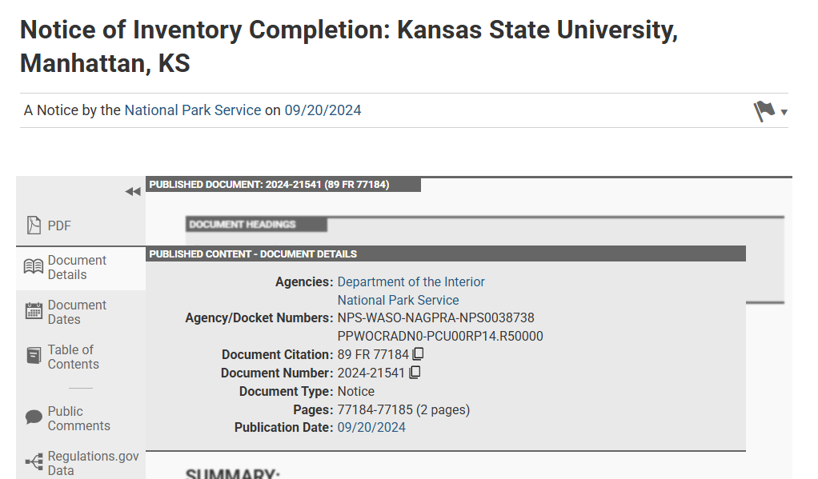

4. Authorized representative’s name and addresses for delivery of written documents. *Documents are timely based on the date sent* ([43 CFR 10.1(f)(2)](https://www.ecfr.gov/current/title-43/part-10/section-10.1#p-10.1(f)(2)))*.*

5. The {number} of individuals *from the published notice(s).*

6. The {number} of associated funerary objects OR No associated funerary objects are present *from the published notice(s).*

7. *A BRIEF abstract of additional information, updated as appropriate, from the published notice.*

8. *List all lineal descendants, Indian Tribes, or Native Hawaiian organizations invited to consult. If applicable, list any Indian groups without Federal recognition invited to consult. In a separate sentence, list those parties who responded to the invitation and participated in consultation.*

9. *Identify* *the type(s) of information available for cultural affiliation under* [43 CFR 10.3(a)](https://www.ecfr.gov/current/title-43/part-10/section-10.3#p-10.3(a)) *from the published notice*.

10. *Identify each of the criteria identified for cultural affiliation under* [43 CFR 10.3(b)](https://www.ecfr.gov/current/title-43/part-10/section-10.3#p-10.3(b)) *from the published notice.*

**DO** **NOT** make any changes to the font (Times New Roman 11pt), line spacing (double), margins, or headings. **DO** **NOT** change the brackets [INSERT DATE 30 DAYS AFTER DATE OF PUBLICATION IN THE **FEDERAL REGISTER**]. This instructs the *Federal Register* to calculate the date upon publication. The notice must conform to the mandatory format of the *Federal Register* and include the required information listed above. Deviation from the template may result in the return of the notice for edits and delayed publication.

**VERIFY** all information, especially any numbers or internal addition. The National NAGPRA Program does not review or validate the content of your notice and is not responsible for the determinations or errors in the notice. **REMOVE** these instructions, highlighting, italics, and {braces} before submission.

**Submit a notice** by sending it to any consulting party and to the Manager, National NAGPRA Program, (nagpra_info@nps.gov) for publication in the *Federal Register.* National NAGPRA will verify receipt within one business day. No later than 21 days after receiving a notice, the Manager, National NAGPRA Program, will either:

* Approve it for publication in the *Federal Register*, or
* Return it to the museum or Federal agency. No later than 14 days after the submission is returned, the museum or Federal agency must resubmit the notice to the National NAGPRA Program.

**The notice will publish in the *Federal Register* 5-10 days** after it is approved by the Manager, National NAGPRA Program. You will receive an email from the National NAGPRA Program once it is published.

**4312-52**

**DEPARTMENT OF THE INTERIOR**

**National Park Service**

**[NPS-WASO-NAGPRA-DTSNUMBER; PPWOCRADN0-PCU00RP14.R50000]**

**Notice of Proposed Transfer or Reinterment:** **{1. Museum or Federal Agency, City, State Abbreviation}**

**AGENCY:** National Park Service, Interior.

**ACTION:** Notice.

**SUMMARY:** In accordance with the Native American Graves Protection and Repatriation Act (NAGPRA), the {1. Museum or Federal Agency} proposes to {2. *EITHER* transfer *or* reinter} human remains and associated funerary objects listed in a notice of inventory completion published in the *Federal Register* on {3. Month Day, Year}.

**DATES:** Repatriation, transfer, or reinterment of the human remains and associated funerary objects in this notice may occur on or after [INSERT DATE 30 DAYS AFTER DATE OF PUBLICATION IN THE **FEDERAL REGISTER**].

**ADDRESSES:** Send written request for repatriation of the human remains and associated funerary objects to {4. Authorized representative’s Name, Museum or Federal Agency’s Name, Street Address, City, State Abbreviation Zip Code, email [*XXXX@XXXX.XXX*](mailto:XXXX@XXXX.XXX)}.

**SUPPLEMENTARY INFORMATION:** This notice is published as part of the National Park Service’s administrative responsibilities under NAGPRA. The determinations in this notice are the sole responsibility of the {1. Museum or Federal Agency}, and additional information on the determinations in this notice, including the results of consultation, can be found in its inventory or related records. The National Park Service is not responsible for the determinations in this notice.

**Abstract of information available**

This notice follows publication of a notice of inventory completion in the *Federal* Register (3. Identify notice by {Document Citation as Vol. FR Page No.}, {Publication Date as MM/DD/YYYY}). Human remains representing, at least, {5. number} individuals have been identified. The {6. number} associated funerary objects are {*list type of each object or group of objects, e.g., pottery sherds, tools, beads, and buttons*, OR No associated funerary objects are present}. {7. *Include a BRIEF abstract of information in the published notice, updated as appropriate. Include, if available, the geographical location, acquisition history, and the presence of any potentially hazardous substances used to treat any of the human remains or associated funerary objects.*}

**Consultation**

Invitations to consult were sent to the {8. list Indian Tribes in alphabetical order per the most recent Secretary’s list of federally recognized Indian Tribes, as published in the *Federal Register*, or list Native Hawaiian organizations. *If appropriate, list any Indian groups without Federal recognition that were invited to consult. In a separate sentence, list those parties who responded to the invitation and participated in consultation.}*

**Cultural affiliation**

The following types of information about the cultural affiliation of the human remains and associated funerary objects in this notice are available: {9. *Choose the appropriate type(s) of information:* anthropological, archaeological, biological, folklore, geographical, historical, kinship, linguistics, oral traditional, other relevant information, expert opinion, or Native American traditional knowledge. *List only the* ***types*** *of information available, not detailed information related to any particular type. Detailed information should be in the inventory or in a written record of the determination*.} The information, including the results of consultation, identified {10. *Insert responses below, as appropriate.*}:

1. {{Name of earlier group(s)} as an earlier group OR No earlier group} connected to the human remains or associated funerary object.
2. {{Name of Indian Tribe(s) in alphabetical order per the most recent Secretary’s list of federally recognized Indian Tribes, as published in the *Federal Register*, or list Native Hawaiian organizations} as an Indian Tribe or Native Hawaiian organization OR No Indian Tribe or Native Hawaiian organization} connected to the human remains or associated funerary objects.
3. No relationship of shared group identity between the earlier group and the Indian Tribe or Native Hawaiian organization that can be reasonably traced through time.

**Determinations**

The {1. Museum or Federal Agency} has determined that:

* The human remains described in this notice represent the physical remains of {5. number} individuals of Native American ancestry.
* The {6. number} objects described in this notice are reasonably believed to have been placed intentionally with or near individual human remains at the time of death or later as part of the death rite or ceremony.
* No known lineal descendant who can trace ancestry to the human remains and associated funerary objects in this notice has been identified.
* No Indian Tribe or Native Hawaiian organization with cultural affiliation to the human remains and associated funerary objects in this notice has been clearly or reasonably identified.
* {2. *Choose EITHER:* The {*list Indian Tribes or Native Hawaiian organizations who requested transfer in alphabetical order*} have requested transfer of the human remains and associated funerary objects described in this notice. *OR* The human remains and associated funerary objects will be reinterred according to applicable laws and policies.}

**Requests for Repatriation**

Written requests for repatriation of the human remains and associated funerary objects in this notice must be sent to the authorized representative identified in this notice under ADDRESSES. Requests for repatriation may be submitted by any lineal descendant, Indian Tribe, or Native Hawaiian organization who shows, by a preponderance of the evidence, that the requestor is a lineal descendant or an Indian Tribe or Native Hawaiian organization with cultural affiliation.

Repatriation, transfer, or reinterment of the human remains and associated funerary objects described in this notice may occur on or after [INSERT DATE 30 DAYS AFTER DATE OF PUBLICATION IN THE **FEDERAL REGISTER**]. If requests for repatriation are received, the {1. Museum or Federal Agency}must evaluate the requests and respond in writing to the requestors. The {1. Museum or Federal Agency} is responsible for sending a copy of this notice to the Indian Tribes or Native Hawaiian organizations identified in this notice.

**AUTHORITY:** Native American Graves Protection and Repatriation Act, 25 U.S.C. 3003, and the implementing regulations, 43 CFR 10.10.

Dated:

**Melanie O’Brien,**

*Manager, National NAGPRA Program.*